SMART

(School Measurement,Assessment and Reporting Toolkit)

The following teaching strategies can assist children meet outcomes in the content areas of:

Number and Algebra

Measurement and Geometry

Statistics and Probability

For syllabus details and specific outcomes click here

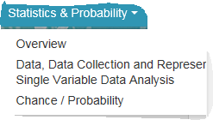

………………………………………………………………………………………………….

Data
Data addresses the need for all students to understand, interpret and analyse information displayed in tabular and graphical forms.
In the primary curriculum students learn to ask questions relevant to their experiences and interests and to design ways of investigating their questions. They need to recognise when information has been displayed in a misleading manner that can result in false conclusions.
In the secondary curriculum students will continue to develop knowledge, skills and understanding in collecting, representing, analysing and evaluating information. The Australian Bureau of Statistics has a number of Education Webpages including a set of activities for students, teacher resources and interactive graphs. Some particularly useful links are:
- What Graph or Display to Use When
- CensusAtSchool Australia
- Statistical Language
- Professional Support Materials
- Interesting Stats
- Interact with our data
Many of the teaching strategies for the Data strand include the use of technologies such spreadsheets, interactive whiteboard activities. Apps downloadable on the iPhone/iPad are also suitable for use in the classroom for demonstration purposes or by students at home. These provide useful starting points for teachers and may be easily adapted to suit specific needs.
Stage 1

Data – Tally Marks

Australian Curriculum Reference: ACMSP049: Collect, check and classify data ACMSP050: Create displays of data using lists, table and picture graphs and interpret them

NSW Syllabus Reference: MA1-17SP Gathers and organises data, displays data in lists, tables and picture graphs, and interprets the results

NSW Literacy Continuum Reference: COMC8M3: Comprehension, Cluster 8, Marker 3: Builds understanding of a text by using knowledge of text organisation and features, e.g. referring to headings and sub-headings to locate information.

Other Literacy Continuum Markers: REAC8M3: Reading texts, Cluster 8, Marker 3: Reads texts in different ways to meet a range of reading purposes.

Links to other curriculum areas: PD/H/PE

Record data using tally marks; record data in a column graph; answer questions about information in a column graph

Strategy

Students can:
- record data using tally marks
- record data in a column graph
- answer questions about information i n a column graph

Activities to support the strategy

Activity 1 – Healthy food choices

Display a number of food items that students could choose as a healthy snack. Items could include apple, banana, pear, yoghurt, cheese stick, salad sandwich, sultanas, fruit kebab, carrot sticks and strawberry smoothie.

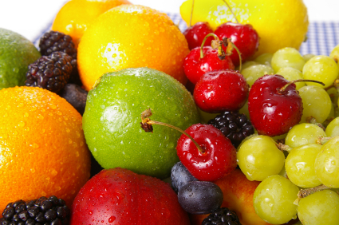
- Students work in pairs and discuss these food items. Each student tells their partner which food item they would choose as a snack.
- Students report back to the class and describe which food item they would choose and why.

Ask: Who chose apple as a snack? (4 students)
Count the numbers 1, 2, 3, 4 and make four strokes on the whiteboard as you count.

Ask: Who chose strawberry as a snack? (2 students). Count the numbers 1, 2 and make two strokes on the whiteboard as you count.

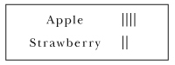

Ask: What if ten children chose a food? How could we show a bigger number using strokes?
- Show how to record using tally marks, by making groups of 5.

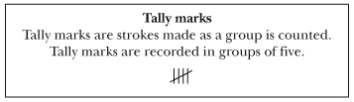
- Record the class information about healthy food choices on a chart using tally marks.

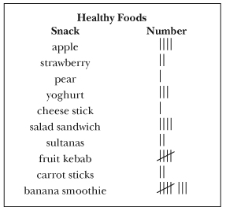
- Gather other information about the students by asking questions. Record the number of responses on the whiteboard by using tally marks.

e.g. How many children have 1 sister, 2 sisters, 3 sisters, 1 brother, etc?

How many children have blue eyes, brown eyes, green eyes, etc?
- For large numbers, students can practise skip-counting by fives to count the total number of tally marks.
e.g.

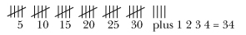

Activity 2 – Constructing a Column Graph

Display the table below. The table shows the favourite colours of children in one class.

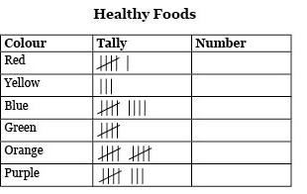

view and print

Have students look at the headings - Colour, Tally, Number (How many altogether).

Read the list of colours with the class.

The tally marks show the number of children who chose each colour. Count the tally marks and write the total in the last column.

Ask: What is another way we can show this information? (in a picture graph, in a column graph)

Display this graph.

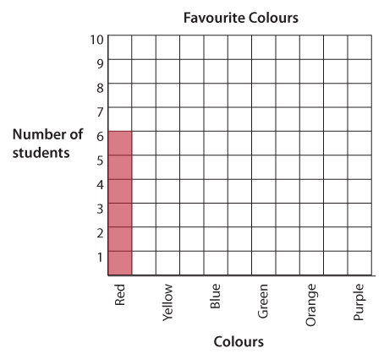

view and print

Say: Look at the words along the bottom. Read them.
What are all of these words? (colours)
How many squares are coloured red? Why?
Why are there numbers up the side of the graph?

How many squares should we colour for yellow?

Ask a student to colour in the correct number of yellow squares.

Ask different students to help complete the column graph by colouring the correct number squares to match the tally.

Once the columns have been correctly coloured, ask the students what this graph is about.

What should we call this graph? (Favourite colours). Write the title above the graph.

Activity 3 – Interpreting a Column Graph

Say to the class:
A class kept a tally of all the lunches ordered at the canteen in one week.
Each tally mark shows one lunch order. Count the tally marks and write the total number of lunch orders for each day in the last column.

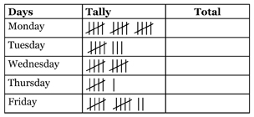

view and print

The class then made a graph to show the number of lunches ordered.

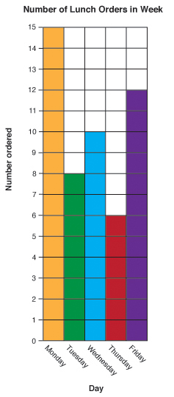

view and print

Use the information presented in the graph to answer these questions.
- How many lunches were ordered on Monday? On Tuesday? etc.
- Which day had the least number of lunch orders?
- Which day had the most number of lunch orders?
- How many more lunches were ordered on Wednesday than on Thursday?
- How many lunches were ordered altogether during the week?

Students think of one other question they could ask about the information in this table. Students share their question with the class.

Further Activity – Healthy food choices

In small groups, ask students to identify what snacks and drinks they have brought to school. Each group collects the information in a table.
e.g

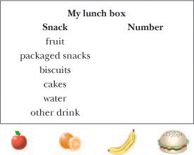

view and print

Students construct a column graph to represent the information in the table. Some teacher guidance may be necessary.

Ask students questions such as:
- What was the most popular food choice?
- What was the least popular food choice?
- Why is it important to choose a healthy food as a snack?

In pairs, ask students to write two sentences about the information presented in the class graph. Share the sentences in small groups or with the whole class.

Further activities to support Data in Stage 2

Mathematics K-6 Activities to support the syllabus – Stage 1 DATA

Online resources

Teacher resources

Nrich enriching mathematics website
Activities on Data Stage 1
nrich.maths.org

CensusAtSchool – Australian Bureau of Statistics
www.abs.gov.au/censusatschool

Interactive White Board Activity

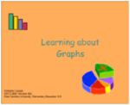

Learning About Graphing

Other online resources

h1 header

h2 header

h3 header

h4 header

h1 header

h1 header

Worksheets which show how to record tally marks
www.abcteach.com/free/t/tallymarks2.pdf
www.kidzone.ws/math/grade1
www.oblockbooks.com/tec3225.pdf
www.teacherled.com/resources/survey/surveyload

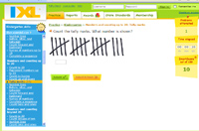
Kindergarten tally marks up to 20

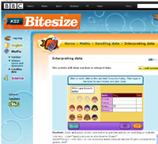
Bite size maths

Back to top
© Learning, High Performance and Accountability
Stage 3

Data – Interpreting information in a table

Australian Curriculum Reference: ACMSP119: Construct displays, including column graphs, dot plots and tables, appropriate for data; type, with and without the use of digital; technologies

NSW Syllabus Reference: MA3-18SP: Uses appropriate methods to collect data and constructs, interprets and evaluates data displays, including dot plots, line graphs and two way tables.

NSW Literacy Continuum Reference: REAC11M4: Reading texts, Cluster 11, Marker 4: Manipulates multiple texts that include a variety of purposes and modes to locate information for a specific purpose.

Other Literacy Continuum Markers: COMC11M2: Comprehension, Cluster 11, Marker 2: Re-examines sections of texts for evidence to support interpretations and opinions. WRIC11M6: Aspects of writing, Cluster 11, Marker 6: Uses topic sentences and appropriately organises main and subordinate ideas.

Links to other curriculum areas: Geography

Organise information into columns and rows using a variety of tables; collect suitable tables from books or the internet on a variety of topics; locate and interpret information presented in two – way tables; calculate mean

Strategy

Students can:
- organise information into columns and rows using a variety of tables
- collect suitable tables from books or the internet on a variety of topics
- locate and interpret information presented in two-way tables
- calculate mean

Activities to support the strategy

When students read a question that contains a picture, graph, table or diagram they need to read all the information provided and be able to interpret the visual representations that the tables and graphs provide.

At this Stage, students need to collect their own data, create tables and graphs and interpret graphs and tables. It is also vital to expose students to the use of data and graphs in the media and wider community and how they convey meaning and information, sometimes showing a bias or presented the information in a way to persuade the consumer. This provides an opportunity to discuss how and why scale is used and that it is sometimes used to change how information may be interpreted.

The advantages and disadvantages of different representations of the same data in different graphs should be explicitly taught. Students need to choose an appropriate graph to convey meaning for their information, understanding that some graphs have particular uses e.g. Line graphs should only be used where meaning can be attached to the points on the line between plotted points. Graphs are chosen based on what data is being represented, not based on what the student likes.

Activity 1
- Collect a variety of weather and sport reports where the term 'average' has been used.

In small groups students discuss:
  - What is meant by the term 'average'?
  - How did the newspaper calculate the average maximum and average minimum temperatures/sports scores?
  - What is another word for average?

Brainstorm some other ways the term 'average' (mean) is used,
e.g. average number of students in each class,
average rainfall in a month.
- Pose this problem for students to solve. Ask them to underline the key words they need to solve the problem:

A baseball team scored the following runs during the first round of competition: 7, 10, 8, 7, 10, 8, 6, 8.
What was the average number of runs scored per game?

Students explain how they solved the problem by identifying each step, e.g.

To calculate the average (mean)

Step 1: Find the total number of runs
(7 + 10 + 8 + 7 + 10 + 8 + 6 + 8 = 64)

Step 2: Divide the total number of runs by the total number of games
(64 ÷ 8 = 8)
- Present students with other problems which involve calculating the average.

Activity 2 – Geography

When teaching students how to identify and interpret information from tables, it is important that teachers guide students to determine the context of the table using probing questions such as:
- What is the title?
- What is the heading for each column?
- What is the heading for each row?
- Is it a simple or two-way table?
- How does this affect the organisation and analysis of the information?
- How does this help to sort the information?
- Can we present this information in a different way, as a graph?
- Which type of graph would be the most suitable?

Students justify their answers.

This will give students clues as to what the table is about and the focus of the information to:
- identify the units of measurement or types of data used in the table
- consider the date and source of the data to determine reliability
- read data and find information within the table
- use mathematical methods, such as calculating maximum, minimum, total, range, rank and averages.

Discuss with the class the validity of each type of calculation in light of the data presented.

Students complete calculations where appropriate.

Activity 3

In this activity students will identify, interpret and match data to make calculations and provide information about tourists visiting Australia. Give students a copy of the table Tourists to Australia (2006). Ask students some of the questions listed in Activity 2.

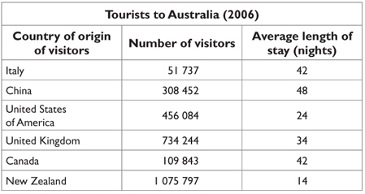

Source: adapted from visitor profile statistics available for each country listed in the Markets section
of the Tourism Australia website.

view and print

Remind students to look at the title, column headings and row headings for clues.

Ask students to:
- write a statement about the information contained in the table
- identify the different types of data present
- discuss the relevance of the data as being recent and/or reliable
- make judgments about the reliability of the source and justify their decisions.

Activity 4

Revise terminology relating to calculations such as average, total, etc.

Test for understanding of the information contained within the table by asking questions and modelling answers such as:
- From which country did the most number of visitors originate?
- From which country did the least number of visitors originate?
- Italy and which other country had visitors staying for the same average length of stay?
- What was the average length of stay of the visitors to Australia in 2006?
- What was the average number of visitors from the countries listed?
- What was the difference between the numbers of visitors from China compared to the number of visitors from the USA?
- What was the total number of visitors to Australia from these countries in 2006?

Students work in pairs to devise questions about the information in the table. Ask students to write the answers to their questions and then swap questions with another pair to answer.

Upon completion of these questions students could write a brief report outlining where tourists to Australia in 2006 originated, as well as providing a comparison of how long the visitors stayed.

These activities can be further extended by:
- visiting the Tourism Australia website and adding data from other countries to the table
- accessing the data from more recent years to make comparisons and identify possible reasons.

Online resources

Teacher resources

Australian Bureau of Statistics ‘Four Graphs Story’

Numeracy Wrap

Two-way tables

Lesson Plans and Activities

The Learning Federation – Learning Objects through TaLe

Schools who are not part of the NSW Department of Education and Communities can gain access to The Learning Federation objects through their own jurisdiction or Scootle.
Leisure survey: team sport
Home internet survey
Healthy life survey
Media report: water usage
Skateboard survey
Scatter plots: create your own data [EAL/D]
Data handler: bus timetable

Student resources

www.shodor.org/interactivate/activities/MultiBarGraph
nces.ed.gov/nceskids/createagraph

Other online resources

Nrich enriching mathematics website
Activities on Graphs Stage 3
Activities on Data Stage 3
CensusAtSchool – Australian Bureau of Statistics

Back to top
© Learning, High Performance and Accountability Directorate 2014

Data – Sector Graph

Australian Curriculum Reference: ACMSP147: Interpret and compare a range of data displays, including side-by-side column graphs for two categorical variables

NSW Syllabus Reference: MA3-18SP: Uses appropriate methods to collect data and constructs, interprets and evaluates data displays, including dot plots, line graphs and two way tables. MA3-7NA: compares, orders and calculates with fractions, decimals and percentages

NSW Literacy Continuum Reference: REAC11M4: Reading texts, Cluster 11, Marker 4: Manipulates multiple texts that include a variety of purposes and modes to locate information for a specific purpose.

Other Literacy Continuum Markers: COMC11M2: Comprehension, Cluster 11, Marker 2: Re-examines sections of texts for evidence to support interpretations and opinions. WRIC11M6: Aspects of writing, Cluster 11, Marker 6: Uses topic sentences and appropriately organises main and subordinate ideas.

Links to other curriculum areas: Geography PD/H/PE

Interpret a sector graph

Strategy

Students can:
- interpret a sector graph

When students read a question that contains a picture, graph, table or diagram they need to read all the information provided and be able to interpret the visual representations that the tables and graphs provide.

At this Stage, students need to collect their own data, create tables and graphs and interpret graphs and tables. It is also vital to expose students to the use of data and graphs in the media and wider community and how they convey meaning and information, sometimes showing a bias or presenting the information in a way to persuade the consumer. This provides an opportunity to discuss how and why scale is used and that it is sometimes used to change how information may be interpreted.

The advantages and disadvantages of different representations of the same data in different graphs should be explicitly taught. Students need to choose an appropriate graph to convey meaning for their information, understanding that some graphs have particular uses e.g. Line graphs should only be used where meaning can be attached to the points on the line between plotted points. Graphs are chosen based on what data is being represented, not based on what the student likes.

Activities to support the strategy

Activity 1 – Interpreting sector graphs

When teaching students how to interpret data from a sector graph, it is important that teachers guide students to consider each of the following:
- identify the graph's title which indicates what the graph is about
- examine the sectors to identify that each sector represents part of a whole. If the sectors are labelled as percentages the total of all the sectors should add to 100%
- consider the sector labels to determine the category of information represented in each sector
- use mathematical methods to perform calculations such as combined percentages and to find missing values.

In this activity students will interpret data from a sector graph to make calculations which provide information about the relative size of each Australian state and territory's coastal waters as a percentage of the whole of Australia's marine area.

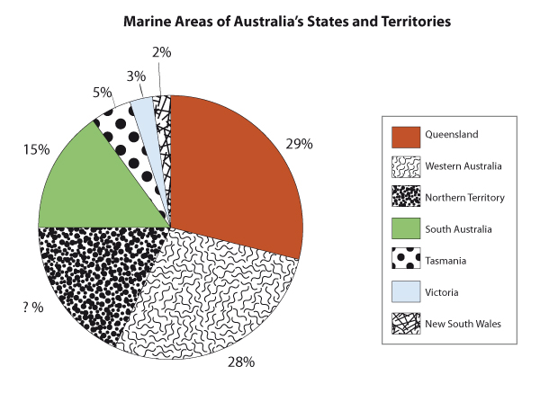

view and print

Ask students to look at the sector graph and identify the title, the key and each of the sectors.
- Have students identify each of the different sectors. Remind students to use the key.
- Ask students to write a statement about the information displayed in the sector graph. Remind them to look at the title for a clue.
- Have students present the information as a table. Ask them to list each of the sectors in the graph with the associated numerical data (percentage value).
- Discuss the process required for calculations such as:
  - determining missing values
  - calculating combined percentages
  - calculating total percentages etc.
- Test for understanding of the information contained within the graph by asking questions such as:
  - List the marine areas of Australia's states and territories in order of percentage size from smallest to largest.

Discuss
  - Which state or territory has the largest percentage of marine area?
  - Which state or territory has the smallest percentage of marine area?
  - What is the Northern Territory's percentage of marine area?
  - Which state has approximately half of the marine area of Queensland?
  - What fraction of Australia's total marine area are the four smallest states when they are combined?

Upon completion of these questions, students could present the information from the sector graph in a column graph then compare which graph is more appropriate.

Activity 2 – Interpreting sector graphs
- Collect and display a variety of sector graphs from books, newspapers or the Internet. Discuss:
  - What is similar to all of these graphs?
  - Are the same colours/patterns always used to show the different sectors?
  - Do the graphs all have the same number of sectors?

Where a key is used to interpret the graph discuss the key with the class.

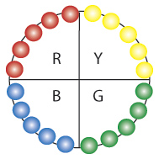
- Select 20 lollies (jelly beans/Smarties) of 4 different colours in the same proportions e.g. 5 red, 5 blue, 5 green and 5 yellow.

Place the lollies in colour groups along the circumference of a circle.
- Draw lines from the centre of the circle to the circumference to divide the circle into colour groups. Label each sector and describe the fractional parts. Discuss:
  - What fraction of the circle is represented by each colour?
  - What fraction of the circle is not red/yellow?
- Explain that:
  - the sector graph is equal to one whole which is the same as 100%.
  - there are four equal sectors in the graph, so each sector must be one-quarter.
- Using fractions, determine what percentage of the circle is represented by each colour.
¼ of 100% = 25%
- Demonstrate that 50% is half of the sector graph. Students identify pairs of sectors which make up 50%.

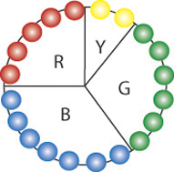
- Repeat, selecting 20 coloured lollies (jelly beans/Smarties) of 4 different colours and in different proportions. e.g. 5 red, 7 blue, 6 green and 2 yellow.

Discuss:
  - Which colour group is equal to one-quarter of the circle?
  - Is the blue sector more or less than one-quarter of the circle?

Order the coloured sectors from smallest to largest. Emphasise that the highest percentage sector represents the largest quantity.
- Demonstrate how to determine the size of each sector as:
  - a fraction of the whole
  - a percentage of the whole
- Students refer back to the sector graph with equal sectors (quadrants). Use a protractor to measure the angle size of each quadrant (90°).
  - calculate the angle size at the centre of the circle percentage

90° x 4 = 360°

Using angle size, determine what percentage of the circle is represented by each colour.

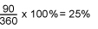
- Repeat step 7 using a different number of lollies (jelly beans/Smarties) such as 5 or 12 or 18 or 54. Discuss graphs.

Further activities
- Students in pairs, conduct a class survey to collect data on a chosen topic. Record the data in a table.
- Use the data to construct a sector graph. Use a key to identify each sector.
Students demonstrate the relationship between the key and the sectors.
- Students write their own questions using the graph and key and give to other students to answer.

Online resources

Teacher resources

Nrich website activities
Activities on Graphs Stage 3
Activities on Data Stage 3
CensusAtSchool – Australian Bureau of Statistics

Australian Bureau of Statistics 'Four Graphs Story'
www.mathplayground.com/piechart
www.shodor.org/interactivate/activities/PieChart
www.shodor.org/interactivate/activities/CircleGraph
nces.ed.gov/nceskids/graphing/classic/bar_pie_data

Interactive White Board Activity

Learning About Graphing

Data – Displaying and Interpreting Graphs

Australian Curriculum Reference: ACMSP148: Interpret secondary data presented in digital media and elsewhere

NSW Syllabus Reference: MA3-18SP: Uses appropriate methods to collect data and constructs, interprets and evaluates data displays, including dot plots, line graphs and two way tables.

NSW Literacy Continuum Reference: REAC11M4: Reading texts, Cluster 11, Marker 4: Manipulates multiple texts that include a variety of purposes and modes to locate information for a specific purpose.

Other Literacy Continuum Markers: COMC11M2: Comprehension, Cluster 11, Marker 2: Re-examines sections of texts for evidence to support interpretations and opinions. WRIC11M6: Aspects of writing, Cluster 11, Marker 6: Uses topic sentences and appropriately organises main and subordinate ideas.

Links to other curriculum areas: Geography HSIE

Determine a suitable scale for data and recording the scale in a key; draw picture or column graphs using a scale or key; interpret a given picture or column graph using a scale or key

Strategy

Students can:
- determine a suitable scale for data and recording the scale in a key
- draw picture or column graphs using a scale or key
- interpret a given picture or column graph using a scale or key

Activities to support the strategy

Activity 1 – Surveying the class

Pose the following problem:

What question would you ask the class if you were going to conduct a survey to find out:
- the favourite milkshake flavour
- the most popular fruit
- the preferred team game during sport time, etc.

What if your survey included all students in the school and your numbers were large, how could you display the data for large numbers? Discuss the use of symbols e.g.10 symbols can represent 100.

Draw one car on the whiteboard. One car = 10

Draw three more symbols.

What number would be represented now?

Change the number of symbols to 4, 8, 11, etc and students determine the matching number.

Repeat, but change the key so that one symbol equals 5 (or 20) and students determine the numbers for 5 cars. Ask the class what the symbol of a car could represent. List the students' suggestions on the whiteboard.

e.g.
- Ways of getting to school.
- Types of cars owned by class families
- The number of cars passing the school in a given time period.

Students suggest other symbols that could be used to represent transport themes.

Activity 2 – Picture Graphs

Display a variety of tables, with larger numbers for students to discuss.

For example

This table records the number of tourist buses visiting a town in one year. 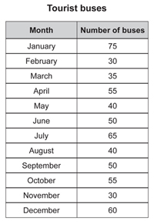
- Students will use the information to complete a picture graph showing the bus arrivals during the year.

Before they start discuss the following points:
  - What are some advantages of using a picture graph?
  - What are some disadvantages of using a picture graph?
  - Because of the large numbers, can we make the task of showing the numbers in a graph easier?
  - Would using a symbol, to represent more than one object, make it easier to present the large numbers?
  - What number could each symbol represent? (1 symbol could equal 5 buses, 10 buses). Have students justify their answer.
  - If one symbol equals 10 buses, how many symbols would need to be shown for each month? Add another column to the table to show the number of symbols that have to be used.
  - What if we need to show five buses, what symbol could be used?

view and print
- Students are given this template of picture graph to graph the bus arrivals during the year. They use the key because there are a large number of buses to record on the graph. Students draw half a bus for numbers like 15, 25, 35 and 45.

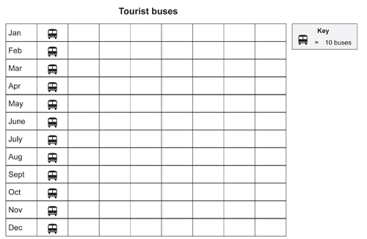

Each symbol drawn on the graph represents 10 buses. Half a symbol represents 5 buses

view and print
- When students finish their graph, they:
  - work in pairs and discuss some facts that can be obtained from the graph
  - write three questions that could be answered using the information presented in the picture graph.

Activity 3 – Column Graphs

This table records the predicted weather in each of the capital cities on one day in February.

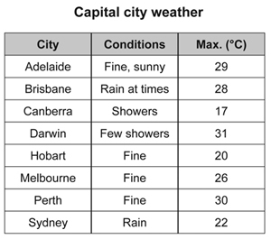

view and print
- Students will use this information and the template below to complete a column graph, which will show the predicted weather in each of the cities.

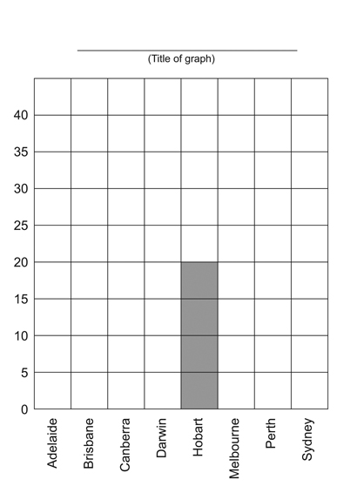

view and print

Discuss:
- What information is along the horizontal axis? (name of each capital city)
- What label could be written to match this information? (Capital city)
- What information is along the vertical axis? (temperature)
- What label could be written to match this information? (Temperature oC)
- What is the difference between each number on the vertical axis? (5)

The markers on the vertical axis are 5 numbers apart.

The temperature scale on the vertical axis is marked in 5°C intervals
- Students use the information in the table to complete the column graph by drawing the missing columns, giving the graph a title and labelling the axes. As the maximum temperature for some of the capital cities lies between the intervals on the temperature scale, students will have to measure the height of the columns carefully.

Activity 4 – Drawing Graphs

Students will use information in a table to present a graph, of their choice. The table shows data from the 2012 Olympic Games medal tally and ranks the top 20 medal-winning countries.

The 20 most succesful nations at the 2012 London Olympic Games
Rank by Gold | Country | Gold | Silver | Bronze | Total
1 | United States of America | 46 | 29 | 29 | 104
2 | People's Republic of China | 38 | 27 | 23 | 88
3 | Great Britain | 29 | 17 | 19 | 65
4 | Russian Federation | 24 | 26 | 32 | 82
5 | Republic of Korea | 13 | 8 | 7 | 28
6 | Germany | 11 | 19 | 14 | 44
7 | France | 11 | 11 | 12 | 34
8 | Italy | 8 | 9 | 11 | 28
9 | Hungary | 8 | 4 | 5 | 17
10 | Australia | 7 | 16 | 12 | 35
11 | Japan | 7 | 14 | 17 | 38
12 | Kazakhstan | 7 | 1 | 5 | 13
13 | Netherlands | 6 | 6 | 8 | 20
14 | Ukraine | 6 | 5 | 9 | 20
15 | New Zealand | 6 | 2 | 5 | 13
16 | Cuba | 5 | 3 | 6 | 14
17 | Islamic Republic of Iran | 4 | 5 | 3 | 12
18 | Jamaica | 4 | 4 | 4 | 12
19 | Czech Republic | 4 | 3 | 3 | 10
20 | Democratic People's Republic of Korea | 4 | 0 | 2 | 6

Source: http://www.london2012.com/medals/medal-count/

view and print

Students work in pairs and discuss how they will present their information as a graph. Brainstorm some of the decisions that will need to be made. The following points could be used to stimulate discussion:
- select the category of data that you wish to graph. You could choose gold medals, silver medals, bronze medals or the total medals. (They may choose more than one category to graph.)
- decide on the type of graph you are going to present – picture graph, column graph or another type of graph.
- choose an appropriate scale, symbol and key. e.g.
- give your graph a title.
- decide whether you will draw it or use a computer program.

Students construct their graphs either on paper or on computer and print a copy.

When their graph is complete they could present it to the class using these questions as a guide.
- What is the title of your graph?
- Have you labelled your graph?
- What key did you use?
- How did you determine the key or scale?

Graphs are useful because they present information clearly and simply. After they have presented their graph, each student writes 3 -4 facts that their graph provides.

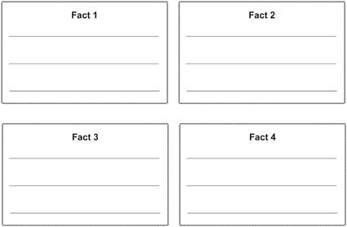

view and print

Activity 5 – Interpreting a graph

Introduce this activity to the class by saying:

This activity requires your detective skills to analyse the information provided in a graph and do some clever problem solving. Your assignment is to work out what this graph could be about because some vital information is missing.

To carry out this investigation you need to look at the column graph below which displays some 'Mystery Data'.

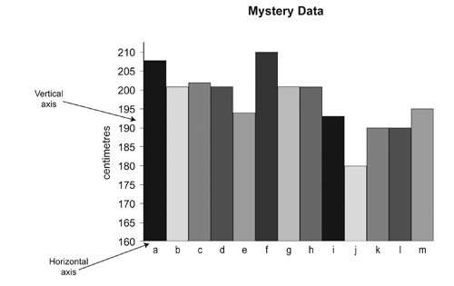

view and print

By studying the graph you can see that:
- The vertical axis (the left edge of the graph) is marked in centimetres.
- The horizontal axis (the bottom edge of the graph) is labelled 'a' to 'm'.
- There is no title for this graph. At present it is just called "Mystery Data".

Think...
- What could this graph be about?
- What could be that long? or tall?
- Why are there so many columns?

After carefully analysing the graph, students decide what the title for this graph could be and record their suggestions and reasons.

They may like to share their ideas with a partner.

Students answer these questions.

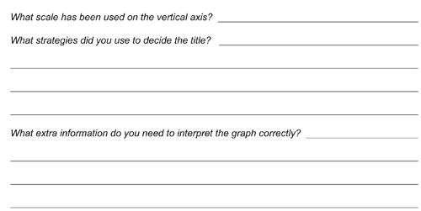

Activity 6 – Graphing Data

(Activity 6 can be used as an assessment task.)

Prior Learning

Students have had experiences reading and interpreting different forms of data representation. They have constructed and labelled a variety of graphs to represent information. Students have discussed how a scale is used and have constructed and answered questions based on the observations and analysis of information provided in graph form.

Description of activity

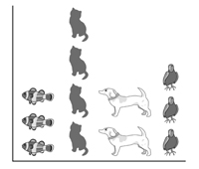Students are given the results of a school survey and asked to:
- Write the missing features, such as labels, on the graph.
- Explain the information presented in the graph, including how many students were surveyed.
- Represent the information in different ways.

view and print

Activity 7 – Graphing Data

Students can survey the class on other suitable topics and present their graphs on computer using Excel. They can use symbols from the Internet or clip art to represent their data.

Online resources

Teacher resources

Australian Bureau of Statistics ‘Four Graphs Story’
Censusatschool

Nrich website activities
If the world were a village
How big are classes 5, 6 and 7?
The Pet Graph
Real Statistics
Olympic Records

Lesson Plans

www.teach-nology.com/worksheets/math/graph

Worksheets

www.superteacherworksheets.com/graphing

Student resources

www.amblesideprimary.com/ambleweb/mentalmaths/grapher

Back to top
© Learning, High Performance and Accountability

