SMART

(School Measurement,Assessment and Reporting Toolkit)

The following teaching strategies can assist children meet outcomes in the content areas of:

Number and Algebra

Measurement and Geometry

Statistics and Probability

For syllabus details and specific outcomes click here

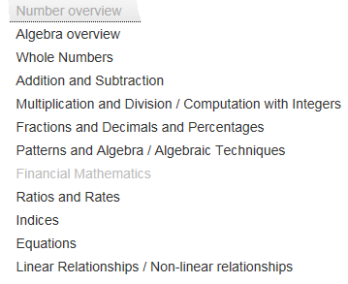
Number
Number encompasses the development of number sense and confidence and competence in using mental, written and calculator techniques for solving problems.
Teaching Strategies for this strand include a range of engaging interactive activities for stages ES1 to 5 to support the development of skills in Number. They link to the progression of strategies that form The Numeracy Continuum, strategies such as counting on-and-back, split and jump are vital for students to gain an understanding of place value and to become numerate.
In the primary curriculum, formal written algorithms are introduced after students have gained a firm understanding of basic concepts including place value, and have developed mental strategies for computing with two-digit and three-digit numbers.
In the secondary curriculum, students will continue to develop knowledge, skills and understanding in mental and written computation and numerical reasoning.
Patterns and Algebra was incorporated into the primary curriculum to demonstrate the importance of early number learning in the development of algebraic thinking.
In the primary curriculum the emphasis is on number patterns and number relationships leading to an investigation of the way that one quantity changes relative to another.
In the secondary curriculum students will continue to develop knowledge, skills and understanding in patterning, generalisation and algebraic reasoning.
Teaching Strategies for this strand include a range of engaging interactive activities for stages ES1 to 5 to support the development of skills in this strand.
Teachers may adapt many of these resources to suit specific needs.

Algebra
Patterns and Algebra was incorporated into the primary curriculum to demonstrate the importance of early number learning in the development of algebraic thinking.
In the primary curriculum the emphasis is on number patterns and number relationships leading to an investigation of the way that one quantity changes relative to another.
In the secondary curriculum students will continue to develop knowledge, skills and understanding in patterning, generalisation and algebraic reasoning.
Teaching Strategies for this strand include a range of engaging interactive activities for stages ES1 to 5 to support the development of skills in this strand.
Teachers may adapt many of these resources to suit specific needs.
EARLY STAGE 1

Number – Ordinal Numbers

Australian Curriculum Reference: ACMNA001: Establish understanding of the language and processes of counting by naming numbers in sequences, initially to and from 20, moving from any starting point; ACMMG010 Describe position and movement

NSW Syllabus Reference: Mae-4NA Whole Numbers: read and use the ordinal names to at least 'tenth'; Mae-16MG Position: describe the position of an object in relation to another object using everyday language, such as 'between', 'next to', 'behind' or 'inside', eg 'The book is inside the box'

Use ordinal names for positional value of objects; Match ordinal names to images in a line; Describe the place of an item using ordinal names

Strategy

Students can:
- Use ordinal names for positional value of objects
- Match ordinal names to images in a line
- Describe the place of an item using ordinal names

Activities to support the strategy

Students at this Stage need to have an understanding of number word sequence to 10 and beyond before they can understand ordinals. Students also need to be able to count forwards and backwards between 1-10.

Activity 1

Ice-cream scoop counting

Provide students with images of an ice-cream cone and three different scoops of ice-cream. Allow time for the students to colour in the cone and the ice-cream scoops. Make sure students use a different colour for each scoop of ice-cream. Student then build their ice-cream by pasting the cone on a sheet of paper and then pasting on each scoop of ice-cream.

Discussion questions should follow:

What flavour scoop did you add on first?
What flavour was second?
Can you point to the scoop you put on third?

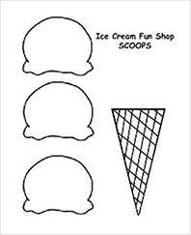

view and print

Alternatively you could bring in cones and different flavoured ice-cream to the classroom and perform a demonstration for the class.

Activity 2

Teddy line-up

Students explore placing teddies in a line according to colour to match position.

The teacher provides the verbal instructions for students to follow;

There are four teddies in the line. The blue teddy is first, the yellow teddy is second, the green teddy is third and the red teddy is fourth.
Which teddy is in between the blue and the yellow teddy?
Which teddy is second from the front?

Alternatively, students can place a number of teddies in a line and the teacher or another student can ask the questions;

Which teddy is second in line? Which teddy is last?

Students can write sentences to describe the ordinal position of one or more teddies.

Online resources

Teacher resources

Ordinal numbers activities
Count Us In

Stand in order
Lesson from DEC Teaching Measurement Book Early Stage 1 and Stage 1 (page 28)
STAGE 1

Number – Whole Numbers

Australian Curriculum Reference: ACMNA027: Recognise, model, represent and order numbers to at least 1000; ACMNA029: Explore the connection between addition and subtraction.

NSW Syllabus Reference: MA1-4NA: applies place value, informally, to count, order, read and represent two and three digit numbers; MA1-5NA: Addition and Subtraction

NSW Numeracy Continuum Reference:
Aspect 1: Numeral Identification: 1 – 100
Aspect 4: Place value: Tens and ones.

NSW Literacy Continuum Reference: VOCC7M1: Vocabulary knowledge, Cluster 7, Marker 1: Knows the meaning of commonly used words in increasingly challenging texts and can demonstrate this knowledge when reading, writing and speaking.VOCC8M4: Vocabulary knowledge, Cluster 8, Marker 4: Recognises that different words can be used to describe similar concepts, e.g. everyday or technical language, synonyms.

Other Literacy Continuum Markers: COMC7M4: Comprehension, Cluster 7, Marker 4: Interprets and responds to texts by skimming and scanning to confirm predictions and answer questions posed by self and others while reading. COMC8M1: Comprehension, Cluster 8, Marker 1: Refers to prior knowledge and experiences to build understanding of a text.

Skill focus count forwards by ones from a given 3-digit number

Strategy

Students can:
- count forwards by ones from a given three-digit number

Activities to support the strategy

Students in Stage 1 and 2 need to develop an understanding of place value. For example, in the number 3 450, the 'four' represents four hundred. Students need to understand how a number is constructed and the value each digit holds within the total number. We use expanded notation to show this. E.g. 3 450 = 3 000 + 400 + 50.

However, we also need students to understand that place value is more than just position value. For example, if I ask "How many hundreds are in 3 450?" some students may answer, "There are four, as there is a four in the hundreds column". This is not entirely accurate, because there are 34 hundreds in 3 450 as 3 000 is made up of 30 hundreds. We need to focus on the whole number not just on column values. This is important for addition and subtraction as there are different ways to break up 3 450 depending on what we are adding it to.

If I need to solve:
3 450 + 1 400 =

I could use standard decomposition to split the thousands and hundreds,
3 000 + 1 000 + 400 + 400 + 50

But say I was asked to solve
3 450 + 2 450 =

I could see 3 450 as 2 450 + 1 000 (non-standard decomposition)

Therefore it may be easier to double 2 450 then add on the remaining 1 000

Students also need to have opportunities to create numbers using concrete materials. Students can build numbers using a variety of resources such as Base 10 Blocks, unifix cubes, ten strips or ten frames and bundles of pop sticks (for one- and two-digit numbers). Unifix cubes are particularly useful as students can build rows of ten and can break them up when necessary- this supports addition and subtraction skills.

Activity 1

Flip and see

Provide each student with a large collection of popsticks and a base board divided into a "tens" and a "ones" column. Place numeral cards in the range zero to nine face down on the floor. The students take turns to flip over two numeral cards and place one card in the tens column and one card in the ones column on their base board. Students then bundle popsticks into tens and place the correct number of bundles and units onto their base board to match the numeral cards. Discuss how many tens and ones were made.

Developing Efficient Numeracy Strategies Stage 1 pp. 155, NSW Department of Education and Communities.

Activity 2

Materials Required:

Dice
A collection of Base 10 Blocks or Unifix cubes
- Race to 100

This is a partner activity, so place each student with a partner.
Have each partner roll the dice and the one who rolls the highest, goes first.
The players will take turns rolling the dice, adding each number rolled onto their previous total using base ten blocks, and racing to reach 100.

Player 1 rolls the dice. Let's say this player rolls a 5, they will then take 5 units, showing what their score is. Their partner does the same.
Player 1 has their turn again and let's say they roll a 6. The 6 has to be added onto their previous number (5).

The goal is for students to use mental strategies by putting back their 5 units and trading for one ten and one unit. This shows they understand addition place value.
If they take 6 more units, count, and then realise that they have enough units to trade for a tens, then this shows they are still developing an understanding of the concept.

Players continue adding and trading until they have enough tens to trade for a 100 block. The first player to reach 100 is the winner.

When students gain confidence in the activity, have students record their working out on paper as they go, representing the blocks with numbers.

E.g. 5 + 6 =

I know that 5 + 5 gives me 10 and 1 more makes 11
- Less Than and Greater Than, Ordering

Version 1: In pairs, students are given three dice of different colours, representing hundreds, tens and ones. Students take turns to throw the dice, record their three-digit number and writing the number before and after the number rolled.

Version 2: In pairs, students are given three dice of different colours, representing hundreds, tens and ones. Students take turns to throw the dice and record their three-digit number. Students nominate whether their number will be 'greater than' or 'less than' their partner's number.

They compare their numbers by showing the relationship between the two three-digit numbers they have made by using a < or > sign.

For example, Student A rolls 431 and says 'greater than'. Student B rolls 146 which is 'less than'. Student B wins the point. The winner is the first to 20 points.

This activity could be repeated using four dice.

Online resources

Teacher resources

Developing Efficient Numeracy Strategies: Stage 1, NSW Department of Education and Training, pp. 200–201

Lesson Plans and Activities

Place value Worksheet
math.about.com/lr/expanded_notation

Student resources

www.mathcats.com/explore/reallybignumbers
www.bbc.co.uk/schools/ks1bitesize/numeracy/ordering/index
www.abc.net.au/countusin/games/game11
education.jlab.org/placevalue/index

Washing Line - ordering numbers
www.curriculumsupport.education.nsw.gov.au/countmein/teachers_teaching_ideas_-_washing_line

Numeracy Apps

OKTA: Oh, no! Okta and his friends need help. Help rescue them by transporting them to a safe ocean. How fast can you transport the Oktas? Use your counting skills to save as many as you can before the timer runs out.This app was developed for children in grades preK–2 by Illuminations. It is also available as an online activity along with many other free math resources for children at illuminations.nctm.org.
STAGE 2

Number – Whole Numbers

Australian Curriculum Reference: ACMNA052: Recognise, model, represent and order numbers to at least 10 000 ACMNA054: Recognise and explain the connection between addition and subtraction

NSW Syllabus Reference: MA2-4NA: applies place value to order, read and represent numbers up to five digits; MA2-5NA: Addition and subtraction – Uses mental and written strategies for addition and subtraction involving 2,3.4 and 5 digit numbers

NSW Numeracy Continuum Reference:
Aspect 1: Numeral Identification 1 – 1000
Aspect 4: Place value: Hundreds,tens and ones.

NSW Literacy Continuum Reference: VOCC9M2: Vocabulary knowledge, Cluster 9, Marker 2: Uses simple content specific vocabulary in appropriate ways when creating texts.

Other Literacy Continuum Markers: COMC9M7: Comprehension, Cluster 9, Marker 7: Analyses a text by discussing visual, aural and written techniques used in the text.

Use place value to read, represent and order numbers up to 4 digits; record numbers using expanded notation

Strategy

Students can:
- use place value to read, represent and order numbers up to four digits
- record numbers using expanded notation

Activities to support the strategy

Students in Stage 1 and 2 need to develop an understanding of place value. For example, in the number 3 450, the ‘four’ represents four hundred. Students need to understand how a number is constructed and the value each digit holds within the total number. We use expanded notation to show this. E.g. 3 450 = 3 000 + 400 + 50.

However, we also need students to understand that place value is more than just position value. For example, if I ask “How many hundreds are in 3 450?” some students may answer, “There are four, as there is a four in the hundreds column”. This is not entirely accurate, because there are 34 hundreds in 3 450 as 3 000 is made up of 30 hundreds. We need to focus on the whole number not just on column values. This is important for addition and subtraction as there are different ways to break up 3 450 depending on what we are adding it to.

If I need to solve:
3 450 + 1 400 =

I could use standard decomposition to split the thousands and hundreds,
3 000 + 1 000 + 400 + 400 + 50

But say I was asked to solve
3 450 + 2 450 =

I could see 3 450 as 2 450 + 1 000 (non-standard decomposition)

Therefore it may be easier to double 2 450 then add on the remaining 1 000

Students also need to have opportunities to create numbers using concrete materials. Students can build numbers using a variety of resources such as Base 10 Blocks, unifix cubes, ten strips or ten frames and bundles of pop sticks (for one- and two-digit numbers). Unifix cubes are particularly useful as students can build rows of ten and can break them up when necessary- this supports addition and subtraction skills.

Activity 1

Three-and Four-Digit Numbers

In small groups, students use a pack of playing cards with the tens and picture cards removed. The Aces are retained and count as 1.

Student A turns over the first 3 cards and each player makes a different three-digit number, Student A records the three numbers. Student A then puts the cards at the bottom of the pile. Students each take a turn in turning over three cards and recording the group's three-digit numbers. When each student has had a turn they sort and order their numbers and write them in ascending order, students can then check each other’s working out.

Students extend the game by making four-digit numbers.

Possible questions include:
- Can you read each number aloud?
- Can you order the numbers in ascending and descending order?
- Can you state the place value of each numeral?
- What is the largest/smallest number you can make using three cards/four cards?
- What is the next largest/smallest number you can make using three cards/four cards?
- Can you identify the number before/after one of your three digit/four-digit numbers?
- Can you find a pattern? How can you describe your pattern? How can you continue the pattern?
- How many different ways can you represent each number? (expanded notation, in words)
- Can you count forwards/backwards by tens/hundreds from one of your three-digit/four-digit numbers?
- Can you round one of your three-digit or four-digit numbers to the nearest hundred? to the nearest thousand?

Activity 2

How Many Ways?

The teacher selects a four-digit number and records it on the board. Students express and present the number in as many ways as they can. A time limit may be imposed. Students can show the class what each variation looks like using concrete materials or drawings.

For example:

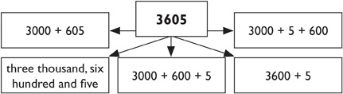

Activity 3

Highest Number

Students play in pairs, sharing one score sheet. Players take turns to roll a die to try to make the highest number they can. Once a number has been placed in a column its position cannot be changed. The student who makes the higher number wins that game.

Students play several games to determine an overall winner.

The teacher ties the lesson together by asking:
- What is the largest possible number you can score? (9999 if you are using 0–9 dice and playing a 4-digit game)
- Who scored closest to this?
- What was your highest number?
- What was your lowest number?

Some of the results may be written on cards and pinned onto a “clothesline” to help students order 3-digit and 4-digit numbers

Highest Number Score Sheet

This activity is from the Counting On resource and can be downloaded from Curriculum Support Counting On website

There is also a follow up activity “The Nasty Game” that is in the Counting On document.

Activity 4

Place Value Bingo

Materials required:

Place Value Cards
Pen
A4 paper

The teacher will need a set of Place Value Cards. On the top of the card write "ones" then write a "0". Then on the next card write "ones" and put a "1" on it. You will continue this through to 9. Then start a set of cards for the "tens" from 0 to 9, the "hundreds" from 0 to 9 and the "thousands" from 0 to 9. Alternately you can use different coloured paper to represent each value, e.g. red = thousands, green = hundreds, yellow = tens, orange = ones

On a piece of paper the students draw a place value chart. On the chart they write a three- or four-digit number of their choice.

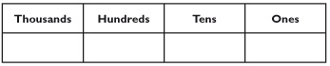

view and print

To play the game

The teacher calls out a number e.g. 9 hundreds. If the student has a 9 in the hundreds column they circle the number. The teacher places or writes the number on the board to keep track of past numbers. The teacher continues calling numbers e.g. 3 tens, and so on, until a student has all digits circled in one number. The student then calls out 'bingo' and says their numbers using place value.

For example:

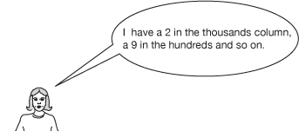

Then they have to read the whole number, e.g two thousand, nine hundred and fifty-one. If they are correct, they win. A new game starts with the students writing another number on their bingo card.

Online resources

Teacher resources

Developing Efficient Numeracy Strategies: Stage 1, NSW Department of Education and Training, pp. 200–201

Lesson Plans and Activities

Place value Worksheet
math.about.com/lr/expanded_notation

Student resources

www.mathcats.com/explore/reallybignumbers
www.bbc.co.uk/schools/ks1bitesize/numeracy/ordering/index
www.abc.net.au/countusin/games/game11
education.jlab.org/placevalue/index

Washing Line – ordering numbers
www.curriculumsupport.education.nsw.gov.au/countmein/teachers_teaching_ideas_-_washing_line

Numeracy Apps

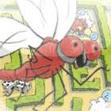Red dragonfly mathematics challenge: Developing students’ mathematical reasoning relies upon having access to tasks that are easily understood and promote thinking. Yet where do you find challenging mathematical problems suitable for primary mathematics lessons? This publication has been developed to help to address this need.
The Red dragonfly mathematics challenge is an English adaptation of a classic Japanese mathematics problem-solving book, known as the Math Brain Quiz (Red) or more commonly as the Red book, by Mr Yasuhiro Hosomizu. The Red dragonfly mathematics challenge offers many open-ended problems that can be challenging to students and teachers alike.

STAGE 3

Number – Whole Numbers

Australian Curriculum Reference: ACMNA107: Describe, continue and create patterns with fractions, decimals and whole numbers resulting from addition and subtraction ACMNA124: Investigate everyday situations that use integers. Locate and represent these numbers on a number line

NSW Syllabus Reference: MA3-4NA: Orders, reads and represents integers of any size and describes properties of whole numbers.

NSW Numeracy Continuum Reference:
Aspect 4: Place Value – System Place Value.

NSW Literacy Continuum Reference: VOCC12M2: Vocabulary knowledge, Cluster 12, Marker 2: Increasingly uses appropriate content vocabulary when creating spoken and written texts about specific topics.

Other Literacy Continuum Markers: VOCC12M4: Vocabulary knowledge, Cluster 12, Marker 4: Draws on knowledge of word origins to work out meaning of new words.

Round numbers when estimating; understand where negative numbers are used; locate negative numbers on a number line

Strategy

Students can:
- round numbers when estimating
- understand where negative numbers are used
- locate negative numbers on a number line

Activities to support the strategy

In mathematics, students are required to round numbers to the nearest ten, hundred or thousand when estimating. There is an emphasis on number sense, confidence and competence in using mental, written and calculator techniques. It is important that students can approximate and estimate successfully when dealing with problems in everyday life, especially involving money.

Activity 1

When learning to estimate, it is important that students clearly know their number facts and relationships. In teaching students to round numbers, students must understand place value and the meaning 'close to'. It is important that students develop a sense of number and what it 'looks' like.

The following activities will allow students to develop their skills in approximating, estimating and rounding.
- Ask students to give estimates in practical situations, such as:
  - How many counters will fill this large container?
  - How many students could sit comfortably in our classroom, without any chairs and desks in the room?
  - How many steps would it take to reach the school library from our classroom?
  - How many textbooks could fit on the floor in our school hall?
- Students make the number cards 0 to 9 and select four, five or six cards.

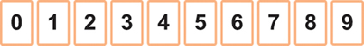

a) Students use the cards selected to:
  - place them in ascending or descending order
  - make the largest/smallest possible number
  - make the next largest/smallest number
  - make the largest/smallest even/odd number.

b) Students use the cards to create four-, five- or six-digit numbers then:
  - identify and write the number before and after some of the numbers made
  - state the place value of each numeral
  - count forwards and backwards by tens/hundreds/thousands from some of the numbers made
  - represent the number in as many different ways as possible (using expanded notation, in words).

c) Working in pairs, students randomly allocate cards to each place value column, e.g.

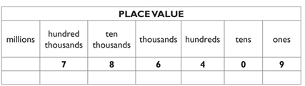

view and print

The students then:
  - round each number they have generated to the nearest ten, then
  - round each number to the nearest hundred, then
  - round each number to the nearest thousand.

Repeat these steps with another random allocation of cards.

Activity 2

Students are given the following cards.

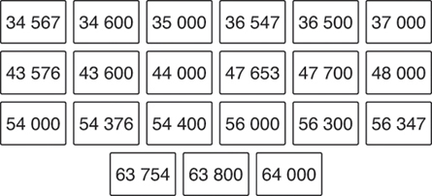

view and print
- In small groups have students write the headings Number, Number rounded to the nearest 100 and Number rounded to the nearest 1000 and place at the top of their working space. The students then sort through the cards, placing each one under the appropriate heading.
- Students use the media or internet to look for real-life situations where large numbers are used. Use these numbers to practise rounding to the nearest hundred, thousand, etc.
This activity can be repeated with six-digit cards.
- As numbers are displayed and read aloud by the teacher, students locate the correct written form and write the matching number in the space provided.

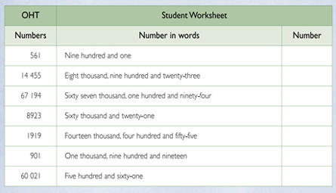

view and print

Further Teaching Activities

Matching numbers to words. Students in pairs/groups cut up the numbers and paste them onto the correct words as below.

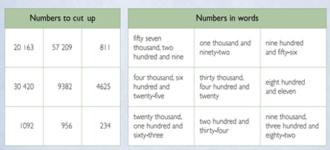

view and print

Activity 3 – Negative numbers

Display a number line from 0 to 19.

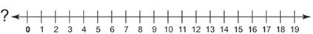

Discuss:
- Starting from the zero on the number line, the numbers are in ascending order towards the right end of the number line.
- What happens to the numbers at the left end of the number line?
- Are there any numbers less than zero?

Students discuss what negative numbers are and when they are used. Collect examples from books, newspapers or the internet, such as:
- temperatures that are below zero
- facts that have negative numbers, e.g. elevations below sea level, such as the Dead Sea which has an elevation of approximately - 420 metres.

Discuss each example.

Hang a 'washing line' across the classroom. As a class activity, students use the following cards to correctly position numbers, including negative numbers, on a number line.

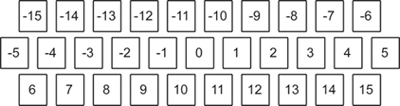

view and print
- Put the card with -15 at the left end and the card with 15 at the right end of the line.
- The teacher randomly chooses a card and asks a student to hang the card in its approximate position on the number line.
- The student must give reasons to justify the chosen position.
- Repeat with other students until all the cards have been positioned on the number line.

These steps can be repeated using cards with negative fractions, decimals and mixed numerals.

Students play Connect Three an interactive game involving negative numbers.

Online resources

Teacher resources

Lesson Plans and Activities

Worksheets
www.helpingwithmath.com/resources/wor_numbers – and select Positive and Negative Integers Worksheets

Interactive Whiteboard Activities

www.topmarks.co.uk/Interactive

Student resources

www.bbc.co.uk/schools/ks1bitesize/numeracy/ordering/index

Numeracy App

Greater Than: GreaterThan is a children’s app that is meant to help them learn which numbers are bigger than others. It tests their knowledge of greater than and less than for numbers up to 10 in a fun, gamelike manner in order to keep the children's interest. The app uses fun sounds in response to the child's selection and encourages them as they go along. The app has a status bar at the bottom which graphically shows the child how well they’re doing!

STAGE 1

Number – Addition and Subtraction

Australian Curriculum Reference: ACMNA029: Explore the connection between addition and subtraction
ACMNA030: Solve simple addition and subtraction problems using a range of efficient mental and written strategies
ACMNA036: Solve problems by using number sentences for addition and subtraction.

NSW Syllabus Reference: MA1-5NA: (+ & -) Uses a range of strategies and informal recording methods for addition and subtraction involving one – and two – digit numbers. MA1-8NA: P & A – Creates, represents and continues a variety of patterns with numbers and objects

NSW Numeracy Continuum Reference:
Aspect 2: EAS: Facile
Aspect 3: Pattern and Number Structure: Part whole to 10 and Part whole to 20
Aspect 4: Place Value: Ten as a unit; Tens and ones.

NSW Literacy Continuum Reference: VOCC8M4: Vocabulary knowledge, Cluster 8, Marker 4: Recognises that different words can be used to describe similar concepts, e.g. everyday or technical language, synonyms.VOCC8M5: Vocabulary knowledge, Cluster 8, Marker 5: Shows evidence of capacity to improve vocabulary choices in response to purpose and audience when reviewing and editing writing.

Other Literacy Continuum Markers: WRIC8M4: Aspects of writing, Cluster 8, Marker 4: Writes for a wider range of purposes, including to explain and to express an opinion.

Use a range of mental strategies including counting on from, counting back from, counting on and back, doubles, near doubles, bridging to ten; use a range of informal recording methods for addition and subtraction including jump and split strategies; record number sentences using drawings, numerals symbols and words; use the language of addition and subtraction

Strategy

Students can:
- use a range of mental strategies including counting on from, counting back from, counting on and back, doubles, near doubles, bridging to ten
- use a range of informal recording methods for addition and subtraction including jump and split strategies
- record number sentences using drawings, numerals, symbols and words
- use the language of addition and subtraction

Activities to support the strategy

Students need to recognise and use the terms ‘add’, ‘plus’, ‘is equal to’, ‘take away’, ‘minus’ and ‘the difference between’ to describe addition and subtraction. They also need to record number sentences using drawings, numerals, symbols and words. Students need opportunities to both pose and solve problems in addition and subtraction.

In Stage 1 the syllabus focuses on developing a range of mental strategies and informal recording methods for addition and subtraction. The following activities assist students in making connections between counting and addition and subtraction strategies and provide students with opportunities to demonstrate their understanding of place value and how numbers can be combined and partitioned.

It is important to present number sentence problems to students horizontally e.g. 34 + 49 =, this assists students in reading the numbers from left to right and will develop their understanding of place value and of how to read numbers. This will also provide students with opportunities to look at the whole number, not just the digits, assisting students with estimating the solution.

Activity 1

Language of Mathematics

The Herrington Think Board is one way to organise and solve problems with students that also focuses on the language of mathematics.

A process for understanding mathematics by Sue Gunningham (APMC) www.aamt.edu.au

e.g. the teacher can supply the story “Mary had five oranges, Tom took two away, how many oranges does Mary have left?”

Students can then draw a picture of the story, use objects such as counters or play dough to create and work out the problem, then record a number sentence that matches the story.

To focus on the language, provide students with the number sentence and ask them to write a story to match.

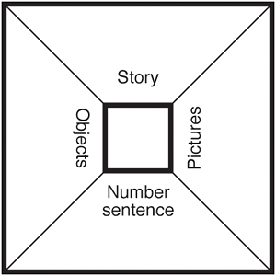

view and print

Activity 2

Warm Up activities

Short, focused, frequent activities are great ways to start or conclude a mathematics lesson. They are an opportunity to repeat skills that need to be practised to then be recalled often, they should be supportive of strategy development and conceptual understanding.

Roll two dice and Add

This is a whole class activity where students sit in a circle and two six-sided dice are thrown. Students share strategies for adding the numbers together. This activity can be played using subtraction and can be extended by changing the dice to eight- or ten-sided dice or by adding in a third dice. The third dice will provide opportunities for students to look for doubles, or friends of ten or to use known facts.

Calendar Addition

Students find today's date on the calendar, count how many days until the end of the month and work out the date 10 days later. Students explain strategies for their addition.

Hand Addition Pairs

Write a number on the board (less than 20). In pairs students make the number and record their combination. Ask how else can they make it.

Hands Up

Students are asked to come out the front and make a two-digit number e.g. 24 with their hands. Students soon realise they will need two others to help them. Do the same for another two-digit number e.g. 27. Students then discuss how to add the numbers e.g. grouping all the tens together then adding the ones, they will be able to make an extra ten from the 4 and 7, so the student with seven fingers up changes to ten (and joins the other tens) and the student with four changes to one. This activity assists students in understanding the place value of tens and ones and how to re-unitise numbers. You can record students’ strategies as they are explaining what they are doing. You can then move on to representing the numbers using unifix cubes in sticks as tens and loose blocks as ones. These strategies assist students in visualising the numbers.

www.curriculumsupport.education.nsw.gov.au/primary/mathematics/assets/pdf/stage1/handsup.pdf

Activity 3

Make 100

The teacher removes the picture cards (Kings, Queens, Jacks) from a standard pack of playing cards. The Ace is used to represent one. In small groups, each student is dealt six cards. The aim of the activity is to add all six card numbers together to make the closest total to 100 (but no greater than 100). Each student can nominate one of their cards to be a 'tens' card.

For example, if the student was dealt

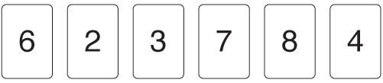

they could nominate the 7 card to have the value 70 and add the remaining cards for a total of 93. They should be encouraged to record their calculations and share their strategies.

Activity 4

Finding the difference

Students are given a number sentence with a missing element (using numbers less than 20) e.g.

Using unifix cubes, students work in pairs to make towers to represent the 13 and 5. They then compare the towers to work out the difference between the two towers. As a follow on activity, you can have students make the number differentiating between tens and ones using two colours. This will link to bridging to ten strategies.

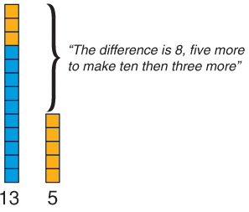

Developing Efficient Numeracy Strategies Stage 1, NSW Department of Education and Training, 2003, “Diffy Towers” pp. 119

Activity 5

Using a Number Line for difference

Use a 1 to 100 number line (commercially made, drawn on the board, created on the IWB or simply use a tape measure/ one metre ruler). Mark the place of two numbers, e.g. 32 and 41 Have students come out and work out the difference between the two numbers. Be aware that although we generally relate difference to subtraction, some students will use a ‘count on’ not ‘count back’ strategy to solve the problem and therefore it can be related to addition as well. Have students write number sentence to match the working out.

e.g. 41 – 32 = 9

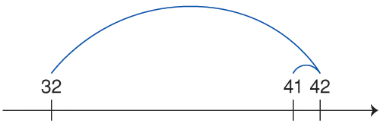

Students can also write sentences using words to describe the working out.

e.g. “The difference between 32 and 42 is ten, so the difference between 32 and 41 must be nine.”

Linking to other Strands

The concept of difference can also be explored when learning about length. Students can compare lengths and discuss the difference between the objects- either informally (e.g. using paper clips) or formally (e.g. using cms)

“The ruler is longer than the pen. The rule is 12 cm and the pen is 9 cm. There is 3 cm difference between the objects.”

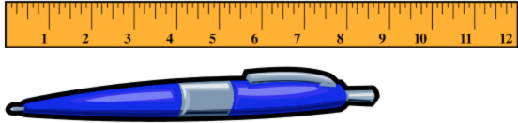

Online resources

Teacher resources

Curriculum Support Connecting Learning IWB activities

www.curriculumsupport.education.nsw.gov.au/connected/resources/s1/index – Click on ‘Mathematics’ tab, to proceed to ‘Chook’ notebook file.

Curriculum Support Count Me In Too site

Other Online Resources

www.teacherled.com/resources/dice/diceload

Comparing Line Lengths
www.iboard.co.uk/activity/269

Interactive Whiteboard Files

Race to 30.notebook

TenFrames8AU.notebook

Numeracy Apps

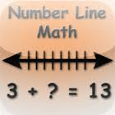Number Line Math: Practice addition and subtraction facts 1–10 using a number line as a tool for solving problems. Adjust the options to include any combination of Result, Change, or Start as the unknown quantity. Select the facts to practice.

Iphone/Ipad apps

Mathoku Junior
Numeracy Basics
Tens Frame
100s Board
Math Kid
Friends of Ten

Back to top

Stage 2

Number – Addition and Subtraction

Australian Curriculum Reference: ACMNA054: Recognise and explain the connection between addition and subtraction; ACMNA055: Recall addition facts for single – digit numbers and related subtraction facts to develop increasingly efficient mental strategies for computation. ACMNA083: Use equivalent number sentences involving addition and subtraction to find unknown quantities. ACMNA080: Solve problems involving purchases and the calculation of change to the nearest five cents with and without digital technologies

NSW Syllabus Reference: MA2-5NA: uses mental and written strategies for addition and subtraction involving two – , three – , four – and five – digit numbers; MA2-7NA: models compares and represents decimals of up to two decimal places

NSW Numeracy Continuum Reference:
Aspect 2: EAS – Facile
Aspect 4: Place value: Hundreds,tens and ones; Decimal Place Value.

NSW Literacy Continuum Reference: WRIC10M4: Aspects of writing, Cluster 10, Marker 4: Rereads and revises text to check and improve meaning, deleting unnecessary information or adding new information.

Other Literacy Continuum Markers: REAC9M2: Reading texts, Cluster 9, Marker 2: Uses visual representations, e.g. photographs, tables, charts to enhance meaning when reading factual texts. REAC10M4: Reading texts, Cluster 10, Marker 4: Uses topic knowledge, vocabulary knowledge and context to read unknown words when engaging with subject texts. COMC9M7: Comprehension, Cluster 9, Marker 7: Analyses a text by discussing visual, aural and written techniques used in the text. COMC10M6: Comprehension, Cluster 10, Marker 6: Analyses and evaluates the relative importance of key ideas and information in a text to construct an overview.

Use a range of mental strategies for addition and subtraction, including the jump, split and compensation strategies; explain and record methods for adding and subtracting

Strategy

Students can
- use a range of mental strategies for addition and subtraction, including the jump, split and compensation strategies
- explain and record methods for adding and subtracting

Activities to support the strategy

In the NSW Syllabuses for the Australian Curriculum, Mathematics K-10 requires students to use mental strategies such as jump, split and compensation strategies to add and subtract up to 4-digit numbers. Before introducing a range of strategies, teachers need to establish how students would typically work out the answer using their own mental strategies.

Example: Students may use a variety of strategies to solve the following addition.

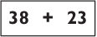

A student who says '38, 39, 40 …' is counting by ones. Such students need to be taught what a representation of 38 and 23 looks like using concrete materials to represent tens and ones. This will help build their understanding of Place Value and how numbers are structured.

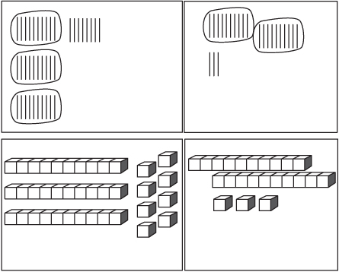

Students then need to be taught how to manipulate the concrete representation using different strategies, including:
- Counting by tens and then ones

Count 38, 48, 58 and then 59, 60, 61
- Jump strategy where a number line is used to count forwards or backwards first by tens then ones (the ones may be split to bridge to a decade)
- Split Strategy where the tens are grouped and the ones are grouped.

30 + 20 = 50 and 8 + 3 = 11

50 + 11 is the same as 60 + 1

When children understand how these strategies work using the concrete representations they are able to mentally manipulate the groups. This underpins using mental strategies.

Some activities for developing mental computation in addition and subtraction are detailed below.

Activity 1

Hundreds Chart

A variety of warm-up activities can use the hundreds chart. Each class should have a large hundreds chart for whole class activities as well as a class set of individual charts for student use. Using an interactive whiteboard version of a hundreds chart is one way to incorporate basic number skills into your warm up activities.

IWB Hundred Square

Hundred chart ideas

Here are just a few ideas to use to start your lesson using a hundred chart

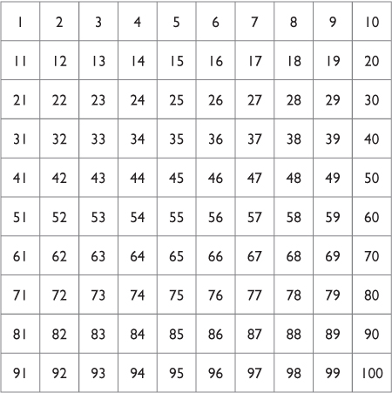

view and print
- Find 1 more than, 1 less than, 10 more than, 10 less than on the hundreds chart.
- Count by tens off the decade, forwards and backwards.
- Arrows - Start at a number, say 24, flash a large arrow.

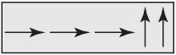

Ask: Where are we now?

What did we do to get to this number?

Do this activity as subtraction
Add 23 to 54, Subtract 35 from 78.

Link this to the jump method of addition and subtraction.

See Unit 5: Hundreds Chart from the Curriculum support resource Counting On pp. 69-76
- Expand the hundreds chart into the number system so that students can use it to add and subtract larger numbers, such as 235 + 78. Create different charts that range from 101- 200, 201- 300 and so on…
- Remove the hundreds chart and ask the students to visualise it. Then ask students to add and subtract. Link this to the jump method of addition. Some students may require a blank hundreds chart grid to represent where the numbers are as a visual assistance.
- Ask students to mentally work out some addition and subtraction number sentences, such as 249 + 321.
- Provide opportunities for students to explain the strategies they used. The teacher records the various strategies on the board and allows the students to discuss the most efficient methods.

Activity 2

Fancy Dice

This is a great game to move the students from using a hundreds chart as a game board to scoring on an empty number line. This game is suitable for two players as there is a need to wait for a turn.

The first player throws five dice (1 - 6 dot dice).

The second player is allowed to remove any dice that show 2 or 5.

The first player then adds the remaining dice and moves his or her playing piece forward the corresponding number of places on their hundreds chart, starting at zero.

The first player continues their turn by rolling the remaining dice and adding those dice that are left after the second player takes away any 2s and 5s.

The game continues until the second player has all five dice.

Now, the second player rolls the five dice and the first player removes the 2s and 5s.

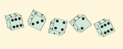

Deadly play No. 1: If a player rolls two 6's during their turn, they immediately turn over all the dice to the other player, losing their turn.

Deadly play No. 2: If a player rolls three 6's during their turn, they not only lose their turn, but they go back to the start.

Play continues until someone reaches 100 plus.

For the next game, the players start on 100 and subtract their score.

Encourage students to move through the hundreds chart without counting by ones. Ask questions that encourage students to see the partitioning of numbers. That is, if they are on 27 and they have a score of 9, ask them, How many do I need to get to 30? (3) and how many left over? (6), so go to 36.

As students get more confident on jumping through the hundreds chart, introduce the Empty Number Line as a method of scoring.

Activity 3

Red and Black

Variation 1

Remove the court cards from a pack of cards, shuffle the remaining cards and turn them face down in a pile between two players. Both players decide a starting score between 100 and 500 and record it on their empty number line.

The first player guesses what colour they think the top three cards will be, either black or red. If correct, that is, two out of the three cards selected are of the nominated colour, then the first player adds their cards and adds the total to the starting score.

If incorrect, that is, two out of the three cards are not of their nominated colour, the first player adds their cards together and subtracts the total from the starting score.

The second player now has their guess.

If a player guesses a colour and all three cards are of that colour, the player adds their cards and doubles the total before adding it to their score. Conversely, if all three cards are the wrong colour, the player must add all three, double the total, then subtract the total from their score.

Play continues until all the cards are used. The winner is the player with the highest total.

Variation 2

Remove the court cards from a pack of cards, shuffle the remaining cards and turn them face down in a pile between two players. Both players decide a starting score less than 500 and record it on their empty number line.

The first player guesses what colour they think the top three cards will be, either black or red. If correct, that is, two out of the three cards selected are of the nominated colour, they arrange the two correctly coloured cards into the largest two-digit number possible and adds the number to their score.

If incorrect, that is, two out of the three cards are not of their nominated colour, they arrange the two incorrect cards into the smallest possible two-digit number and subtract the total from their starting score.

The second player now has their guess.

If a player guesses a colour and all three cards are of that colour, the player arranges all three cards into the highest possible number before adding it to their score.

Conversely, if all three cards are the wrong colour, the player arranges all three cards into the lowest possible number then subtracts it from their score.

Play continues until all the cards are used. The winner is the player with the highest total.

Variation 3

This is a good game to reinforce the strategies students use to move around the hundreds chart. Follow similar rules to those described in Red and Black Variation 1 or 2, but each player has a hundreds chart as a game board and they start the game by placing their game piece on 50. (Transparent counters allow players to see the numbers.)

Activity 4

Secret Number Scramble

Create a set of number cards with a selection of numbers up to 10 000. Each student draws a number card.

The teacher calls out the secret number, such as 8000, and the students must find, within 2 minutes, someone with a number that, when added or subtracted with their number, is nearest to this secret number.

Students are encouraged to round their number to the nearest thousand and then to the nearest hundred and then look for a number that they need. Once they find a number, they sit with their partner/s.

The students are then asked to share how they worked out their total.

The pair with the answer nearest to the secret number wins.

Activity 5

Missing Digits

Pose this problem to the class:

I solved a subtraction task but I can only remember the answer.

It looked like this:

What might the missing numbers be?

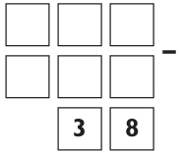

Students determine some of the possible numbers and describe how they worked them out.

See Red Dragonfly Mathematics Challenge as an ipad app or online resource from Curriculum Support for further mathematical problems similar to this activity.

Activity 6

First to Twenty Dollars

Students work in groups of three, two players and a ‘banker’. Students take turns to roll a dice marked with amounts of money (5c, 10, 20, 50c, $1, $2). They place the correct coins on the grid. As they go, they can trade up (e.g. give the banker 2 x 50c and 2 x $2 to receive a $5 note) until they reach $20.00. First player to $20.00 is the winner. During this activity students learn to recognise equivalent amounts of money using different denominations. Students need experience with money and changing money and linking addition facts and strategies to 100 with money. You can play a variation of this activity and start with the $20.00 and work down.

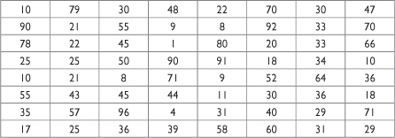

view and print

Online resources

Teacher resources

Interactive White Board Activity

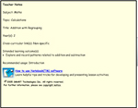

Addition with Regrouping
Red Dragonfly Mathematics Challenge

Curriculum Support

Count Me In Too
Counting on
Additional Counting on support material

Student resources

Videos of Addition Strategies – www.schoolatoz.nsw.edu.au

www.ictgames.com/resources

Numeracy App

Greater Than: GreaterThan is a children's app that is meant to help them learn which numbers are bigger than others. It tests their knowledge of greater than and less than for numbers up to 10 in a fun, gamelike manner in order to keep the children's interest. The app uses fun sounds in response to the child's selection and encourages them as they go along. The app has a status bar at the bottom which graphically shows the child how well they're doing!

Patterns and Algebra – Missing Addends

Australian Curriculum Reference: ACMNA083: Use equivalent number sentences involving addition and subtraction to find unknown quantities

NSW Syllabus Reference: MA2-8NA: complete number sentences involving addition and subtraction by calculating missing numbers, eg find the missing numbers ___ + 55 = 83

Use inverse operations to assist with mental computation; Apply problem solving strategies such as working backwards to find missing numbers

Strategy

Students can:
- Use inverse operations to assist with mental computation
- Apply problem solving strategies such as working backwards to find missing numbers

Students in Stage 2 should be able to flexibly use both addition and subtraction to solve number sentence problems. Problems that involve missing numbers focus on students using the working mathematically process of problem solving, particularly applying strategies.

Activities to support the strategy

True of False?

Students need to develop the concept of seeing the equals sign as meaning ‘the same as’. That the values on both sides of the equals sign are equivalent. Students also need to understand that you can operations on either side of the equals sign.

Provide students with a number of number sentences e.g.
39 – 12 = 15 + 11
45 + 11 = 62 – 1
Ask students if the sentences are true. Why or Why not?

Ask students to design number sentences using addition and subtraction as operators. Students then swap them with a partner and work out which ones are true and which ones are false. Students need to write/ discuss their reasoning for why.

As an extension, provide students with similar number sentences where one of the values is missing. Ask the students to make the sentence true by adding in the missing number. Again, students should discuss their strategies for solving the problems.
e.g. ____ + 36 = 70 – 10

Online resources

NRICH enriching mathematics
Which symbol?

Investigating Number Relationships (DEC Talking about Patterns and Algebra)
Which of these are true? (page 95)
Investigating addition and subtraction facts (page 100

STAGE 3

Number – Addition and subtraction

Australian Curriculum Reference: ACMNA123: Select and apply efficient mental and written strategies and appropriate digital technologies to solve problems involving all four operations with whole numbers

NSW Syllabus Reference: MA3-5NA: Selects and applies appropriate strategies for addition and subtraction with counting numbers of any size.

NSW Numeracy Continuum Reference:
Aspect 4: Place Value – System Place Value.

NSW Literacy Continuum Reference: VOCC12M2: Vocabulary knowledge, Cluster 12, Marker 2: Increasingly uses appropriate content vocabulary when creating spoken and written texts about specific topics.

Other Literacy Continuum Markers: VOCC12M4: Vocabulary knowledge, Cluster 12, Marker 4: Draws on knowledge of word origins to work out meaning of new words.

Use a range of mental strategies for addition and subtraction; round numbers to assist in estimating answers

Strategy

Students can:
- use a range of mental strategies for addition and subtraction
- round numbers to assist in estimating answers

Activities to support the strategy

Activity 1

Addition strategies
- Review some of the strategies that can be used when adding or subtracting numbers, e.g. Split strategy, Bridging to ten and Jump method.

Work through examples of each strategy.

Pose this problem:

Tom’s house is 456 metres from his school. The shops are 560 metres beyond the school. How far is it from Tom’s house to the shops?

Present the following strategies that three different students used to solve the problem.

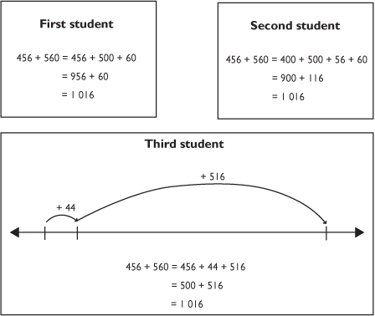

Have students:
  - explain each of these strategies by working through each step
  - determine which strategy they would use to solve the problem.
- Provide other examples of strategies used to solve addition problems and have students explain the strategy used, e.g.

4 210 + 432 = 4 210 + 400 + 30 + 2

= 4 610 + 30 + 2

= 4 640 + 2

= 4 772
- Give students a copy of the grid below (or similar) which has a variety of numbers less than 100.

view and print

Students find all the groups of two or three numbers, side by side, across or down, which can be added together to total 100. Colour these groups, using a different colour for each group.

Encourage students to use a range of mental strategies to add the numbers, such as:
  - adding the tens first, then the ones – split strategy
  - bridging to ten
  - adding the tens onto the first number, then the ones – jump method.

Students report back and identify some of the groups of numbers that added to 100 and the strategies they used.

Activity 2

Estimation

When calculating, students should be encouraged to work out the approximate answer they should get.

Students brainstorm examples of when estimating an amount is recommended. Give details about two examples, e.g. estimating the cost of a holiday, estimating the total cost of the weekly food shopping at the supermarket.
- Discuss strategies for estimating such as rounding off a number before adding or subtracting.

Work through this example of rounding to estimate an answer.

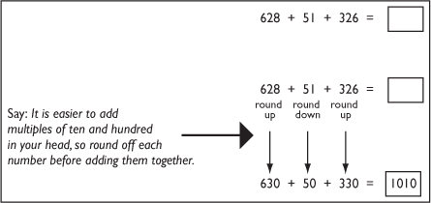

Say: The answer to 628 + 51 + 326 should be approximately 1010.
- Have students work through other examples of rounding numbers when completing addition problems to estimate the answer. They can then check how accurate their estimate is by using a calculator or written strategies.

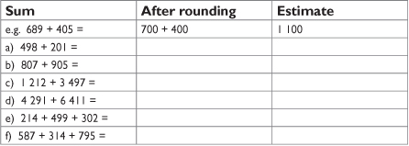

view and print

Activity 3

Human Society and Its Environment

Background learning: The Murray-Darling river system of Australia is one of the most important river systems of the world.

Students use the Murray-Darling Basin Authority web site to research aspects of this river system and its commercial and environmental significance.
- Use an atlas or web search to research the length of different rivers of the world.
- Rank the rivers according to length.
- Calculate the difference between the Murray-Darling river system and both the longest and shortest rivers on the list.
- Pose other numeracy questions for the students to solve using the information contained in the table.

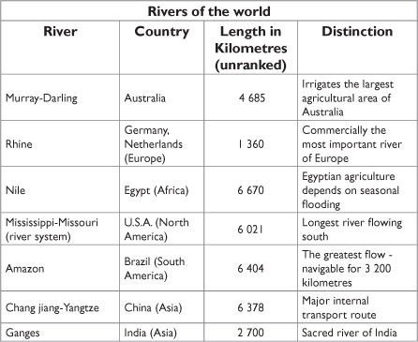

view and print

Future Teaching Point

The Murray-Darling basin provides a relevant topic for HSIE Stage 3 to locate and describe patterns of human involvement in an environmental area of Australia. Students may also identify how some aspects of religious and other belief systems can affect the way in which groups interact with the environment, e.g. the spiritual significance of the Ganges River in India.

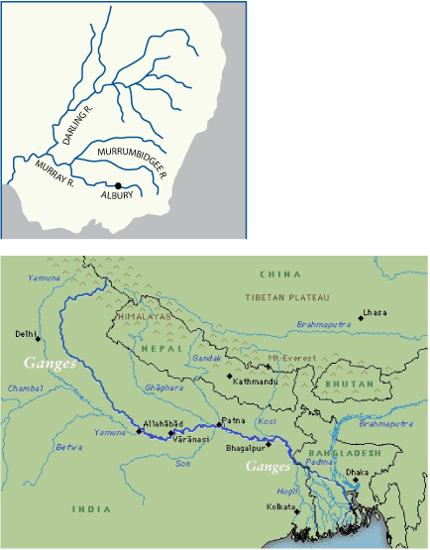

Online resources

Teacher resources

Curriculum Support

Lesson Plans and Activities
Murray-Darling Basin Authority web site at
www.mdba.gov.au

Interactive Whiteboard Activities
www.topmarks.co.uk/Interactive and select from
- Addition of 2 and 3 Digit Numbers
- Expanded Addition
- Horizontal Addition

www.bbc.co.uk/schools/ks1bitesize/numeracy/numbers/index
www.woodlands-junior.kent.sch.uk/maths/numberskills and select from
- Adding up to 10,000 (2 mins)
- Adding up to 10,000 (60 secs)

illuminations.nctm.org/ActivityDetail

Numeracy App

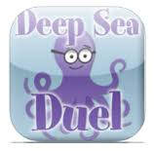Deep Sea Duel: Okta challenges you to a duel! That crazy octopus wants to play you in a game where the first person to choose cards with a specified sum wins. You can choose how many cards, what types of numbers, and Okta's level of strategy
STAGE 1

Number – Multiplication and division

Australian Curriculum Reference: ACMNA031: Recognise and represent multiplication as repeated addition, groups and arrays

NSW Syllabus Reference: MA1-6NA: Uses a range of mental strategies and concrete materials for multiplication and division

Use skip counting to solve multiplication and division problems; build arrays to solve problems; link multiplication and addition facts

Strategy

Students can:
- use skip counting to solve multiplication and division problems
- build arrays to solve problems
- link multiplication and addition facts

Activities to support the strategy

Activity 1

Display a hundreds chart. Students use the hundreds chart to skip count by 2s, 5s and 10s.

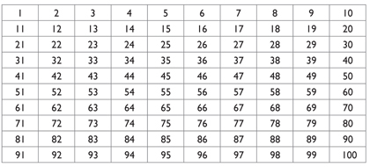

view and print

Students colour their own hundreds chart following these steps.
- Colour all the numbers counting by twos in blue.
- Colour all the numbers counting by fives in red.
- Colour all the numbers counting by tens in green.

Students discuss:
- What patterns can you see in your hundreds chart?
- What numbers did you colour twice?
- What numbers did you colour three times?

Activity 2

Students use a collection of counters to make equal groups, e.g. using 30 counters, make as many groups of 5 as they can.

Students use skip counting to determine the number of counters.

Repeat using other numbers.

Activity 3

Students use rhythmic or skip counting to find the total number of items that are arranged in the octopus.

Students illustrate and write number stories about their combinations using words and symbols.

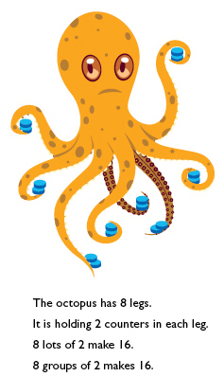

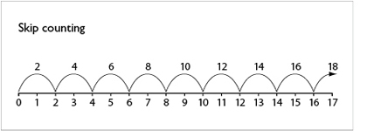

view and print

Activity 4

Students use arrays to make a combination of numbers. They can use items such as counters or marbles to form equal groups, e.g. Make four rows of three counters.

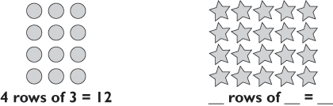

Students look at each array of objects. They count the number of objects in each row and then count the number of rows to determine the total number.

Have students explain how they worked out the total number in each array.

The teacher asks probing questions about their representations to assist students in identifying the relationship between multiplying and dividing groups of numbers.

The teacher writes the language used as students explain the processes, highlighting actions such as:
- puts together
- pulls apart
- groups
- divided into
- quarters, halves, thirds.

Students can use the arrays they have made to link multiplication and addition facts, e.g.

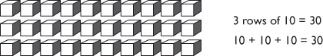

The teacher uses Narrative to bring alive the concepts being explored. Students can demonstrate their understanding by structuring their own experiences or newly acquired knowledge in a narrative form.

Activity 5

Display this array from the 2007 Basic Skills Test, Year 3, question 25.

view and print

The students look at the array. The teacher says:
- Tell me a story about the picture? What might it be? e.g. a set of cards, a block of chocolate, a page of stamps.
- How many are there altogether?

Encourage students to focus on the strategies used to get to 18 rather than the actual answer by asking probing questions such as:
- How many ways can you group the chocolates or stamps to get to a total of 18?
- Are there any others?

Make a list of the different ways on a chart.

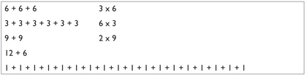

Students draw the arrays to match each of these.

Display the whole BST question.

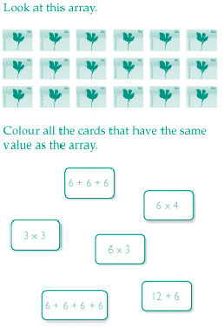

view and print

Ask questions about the whole question.
- What does ‘Colour ALL the …’ mean?

Students need to know there can be more than one answer.
- Do you use both the question and the picture of the array to answer the question? Reinforce that students always check all the possible answers.
- How do you know you have all the correct answers?

Reinforce the need for students to develop sound checking strategies.

Online resources

Teacher resources

www.curriculumsupport.education.nsw.gov.au/countmein/teachers
teachingtreasures.com.au/teaching-tools/mathK-3/add-and-subtract2-3
teachingtreasures.com.au/teaching-tools/mathK-3/chart-add
www.bbc.co.uk/schools/ks2bitesize/maths/number
www.bbc.co.uk/schools/ks1bitesize/numeracy/multiplication/index

STAGE 2

Number – Multiplication and Division

Australian Curriculum Reference: ACMNA031: Recognise and represent multiplication as repeated addition, groups and arrays. ACMNA076: Develop efficient mental and written strategies and use appropriate digital technologies; Develop efficient mental and written strategies and use appropriate digital technologies for multiplication and for division where there is no remainder. ACMNA082: Solve word problems by using number sentences involving multiplication or division where there is no remainder.

NSW Syllabus Reference: MA2-6NA – Uses mental and informal written strategies for multiplication and division

NSW Numeracy Continuum Reference:
Aspect 5: Multiplication & Division; Repeated abstract units; Multiplication and division as operations.

NSW Literacy Continuum Reference: WRIC10M4: Aspects of writing, Cluster 10, Marker 4: Rereads and revises text to check and improve meaning, deleting unnecessary information or adding new information.

Other Literacy Continuum Markers: REAC9M2: Reading texts, Cluster 9, Marker 2: Uses visual representations, e.g. photographs, tables, charts to enhance meaning when reading factual texts. REAC10M4: Reading texts, Cluster 10, Marker 4: Uses topic knowledge, vocabulary knowledge and context to read unknown words when engaging with subject texts. COMC9M7: Comprehension, Cluster 9, Marker 7: Analyses a text by discussing visual, aural and written techniques used in the text. COMC10M6: Comprehension, Cluster 10, Marker 6: Analyses and evaluates the relative importance of key ideas and information in a text to construct an overview.

Use a variety of mental strategies to solve multiplication and division problems; find multiples of a number by skip counting and making arrays; recognise division and multiplication as opposite operations

Strategy

Students can:
- use a variety of mental strategies to solve multiplication and division problems
- find multiples of a number by skip counting or making arrays
- recognise division and multiplication as opposite operations

Activities to support the strategy

Students need to be explicitly taught numerous strategies before they can use multiplication as an operation and recognise division as its opposite operation, for example, skip counting, repeated addition and forming arrays to represent multiplication.

Students need to be aware that there are a number of strategies that they can use to solve multiplication and division questions. More competent students are able to use multiplication to solve a problem and division to double check that same question.

Some activities for developing mental computation in multiplication and division are detailed below.

There is a related strategy in the Patterns and Algebra strand: Patterns and Algebra – Problem Solving

Activity 1

Developing mental computation

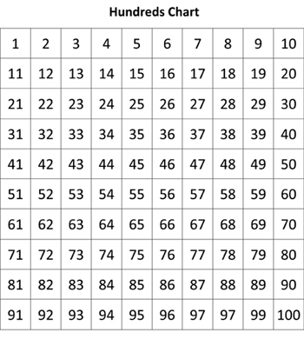

view and print

Hundreds Chart

Have students look for different number patterns on a hundreds chart when counting by 3, 4, 5, 6 etc. Use counters to show the patterns. If counting by 4s, for example, students should count 1, 2, 3 and cover the number using a counter, repeating this for a few rows until they can see a pattern and can continue it for the whole chart. Ask students to describe the patterns that have been made, e.g. multiples of 3 make a diagonal pattern, multiples of 5 make a vertical pattern.

Pairs of students are given a number from 2 to 10 and asked to find the pattern for their number on the hundreds chart.

Students can explore and share their results on the Notebook file Patterns of Multiples, click two pages to the screen in Notebook so you can see the questions and the chart at the same time.

Patterns of multiples

Multiplication Table Square

This activity provides students with a holistic view of multiples (times tables) and assists students in seeing the reciprocal nature of multiples. For example, if I know that 3 x 7 is 21 then I also know that 7 x 3 is 21.

Note: If students are only exposed to ‘times tables’ charts they will see each fact as distinct and a separate piece of knowledge to learn.

When we present multiples in a two-way table, students begin to see the commutative property of multiplication. Give students time to highlight the facts they know, they will soon see there are only a few pockets of facts they need to focus on. This information can be added to over time.

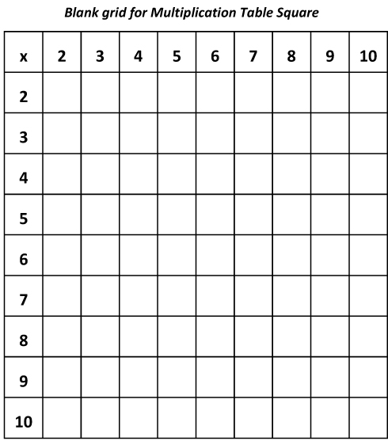

view and print

Whisper or Stress Counting

The teacher leads the class in counting by whispering the numbers not in the sequence and emphasising those that are part of the number pattern.

Skip or Rhythmic Counting

Students should be given opportunities to hear and say number sequences with lots of body movements to assist, such as claps, finger clicks and slaps etc.

Multo

view and print
- Prepare 100 flash cards with the multiplication facts 1 x 1 through to 10 x10.
- Students are given a 4 x 4 grid in which they must write 16 different numbers. The winner is the first student to get four numbers in a row, column or diagonal. On completion of a row of 4 the winning student calls out “Multo”!
- As each flash card is shown, students cross off that product from their game boards. The teacher may decide to have the students read the card aloud and say the answer before they check it off. This is a good way to reinforce prior learning.
- At the completion of a game the teacher runs through the flash cards already shown and students again say the question and provide the answer. This is a check that the winner does indeed have a “correct” grid.
- After the game has been played several times students soon discover that this activity differs from “bingo-style” games in that players can increase their chances of winning in several ways. Students work out for themselves, or with a little help from group discussion, that some numbers are “better” than others. Twenty-four is a “good” number because there are four cards which give that product (6 x 4, 4 x 6, 8 x 3, 3 x 8) whereas only one card (5 x 5) will give the answer 25.
- If students investigate this further they may discover that there are 9 “best” numbers having four chances of being drawn (6, 8, 10, 12, 18, 20, 24, 30, 40). Four numbers have three chances: 4, 9, 16, 36. Students may decide to use the results of this investigation when choosing the numbers to place in the grid. Some students place the “best” numbers on the eight squares which occupy diagonals because they say that these squares have three chances of winning, while the other 8 squares have only two chances.

This activity comes from the Counting On resource document from curriculum support and can be downloaded here

www.det.nsw.edu.au/curr_support/maths/counting_on

Tag

Students spread themselves around the room. The teacher calls out a multiplication, such as 4 x 8, and asks a student for a response. If the student correctly answers, they may take one step towards another student and attempt to tag them out of the game. This game can be used for finding the factors of a number or for division facts.

Activity 2

Using arrays
- Array Flash Cards

Create flash cards of various arrays to represent multiplication facts. In the same way that we use dice patterns as flash cards, show students different arrays, very quickly.

Then ask how many dots did you see?

Allow students time to give various answers, as they answer students need to say how many rows and how many dots in each row.

Show the card again and discuss the answer.

Repeat

Students need a visual representation of the fact to create a mental image of what that number looks like. Students may start out by trying to count all the dots individually, as students practice, they will begin to look across and down to work out how many dots per row and how many rows, this will assist students in forming concepts of area. These array patterns can also be used to show commutative properties by turning the cards sideways. Students in Stage 2 need to be able to tell the difference between three rows of six and six rows of three.

You can also extend the use of these cards to show fractions of collections and to explain division and to cut and paste the arrays in different orientations to show factors.
- Pose this problem. Say to the students, Under this cover there are 6 cards, and under each card there are 3 dots. How many dots are there altogether?

Students discuss the following strategies that could be used to solve the problem.
  - Linking multiplication facts with the division facts - make students aware that their knowledge of times tables is closely related to division, e.g. 6 groups of 3 = 18 and 18 divided by 6 = 3.
  - Skip Counting – to solve the above problem students could count by threes across the cards.
  - Working Backwards – the students are given the final answer and they need to find out how the problem was solved using multiplication or division.
- Use arrays to solve division as well as multiplication problems, e.g. What is 28 divided by 4?

Students use 28 counters to make an array which has 4 counters in each column. Count the number of columns to find the answer:
28 divided by 4 = 7.

Use this 4 x 7 array to solve other multiplication problems.

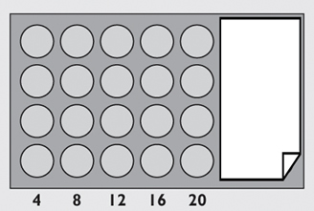

Cover all but 2 columns. Ask:
  - How many counters are showing?
  - How many counters are covered?

Skip count to find the answer.

Provide all students with a 10 x 10 dot array and two strips of cards. Ask them to make a variety of arrays and work out the answer. Relate these arrays to multiplication facts.

Using the same arrays, ask the students to find factors of a given number of dots.

Students can generate division facts from their arrays as well.

Activity 3

Solving word problems

The teacher demonstrates how to solve a word problem using the Newman’s questions shown below as a guide.

Students collaboratively work with a partner to solve other problem using these questions as a guide.

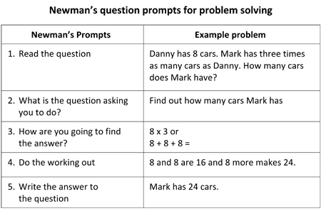

view and print

For more information on Newman’s Error Analysis visit the website
www.curriculumsupport.education.nsw.gov.au/secondary/mathematics/numeracy/newman

Activity 4

Division with remainders

Students in pairs can play a game of Remainders Count. Two students need three 1 to 6 dot dice.

The first player throws all three dice. The player uses two of the dice to form a two-digit number that can be divided by the remaining dice, e.g. the three dice could show a 2, a 6, and a 3. The player could make a 23 and divide it by 6 or a 26 and divide it by 3.

The first player determines the answer and records the remainder as their score, e.g. if the player made a 23 and divided it by 6, the remainder would be 5. However, if they make a 26 and divide it by 3, their remainder would only be 2. The next player has their turn. The aim is to achieve the largest possible remainder. The play continues until someone reaches 20.

This activity is from the Count Me In Too website and can be played online as a Learning Object
www.curriculumsupport.education.nsw.gov.au/countmein/children_remainders_count

Online resources

Teacher resources

Curriculum Support

Developing Efficient Numeracy Strategies: Stage 2, NSW Department of Education and Training, pp.98-101, 252–283
www.curriculumsupport.education.nsw.gov.au/countmein/children

Lesson Plans and Activities
www.primaryresources.co.uk/maths/mathsC2

Student resources

www.bbc.co.uk/schools/ks1bitesize/numeracy/multiplication/index
www.bbc.co.uk/schools/ks1bitesize/numeracy/division/index

Numeracy App

Math Master Free: Practice makes perfect, and Double6 Math Master makes maths practice fun. Now your child can learn to add, subtract, multiply, divide, and more. A fun and engaging game helping to sharpen math skills and keep your child occupied. Match each sum tile with its correct solution tile in the fastest time. Along with Math skills; memory and speed play a big part in this game, making it more challenging and fun. And it’s fun for adults to! Enjoy playing together and see if you can better your child’s time.

STAGE 3

Number – Multiplication and division

Australian Curriculum Reference: ACMNA122: Identify and describe properties of prime, composite, square and triangular numbers ACMNA123: Select and apply efficient mental and written strategies and appropriate digital technologies to solve problems involving all four operations with whole numbers.

NSW Syllabus Reference: MA3-6NA: Selects and applies appropriate strategies for multiplication and division, and applies the order of operations to calculations involving more than one operation.

NSW Numeracy Continuum Reference:
Aspect 5: Multiplication & Division;Multiplication and division as operations.

NSW Literacy Continuum Reference: SPEC11M5: Aspects of speaking, Cluster 11, Marker 5: Uses active listening strategies such as rephrasing ideas and clarifying and repairing breakdowns in communication.

Select and apply appropriate mental, written and calculator strategies to solve multiplication and division questions

Strategy

Students can:
- select and apply appropriate mental, written and calculator strategies to solve multiplication and division questions

Activities to support the strategy

Students need to be aware that there are a number of strategies that they can use to solve multiplication and division questions. More competent students would know that they can use multiplication to solve a problem and division to double check that same question.

Some activities for developing mental computation in multiplication and division are detailed below.

Activity 1

Developing mental computation

Dice tables

Students in pairs can play a game of Dice Tables.

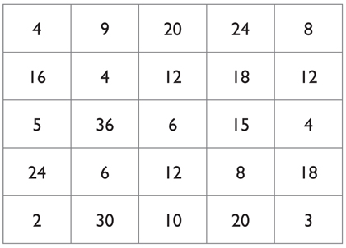

view and print

The two students need three 1 to 6 dot dice, 2 sets of coloured counters and a Dice tables board.

The first player rolls the dice and chooses two of the three numbers to multiply to match a number on their Dice tables board, e.g. if the student rolls 4, 5 and 3 they could make 4 x 5 = 20 or 4 x 3 = 12 or 5 x 3 = 15. They place a counter on the chosen multiple. Students alternate turns. The aim is to be the first to get 4 counters in a row, column, diagonal or square.

Dice to 100

Students in pairs can play a game of Dice to 100.

Two students need two 1 to 6 dot dice.

The students take turns to roll two dice and multiply the numbers. The total for each round is added onto the previous round. The first person to 100 is the winner.

Variation: Use a 10- or 12-sided dice and a larger target number.

Activity 2

Halving and Doubling

Introduce halving and doubling as strategies that can be used to solve multiplication and division problems involving three-digit numbers.

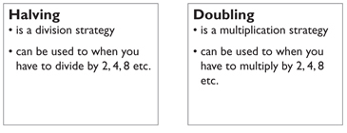

Work through examples to demonstrate the strategy.
- To divide an even three-digit number by 4, students could find half of the number and halve again.

e.g. To find the answer to 324 divided by 4

Ask: Can you use the halving or doubling strategy to find the answer?
How would you use this strategy?
What is half of 324? (162) Is this the answer to the question?
What is half of 162?
- To divide a number by 5, students could divide by 10 and double the answer.

e.g. To find the answer to $4 divided by 5

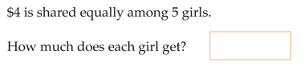

Ask:
- Can you use the halving or doubling strategy to find the answer?
- How would you use this strategy?(divide by 10 then double)
- What is $4/$4.00 divided by 10?(40c)
- What is double 40?

Activity 3

Solving word problems
- Pose this problem for the students to solve.

On the way to school four children found a $50 note. They handed it to the school principal. They will each get an equal share of the money if no one claims it.

Investigate the strategies used by asking these questions.
- How much would each child get?
- What strategy did you use to find each share?
- Can you use doubling or halving?
- Which operation would you use to check if your answer is correct?
- How much would each child get if $5 was found?
- How much would each child get if 50c was found?

Repeat using other division problems, each time discussing the strategies the students used. Emphasise that students should use multiplication to check their answers to division problems.
- Pose this problem for the students to solve in pairs.

It takes four oranges to fill a small juice bottle with juice. If I bought a box containing 93 oranges, how many bottles could be filled? How many oranges left over?

Students in pairs, discuss how they would solve this problem. They determine two different strategies that could be used. Each pair explains the two strategies they would use.
- Students are presented with a variety of multiplication and division problems involving three- and four-digit numbers. Students first estimate their answer before solving, to compare mental and written strategies.

Students discuss the strategies they used and determine which strategy is the most efficient.

Discuss:
- How accurate was your estimation?
- How did your estimation help?
- Which operation did you use?
- Can you describe your strategy?
- Is your strategy efficient?
- How did you check whether your answer is correct?

Students can write other word problems for their partner to solve. Check their answers with a calculator.

Online resources

Teacher resources

Count Me In Too NSW Department of Education and Training
www.curriculumsupport.education.nsw.gov.au/countmein/index

Interactive Whiteboard Activities

www.topmarks.co.uk/Interactive and select from
- Number Facts Grid
- Multiple Matrix
- Bingo

Student resources

www.bbc.co.uk/schools/ks2bitesize/maths/number and select from
www.bbc.co.uk/schools/ks2bitesize/maths/number/multiplication_division/play
www.bbc.co.uk/schools/ks1bitesize/numeracy/multiplication/index
www.bbc.co.uk/schools/ks1bitesize/numeracy/division/index
www.visualmathlearning.com/Games/sliding_factors
nrich.maths.org

Numeracy Apps

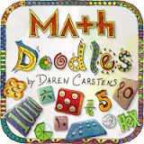Math Doodles: Math Doodles introduces three challenges plus an additional Soap functional sneak peek challenge. Each Challenge provides plenty of mathematical practic e, within a recreational math setting. The mathematical puzzles allow users to play, explore, and experiment with mathematical concepts, while developing and strengthening their strategy and problem solving skills. Math Doodles challenges are designed to allow for multiple solutions and strategies.

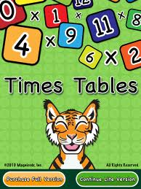TimesTablEAL/Dite: TimesTables is a delightful, challenging, fun and interactive way for children to learn the multiplication tables. Approved by children, parents and teachers. Working with teachers, parents and children, we selected the most effective tools to make learning the multiplication tables easy and fun. TimesTables uses visual, audio and tactile tools to help children remember, understand and retain multiplication facts.

Number – Multi-step Problem solving

Australian Curriculum Reference: ACMNA101: Solve problems involving division by a one – digit number, including those that result in a remainder; ACMNA173: Recognise and solve problems involving simple ratios; ACMNA188: Solve a range of problems involving ratios and rates, with and without the use of digital technologies

NSW Syllabus Reference: MA3-6NA; use mental and written strategies to divide a number with three or more digits by a one – digit divisor where there is no remainder; show the connection between division and multiplication; apply appropriate mental and written strategies, and digital technologies, to solve division word problems; recognise when division is required to solve word problems (Problem Solving); MA4-7NA; use ratios to compare quantities measured in the same units; solve a variety of real – life problems involving ratios; convert given information into a simplified rate

Find common multiples of two numbers; Find relationships between numbers; Use division to solve problems

Strategy

Students can:
- Find common multiples of two numbers
- Find relationships between numbers
- Use division to solve problems

Activities to support the strategy

Students need to use their knowledge of multiples and the inverse relationship between multiplication and division to solve problems that involve ratios. Students need to be able to find a common divisor for both units that are being compared e.g. 400 grams and 24 cupcakes can both be divided by 4. This assist students in finding a base unit to then find the solution to the problem. Students can also see the pattern of multiples to solve problems involving ratios. The concepts of the relationship between division and multiplication and pattern relationships develops into Stage 4 in Rates and Ratios where proportional reasoning is involved.

Activity

‘Real world’ problems

Using real problems is a way to develop students’ working mathematically skills in communicating, problem solving and reasoning in the classroom. This following problem involves students using their knowledge of multiples and their relationship to each other to solve problems. This leads to understanding ratios in Stage 4.

Tony is paid the same amount for each car he washes.
He gets paid $15 for washing 3 cars.

How many cars does he need to wash to get paid $45?

Using Newman’s prompt questions while problem solving is a good guiding structure for problems
- Please read the question to me.
- Tell me what the question is asking you to do.
- Tell me how you are going to find the answer.
- Show me what to do to get the answer. “Talk aloud” as you do it, so that I can understand how you are thinking.
- Now, write down your answer to the question.

For more information on Newman’s follow this link www.curriculumsupport.education.nsw.gov.au/secondary/mathematics/numeracy/newman

Work through the problem as a whole class. Using toy cars and plastic money recreate the problem and have students act it out. Allow students to use these resources and others to work on solving the problem. Allow students time to work in pairs or small groups to trial and number of different strategies for solving the problem. It is important that students can also visualise the problem.

Do students see that 15 can be multiplied 3 times to get 45?

Do students see that finding out how much it costs to wash one car could help in solving the problem?

Online resources

Teacher resources

Number sequences and relationships
(Lessons from Talking about Patterns and Algebra Stage 3 section)

In proportion – range of activities
NRICH Enriching Mathematics website

Numeracy Wrap – Painting in Proportion
Scootle website
STAGE 1

Number – Fractions and Decimals

Australian Curriculum Reference: ACMNA033: Recognise and interpret common uses of halves, quarters and eights of shapes and collections

NSW Syllabus Reference: MA1-7NA: represents and models halves, quarters and eighths; MA1-1WM: Communicating

NSW Numeracy Continuum Reference:
Aspect 6: Fraction Units: Halving.

NSW Literacy Continuum Reference: VOCC5M3: Vocabulary knowledge, Cluster 5, Marker 3: Demonstrates awareness that some words have multiple meanings when reading, writing and speaking.

Other Literacy Continuum Markers: VOCC7M1: Vocabulary knowledge, Cluster 7, Marker 1: Knows the meaning of commonly used words in increasingly challenging texts and can demonstrate this knowledge when reading, writing and speaking.

Use folding and sharing diagrams tro represent fractions; use half and quarter to describe equal parts

Strategy

Students can:
- use folding and sharing diagrams to represent fractions
- use half and quarter to describe equal parts

Activities to support the strategy
- Students are given some paper rectangles and fold each rectangle to show halves. Discuss whether the parts are equal.

Students label the parts of the rectangle. Students then turn the paper over and fold the paper into quarters and label.

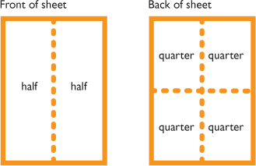

Students can repeat the activity using:
  - circle shapes such as pikelets, cakes, paper circles or paper plates
  - columns or bars including chocolate or lamingtons.

- Students are given some paper circles to represent cup cakes or cookies. Pose these problems:
  - If we wanted to share 4 (or 6) cup cakes between 2 people, how could we do it? Students use the paper circles to model the strategies they would follow.
  - If we wanted to share 3 (or 5) cup cakes between 2 people, how could we do it? Students model the strategies using the paper circles and also by drawing a diagram to show the strategies.

Students describe their sharing diagrams to the class, using the terms ‘halves’ or ‘half’.
- Provide students with a selection of cards. Students determine if the shaded part of each shape shows one half, less than one half or more than one half.

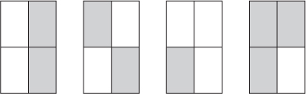

view and print

Students colour parts of a square using the Fraction Paint interactive program. (Refer to the Fraction Paint links under Student Resources below.)
- The teacher cuts different sized round fruits (e.g. oranges or apples) into halves or quarters. The students then select the pieces that are needed to remake the fruit.

Have students describe the steps they followed to remake the fruit using the terms ‘halves’ and ‘quarters’.
- Make collections of objects using centicubes or pencils. Students share the collections equally into two groups and into four groups. Observe the strategies the students use to share equally.

Online resources

Teacher resources

Curriculum Support

Fractions: Pikelets and lamingtons, Department of Education and Training, 2003, pp. 11–12
www.curriculumsupport.education.nsw.gov.au/primary/mathematics/assets/pdf/stage2/pieceofcake.pdf

Lesson Plans and Activities

Fraction worksheets
math.about.com/od/fractionsrounding1/ss/teachfraction
www.education.com/worksheet/article/id-fractions-half

Student resources

An initial practice game for halves can be found at:
www.oswego.org/ocsd-web/games/fractionflags/fractionflags

Fraction Paint
www.oswego.org/ocsd-web/games/FractionPaint/fpaint4
www.oswego.org/ocsd-web/games/FractionPaint/fpaint9
www.oswego.org/ocsd-web/games/FractionPaint/fpaint16
www.oswego.org/ocsd-web/games/FractionPaint/fpaint25
www.oswego.org/ocsd-web/games/FractionPaint/fpaint36

Numeracy Apps

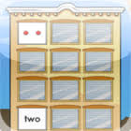Math Concentration: By yourself or against a friend, match whole numbers, shapes, fractions, or multiplication facts to equivalent representations. Practice with the clear panes or step up the challenge with the windows closed. How many socks can you win?

This app was developed for children in grades preK–5 by Illuminations. It is also available as an online activity along with many other free math resources for children at illuminations.nctm.org.

Back to top

STAGE 2

Number – Fractions and Decimals

Australian Curriculum Reference: ACMNA079: Recognise that the place value system can be extended to tenths and hundredths. Make connections between fractions and decimal notation

NSW Syllabus Reference: MA2-7NA – Represents, models and compares commonly used fractions and decimals

NSW Numeracy Continuum Reference:
Aspect 6: Fraction Units: Equal Partitions.

NSW Literacy Continuum Reference: VOCC10M2: Vocabulary knowledge, Cluster 10, Marker 2: Demonstrates expanded content vocabulary by drawing on a combination of known and new topic knowledge.

Other Literacy Continuum Markers: SPEC10M1: Aspects of speaking, Cluster 10, Marker 1: Provides detail and supporting evidence in a logical manner when speaking about opinions and ideas. SPEC10M4: Aspects of speaking, Cluster 10, Marker 4: Listens attentively and responds appropriately to spoken and multimodal texts that include unfamiliar ideas and information.

Read and write common fractions; label the numerator and denominator in any given fraction; explain that the denominator tells how many equal parts make a whole and the numerator tells how many of these parts are used; locate fractions and decimals on a number line

Strategy

Students can:
- read and write common fractions
- label the numerator and denominator in any given fraction
- explain that the denominator tells how many equal parts make a whole and the numerator tells how many of these parts are used
- locate fractions and decimals on a number line

Activities to support the strategy

Activity 1

Modelled

Instruct students that decimals are a type of fraction and that in a decimal number place value indicates the number of equal parts. Explain the numerator is the upper number of a fraction and represents the number of fractional parts. Explain the denominator is the lower number of a fraction and represents the number of equal parts the whole has been divided into.

Write and on the board. Explain that in these fractions the denominator is a multiple of 10 and so these fractions can be written as a decimal fraction. Next to each fraction write the correct decimal (.6 and .36).

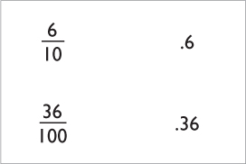

Explain that a decimal point is used and the number of digits after the point tells us if the fraction is tenths or hundredths. Explain that 1 digit after the decimal point tells how many tenths and 2 digits after the decimal point tells how many hundredths. Point to the decimal and read aloud 6 tenths and 36 hundredths.

Write these examples on the board.

Note: Using the same digit and zero in different positions makes the student focus on the number of digits after the decimal point.

Activity 2

Guided
- Ask questions and encourage students to justify (explain) their answer such as:
  - How many digits after the decimal point?
  - How many hundredths?
  - How do we know (a number) is in the hundredths place?
  - How does the position of the digits change the value of the decimal? Why?
  - What pattern do you notice?

Using the example above, point to .08 and ask:
  - How many digits after the decimal point is the 8? Answer: 2
  - Say: 2 digits after the decimal point tells us it is hundredths.
  - How many hundredths? 08 tells us it is 8 hundredths.

Repeat with other examples.

Support incorrect answers by explaining the error and talking through students' thinking using the 'think aloud' strategy, e.g.

If a student says .03 is 3 tenths ask: How many digits after the decimal point is the 3? (Point and count) Answer: 2 places
So what does the .03 tell us? Answer: Hundredths

Once students have demonstrated mastery of decimal notation to two places, introduce decimal notation to three places.

Note: It is important to check that students are saying the 'ths' on the end (tenths and hundredths) as this will avoid confusion when mixed numbers are introduced.
- Attach a one metre long piece of paper or ribbon to the board. Label the length as one metre. Have students mark and initial where they think 0.5 m would be. Have other students estimate the position of 0.25 m and 0.75 m.

Select students to check the measurements. Ask:
  - How did you know where to place 0.5? 0.25? 0.75?

Repeat for other decimals, such as 0.2, 0.3, 0.8.
- Students can organise cards from smallest to largest number on a washing line set up in the classroom with 0 displayed at one end and 1 displayed at the other.

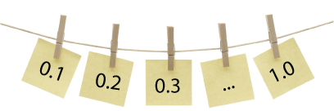

Start with decimals to one decimal place then repeat with decimals to two decimal places.
- Pose this question, Which decimal is larger, 0.7 or 0.07? Ask:
  - How do you know?
  - How can you prove it?

Have students demonstrate which decimal is larger, using blocks, grid paper or another strategy.

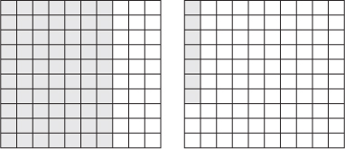

view and print
- A number of these activities can be repeated using fractions instead of decimals.

Activity 3

Guided

Dividing One Whole into Fractions
- Students are given a worksheet with a large circle drawn on it. They imagine that the circle is the top view of a round chocolate cake (or pizza base) which they have to share between five people.
Ask: How would you cut the cake so you have five equal pieces and none left over?

Students draw lines on the 'cake' to show where the cuts would be. They could use pencils to work out where the cuts would be, before they draw the cuts on the large circle.

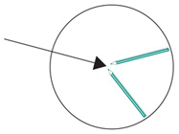

Students discuss the strategy they used to cut the cake into five equal pieces.

Discuss:
  - If you have five equal pieces cut from one whole cake, what would each piece be called?
  - What if the same cake was divided into ten equal pieces, so that each person could eat one piece and take one piece home. How would you change the five equal pieces into ten equal pieces?
  - If you have ten equal pieces, what would each piece be called?
- Students are given three strips of paper of equal length.
  - Strip A represents one whole. Students write ‘one whole’ on the paper.
  - They fold strip B into fifths and label the strip ‘fifths’.
  - They fold strip C into tenths and label the strip ‘tenths’.

Students place the three strips of paper one under the other and discuss these questions
  - What can you tell about the size of each fraction?
  - What strategies did you use to create your fractions?
  - What strategies did you use to obtain equal parts?

Students use their folded strips of paper to count by fifths and tenths. They can complete the missing labels on worksheets showing fifths and tenths.

Write the missing fraction labels on these fraction strips.

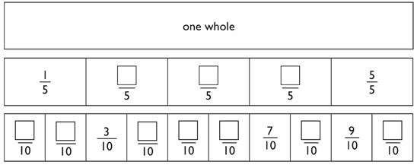

view and print

Online resources

Teacher resources

Curriculum Support

Fractions, pikelets and lamingtons, Department of Education and Training, 2003

Decimal number line and Decimal clothes line
detwww.det.nsw.edu.au/curr_support/maths_prog/prog_support/decimals/decimal_s3

Student resources

www.bbc.co.uk/schools/ks2bitesize/maths/number/decimals/play_popup
www.bbc.co.uk/schools/ks2bitesize/maths/number – and select Decimals
www.amblesideprimary.com/ambleweb/mentalmaths/fracto

Numeracy App

MathPad3: MathPad3 is all about <, >, & = (less than, greater than and equals to). MathPad3 helps build a solid foundation in determining which symbol (greater than, less than or equal to) to use when given set of whole numbers, fractions or decimal numbers. You can focus on whole numbers, decimal number or fractions (reduced/simplified or not).

STAGE 3

Number – Fractions and Decimals

Australian Curriculum Reference: ACMNA127: Find a simple fraction of a quantity where the result is a whole number, with and without digital technologies. ACMNA125: Compare fractions with related denominators and locate and represent them on a number line.

NSW Syllabus Reference: MA3-7NA: Compares, orders and calculates with fractions, decimals and percentages

NSW Numeracy Continuum Reference:
Aspect 6: Fraction Units: Reforms the whole.

NSW Literacy Continuum Reference: SPEC11M5: Aspects of speaking, Cluster 11, Marker 5: Uses active listening strategies such as rephrasing ideas and clarifying and repairing breakdowns in communication.

Compare and order decimals using strategies such as the number line and diagrams; explain or demonstrate the equivalence of fractions; use estimation to check whether an answer is reasonable; interpret and explain the use of fractions in everyday contexts

Strategy

Students can:
- compare and order decimals using strategies such as the number line and diagrams
- explain or demonstrate the equivalence of fractions
- use estimation to check whether an answer is reasonable
- interpret and explain the use of fractions in everyday contexts

Activities to support the strategy

Activity 1

Equivalent fractions
- Provide 3 squares of equal size, one divided in half, one divided into quarters and one divided into eighths.

Discuss the number of equal parts in each square. Establish that , and all equal 1 whole.

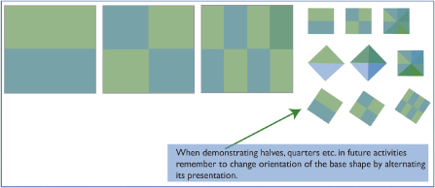
  - Fold each square in half and model that is equal to and .
  - Using cut up squares model that is equal to and that is equal to .
  - Discuss the pattern - if the numerator is doubled, so is the denominator.
- Divide the class into groups and provide each with a variety of shapes divided into fifths, tenths, eighths, quarters and halves. Have groups manipulate the shapes to demonstrate equivalent fractions.

Each group records the sets of equivalent fractions they have modelled, then reports back to the class.
- Teacher holds up a fraction card, e.g. . Students provide an equivalent fraction for . Ask students what has happened to the numerator and the denominator to make the equivalent fraction in each example.

Prompt students to formulate a rule to explain that if the numerator is doubled, so is the denominator.

The rule generated by the students can be placed on a chart in the room.
  - Provide students with a worksheet showing a range of shapes divided into different fractions. Students colour a section/sections of each shape.

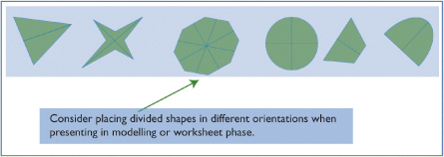

Include examples requiring students to:
  - colour fifths, tenths, hundredths, eighths, quarters and halves
  - colour wholes in the form of , , etc.
  - write the equivalent fraction of a shaded shape, e.g. if half the shape is shaded the students must fill in , , .

Students provide equivalent fractions of a given fraction, e.g.
equals or .

Students fill in missing numerators and denominators in mixed format, e.g.
.

Repeat activities for thirds, sixths and twelfths.

Activity 2

Fraction games

The following activities involve students working in small groups or pairs to complete a game. Concrete materials can help students to develop a sound understanding of the concepts required when calculating with fractions.
- Play the game Fraction Track as a board game with the whole class, prior to playing it on the computer. Fraction Track board game

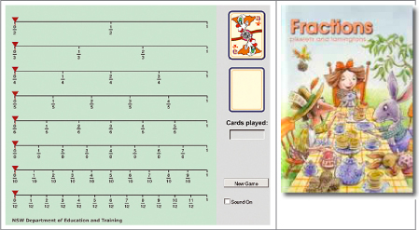

Equipment:
  - two large gameboards of the fraction track
  - cards with the fractions

view and print
  - two post-it notes per team placed at the beginning of the game board (see below)

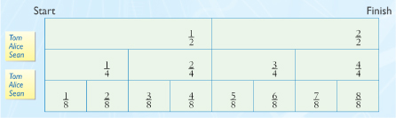

view and print

Students play in two teams. The teacher turns over a card and the team decides where to move the post-it note along the fraction track. More than one post-it note can be moved, as long as the total of the fraction card is not exceeded.

For example, when the teacher turns over , Tom, Alice and Sean may move:
  - one post-it note along by
  - the first post-it note along by and the second post-it note along by
  - both notes along by .

The first team to move all post-it notes to the end of the track wins.
- Play the game Coloured Fractions. Coloured Fractions may be played as a whole class activity, in pairs or small groups.

This activity links closely with the Stage 3 Crossing the Wall activity described on page 52 of Fractions: pikelets and lamingtons.

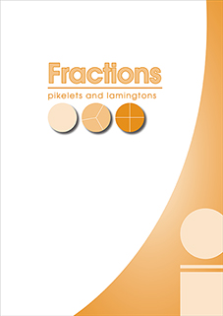

view and print

Equipment
  - green dice (numerator) labelled:
  - blue dice (denominator) labelled:
  - one gameboard for 2 students

view and print

Take turns to throw the dice. Colour in the equivalent of the fraction represented by the dice. Record each fraction as the game is played. The first pair to colour the entire game board is the winner.

At the completion of the game, students add the fractions to check that they total 6.

Activity 3

Decimals

Students complete activities using a decimal double number line folded along the middle so that only the side showing the end points is visible.

Place a paper clip on the folded double number line to estimate the position of a given number. Students justify the position for their number.

Flip over the number line to check their estimation.

For example, ask students to estimate the position of 0.6.

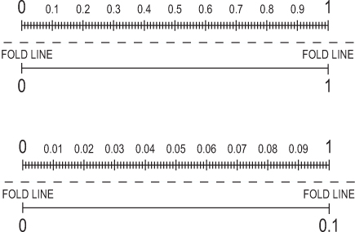

view and print

Online resources

Teacher resources

Counting On Teaching Activities, Department of Education and Training, 2002, p. 60

Fraction Track

Fractions, pikelets and lamingtons, Department of Education and Training, 2003

Interactive Whiteboard Activities

www.topmarks.co.uk/Interactive

Notebook files

Sharing Pikelets
EquivalentFractionsAU
FractionpiecesAU
FractionWallau
Addition_subtraction_common_fractions

CLIC/TaLe resources

Learning Objects from TaLE- The Learning Federation
Kick the goal: add proper fractions 2
Kick the goal: add improper fractions 2
Comparing fractions
Comparing fractions: strategies
Fraction fiddle: reach the target
Fraction fiddle: shoot the hoop
Design a park: 5 by 5 grid
Design a farm: 5 by 10 grid
Design a school: 10 by 10 grid

Count Me In Too website

Pikelet cutter
Ribbon Fractions

Curriculum support website

Red Dragonfly Mathematics challenge

Other Online Resources

Maths problems: Calculating with fractions list of activities
nrich.maths.org

Numeracy Apps

Pick-a-Path : With the new Pick-a-Path mobile app, students can learn about integers, exponents, fractions, decimals, and more! Navigate with Okta the octopus from top to bottom–adding, subtracting, multiplying and dividing as you go–to get the maximum, the minimum, or a target number by the time Okta reaches the bottom of the maze.

Fraction Factory: Enter the Fraction Factory and use your math skills to place fractions into their correct positions on a number line. When the game begins, fraction gears will move across the screen on a conveyor belt. Use your finger and drag the fraction gear to where you think they should go on the number line at the top of the screen.

STAGE 4

Number – Fractions, Decimals and Percentages

Australian Curriculum Reference: ACMNA154: Multiply and divide fractions and decimals using efficient written strategies and digital technologies. ACMNA157: Connect fractions, decimals and percentages and carry out simple conversions.

NSW Syllabus Reference: MA4-5NA: Operates with fractions, decimals and percentages.

NSW Numeracy Continuum Reference:
Aspect 4: Place Value: System Place Value
Aspect 6: Fraction Units – Fraction as numbers.

NSW Literacy Continuum Reference: VOCC13M2: Vocabulary knowledge, Cluster 13, Marker 2: Uses technical vocabulary to explain a complex concept or phenomenon.

Simplify a fraction; convert a percentage to a fraction or decimal; find the percentage of a given amount; increase or decrease an amount by a given percentage

STAGE 1

Patterns and Algebra

Australian Curriculum Reference: ACMNA026: Investigate number sequences, initially those increasing and decreasing by twos, threes, fives and ten from any starting point, then moving to other sequences

NSW Syllabus Reference: MA1-8NA: Creates, represents and continues a variety of patterns with numbers and objects.

NSW Numeracy Continuum Reference:
Aspect 3: Pattern and number Structure – Part – Whole to 10, – Part – Whole to 20, – .

NSW Literacy Continuum Reference: WRIC7M1: Aspects of writing, Cluster 7, Marker 1: Plans texts by making notes, drawing diagrams, planning sequence of events or information, etc.

Identify a repeating pattern; build simple number patterns; continue simple number patterns and determine missing elements; recognise patterns and applies the commutative property; relate addition and subtraction facts

Strategy

Students can:
- identify a repeating pattern
- build simple number patterns
- continue simple number patterns and determine missing elements
- recognise patterns and applies the commutative property
- relate addition and subtraction facts

Activities to support the strategy

In Stage 1, the concept of equality and the understanding that the equals sign also means 'is the same as’ is important. Students need to see the 'equals sign’ like a balance or a set of scales, both sides need to total the same amounts.

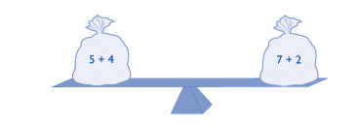

At this stage, students need to start building their understanding of patterns for individual numbers and be able to list all possible combinations. Knowledge of number combinations is the foundation for seeing numbers as flexible. This understanding has strong links to addition and subtraction and can be applied to develop strategies such as; counting on and off the decade, bridging to ten, using related number facts, jump and split strategies.

Activity 1
- Students are allocated a one- or two-digit number and a set of objects, such as counters or cubes and paper. They are asked to show their number in as many different ways as possible and using any of the objects provided - in words, in diagrams, in numbers and using the objects. In small groups, students describe the different ways they have recorded their number, e.g. The number 10 can be shown as

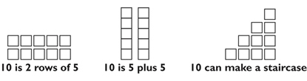
- Students use cubes or plastic squares to build a staircase pattern. They draw, count and record the number of squares used in the pattern. Ask questions about the pattern the students have made.
  - How many squares make up the first shape in the pattern? the second shape? the fifth shape?
  - How many squares were added to the first shape to make the second shape? the second shape to make the third shape?

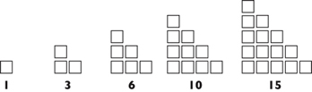
- Students build different interesting patterns using cubes or plastic squares and describe their patterns to a partner. Students tell their partner:
  - how many squares were used in each step of the pattern
  - how many squares were added each time to continue the pattern, e.g.
- The teacher builds the pattern, using buttons or counters.

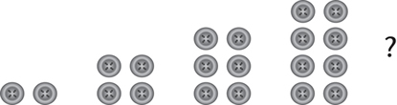

Discuss:
  - How many buttons will be in the next shape in this pattern? How do you know?
  - How did we make the next shape in the pattern?

Continue the pattern by adding more terms. Use a sheet of card to cover one of the middle terms. Ask:
  - How many buttons in the shape I have covered? How do you know?

Activity 2
- Arrange individually numbered cards in a row from one to twelve, face down. Turn over a sequence of four cards at a time asking students what numbers they can see, what numbers are hidden and what the next number will be. Model mathematical statements using students' contributions to explain the patterns created, e.g. Start at 4 and turn over every number card when you count by four.
- Construct a wall chart of key phrases used in number patterns. Discuss the meaning of the phrases using a number chart and write examples next to the phrases.

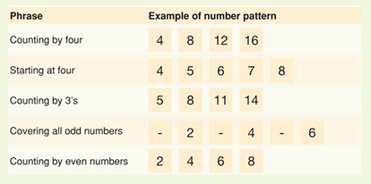
- Provide pairs of students with a set of directions for making patterns (using phrases listed on the wall chart) and a number chart. One student reads the direction for making a pattern from the number chart while the other student follows the direction and makes the pattern using counters or writing numbers.

Directions for making patterns:

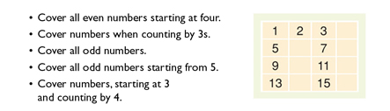
- Students work in pairs to construct a pattern on a number chart using blank cards and Blu-Tack to cover the numbers. Students refer to the wall chart of key phrases to assist them in writing the directions for their pattern.
- Students use the Musical counter Learning Object to explore repeating elements in patterns. Students make sound patterns by following a rule starting from a given number on a number line. Other sound patterns can be added using different musical instruments. (NSW DEC employees)

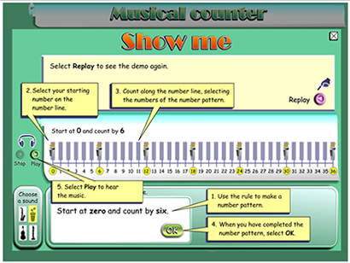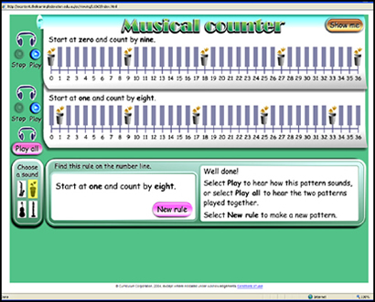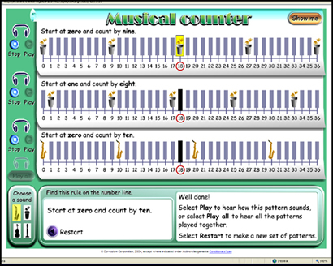

view and print

Online resources

Teacher resources

Curriculum Support

Assessment Resource Centre
boardofstudies.nsw.edu.au/go/stage-1/maths/activities/making-number-patterns

Musical counter (NSW DEC employees)
det.nsw.edu.au/learningobjects

Interactive Whiteboard Activities

Includes an interactive lesson which looks at patterns, where they occur and how they repeat.
www.linkslearning.k12.wa.us/kids/1_math/2_illustrated_lessons/5_Patterns

A teaching tool to help with number sequences which go up or down. The counting sticks are either vertical or horizontal.

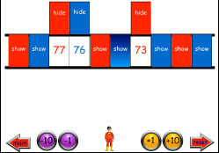

www.wmnet.org.uk

An activity which helps students to identify number sequences. It starts with numbers below 5.

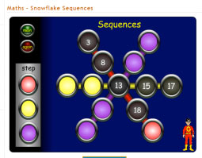

www.topmarks.co.uk

A number sequence game where students have to identify the next two numbers in the pattern.

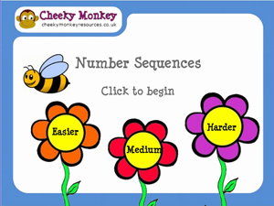

www.cheekymonkeyresources.co.uk/Sequencenew/SEQUENCE

www.nctm.org/standards

Student resources

www.harcourtschool.com/activity/paul_pattern

Numeracy Apps

Digicubes: Digicubes are squares that change colour to help young children explore number patterns.
The colours used reflect the traditional number materials Cuisenaire Rods.
© Learning, High Performance and Accountability Directorate 2014

STAGE 2

Number Patterns

Australian Curriculum Reference: ACMNA060: Describe, continue, and create number patterns resulting from performing addition or subtraction.

NSW Syllabus Reference: MA2-8NA : Generalises properties of odd and even numbers, generates number patterns, and completes simple number sentences by calculating missing values.

NSW Numeracy Continuum Reference:
Aspect 3: Pattern and number Structure – Number Properties.

NSW Literacy Continuum Reference: VOCC10M1: Vocabulary knowledge, Cluster 10, Marker 1: Demonstrates understanding that words can have different meanings in different contexts.

Other Literacy Continuum Markers: SPEC9M4: Aspects of speaking, Cluster 9, Marker 4: Contributes relevant ideas to discussions, asks questions and re-phrases to clarify meaning. WRIC9M4: Aspects of writing, Cluster 9, Marker 4: Structures texts using paragraphs composed of logically grouped sentences that deal with a particular aspect of a topic.

Use the 'think aloud' strategy; build, describe and record number patterns using a variety of strategies; describe number patterns in words

Strategy

Students can:
- use the ‘think aloud’ strategy
- build, describe and record number patterns using a variety of strategies
- describe number patterns in words

Activities to support the strategy

At this stage, students need to be able express their ideas and understanding by communicating and providing reasons for their thinking. Students are required to be able to generate number patterns, describe and record the patterns using diagrams, words or symbols.

The mathematical language required needs to be modelled by the teacher and students need to be provided with opportunities to talk through their thinking. For example, 3, 6, 9, 12… students describing this pattern may say, “It goes up by threes”, or, “It looks like the three times tables”, we would encourage students in Stage 2 to refer to this pattern as showing the “multiples of threes”. This wider classification will help students when they are required to find solutions to problems involving finding higher terms, e.g. the 10th term in a pattern.

Playing games like ‘guess my rule’ e.g 1, 4, 7…what is my rule? Will provide students with the chance to talk about patterns and to apply their knowledge. We also want students to make connections between the patterns they are creating and describing with addition and multiplication facts.

Teaching Strategy – Think Aloud

This teaching strategy focuses on the teacher explaining the thinking process while completing a task. The teacher models the thinking process by talking through the steps. The Think Aloud strategy can be used when applying any problem solving process or procedure. It is best to pre plan exactly what is to be said so that all steps are correctly sequenced and explicit.

Implementation of this strategy reflects best practice in instructional intervention. Critical factors are:
- Control of task difficulty
- Small group instruction ensuring full participation
- Questioning procedures that promote "thinking aloud"
- Use a 'think aloud' strategy to explicitly teach students the steps to identify the next number in a pattern. This strategy focuses on the teacher explaining the thinking process while completing a task. The teacher models the thinking process for a subtraction number pattern by talking through these steps.
  - Say: Look at this pattern. Can you see what has happened to get the next number in the pattern?

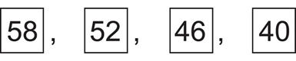
  - Are the numbers getting bigger? No. If the numbers are getting smaller, the pattern might be to take away a number. I need to find the difference between two numbers in the pattern.
  - Two of the numbers are 46 and 40. The difference is 6. Is the difference between 58 and 52, 6? Yes. The pattern is going down by 6 each time.

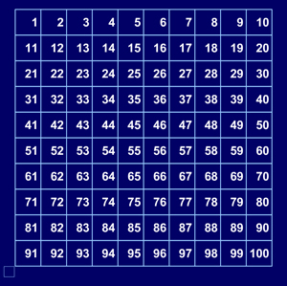

Click here to use the number grid to investigate patterns on the hundreds chart.
- Say: This question asks about a pattern. Can you see what has happened to get the next number in the pattern?

What number can replace the ? ?

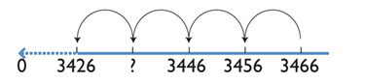
  - Are the numbers getting bigger? Yes. If the numbers are getting bigger the pattern might be to add a number. I need to find the difference between two numbers in the pattern.
  - What is the difference between 3466 and 3456? The 3000 is the same and the 400 is the same. There are two numbers left to compare, 66 and 56. 56 is 10 less than 66.
  - Does 10 less work with the next number? Let's see. 3456 and 3446. 3000 is the same, 400 is the same, then I have 56 and 46. 46 is 10 less than 56. Yes the pattern looks like 10 less.

The teacher continues to work through the ‘think aloud’ strategy with the class to find the missing number.

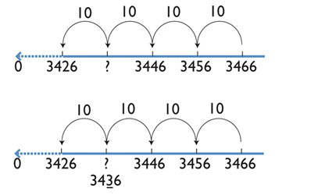

10 less than 46 is 36 and the next number in the pattern is 26, which is 10 less than 36. Therefore the pattern is subtract 10 and the missing number is 3436.

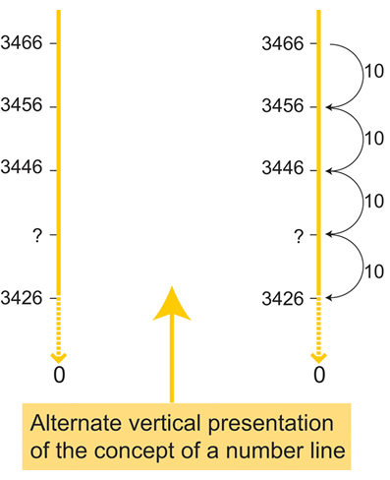
- Students could work in pairs and demonstrate how to use the ‘think aloud’ strategy to find a missing number in this four-digit number pattern involving counting back by 100s.

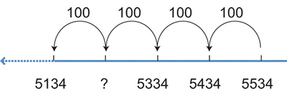
- Provide lots of different examples leading students through the ‘think aloud’ strategy until they can verbalise the process independently.
- Students use the Exploring Patterns Learning Object to explore patterns.This interactive resource generates random number patterns for students to explore, interpret and continue. Instant feedback enables students to correct errors. Included are print activities, solutions and a video which explores patterns in dance.

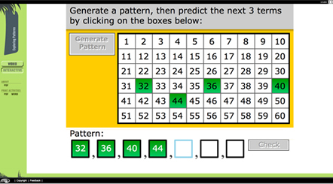
- Number Patterns- Activities from NSW DET K-6 Mathematics Programming Support

Generating and investigating multiples sequences
Students use a variety of materials such as pop sticks, hundreds charts and the constant function on a calculator to investigate and record patterns for threes, fours, sixes, sevens, eights and nines. (pp 71 - 74 Talking about Patterns and Algebra)

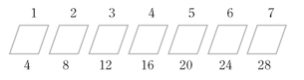

Exploring patterns with pattern blocks
Students use pattern blocks to explore patterns for threes (triangles), fours (squares) and sixes (hexagons). Ask questions such as: If I had 80 popsticks, how many rhombuses could I make?
Investigating sequences of multiples
Look for patterns in sequences of multiples. (pp 75 - 76 Talking about Patterns and Algebra)

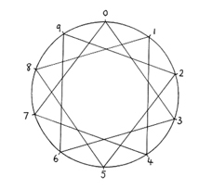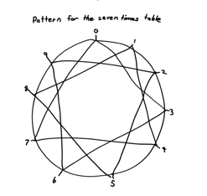

view and print
num_wheel notebook

Online resources

Teacher resources

Nrich website:
Maths Problems: Patterns activities for Stage 2
nrich.maths.org/public/search

Curriculum Support

ebook or pdf document Talking About Patterns and Algebra, Curriculum K–12 Directorate, NSW Department of Education and Training, 2005

Interactive Whiteboard Activities

A teaching tool to help with number sequences which go up or down. The counting sticks are either vertical or horizontal.

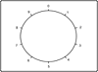

Student resources

www.learnalberta.ca/content...patterns/patternsInteractive

…………………………………………………………………………….
Supporting Students with Learning Difficulties

Patterns and Algebra – Problem solving

Australian Curriculum Reference: ACMNA060: Describe, continue, and create number patterns resulting from performing addition or subtraction.

NSW Syllabus Reference: MA2-8NA : Generalises properties of odd and even numbers, generates number patterns, and completes simple number sentences by calculating missing values.

NSW Numeracy Continuum Reference:
Aspect 3: Pattern and number Structure – Number Properties.

NSW Literacy Continuum Reference: VOCC10M1: Vocabulary knowledge, Cluster 10, Marker 1: Demonstrates understanding that words can have different meanings in different contexts.

Other Literacy Continuum Markers: SPEC9M4: Aspects of speaking, Cluster 9, Marker 4: Contributes relevant ideas to discussions, asks questions and re-phrases to clarify meaning. WRIC9M4: Aspects of writing, Cluster 9, Marker 4: Structures texts using paragraphs composed of logically grouped sentences that deal with a particular aspect of a topic.

Pose problems based on number patterns; solve a variety of problems using problem – solving strategies, including:
– trial and error;
– drawing a diagram;
– working backwards;
– looking for patterns;
– ask questions about how number patterns have been created and how they can be continued

Strategy

Students can:
- pose problems based on number patterns
- solve a variety of problems using problem-solving strategies, including:
— trial and error
— drawing a diagram
— working backwards
— looking for patterns
- ask questions about how number patterns have been created and how they can be continued

Activities to support the strategy

At this stage, students need to be able express their ideas and understanding by communicating and providing reasons for their thinking. Students are required to be able to use words to describe patterns and apply their knowledge in problem solving situations.

The mathematical language required needs to be modelled by the teacher and students need to be provided with opportunities to talk through their thinking. Students need experiences in both solving problems and posing their own problems.

Using question prompts such as Newman’s prompts
- Read the question
- What is the question asking you to do?
- How are you going to find the answer?
- Do the working out
- Write the answer to the question

At this stage, patterns and algebra problems often involve working backwards, using a process of elimination, trial and error and using inverse operations. These strategies need to be explicitly taught to students. The problems below provide students with opportunities to explore these problem solving strategies and share their strategies with others.

For further information on Newman’s Error Analysis click on this link NSW DEC Curriculum Support website.

Activity 1 – Elimination

Bronte is thinking of a number.
The number is less than 12.
When the number is divided by 2 the answer is an odd number.
When it is divided by 3 the answer is an even number.
What number is Bronte thinking of?

Use the Newman’s prompts (listed above) as a whole class to model how to start thinking about solving the problem.
When you reach questions 3 and 4 that deal with how to work the problem out, ask students what problem solving approach they might take. Some may suggest guess, or trial and error. Discuss with the students how they could use the process of elimination to assist in solving this problem.
“We know the number is less than 12, let’s write those numbers on the board.
It says the number can be divided by 2, let’s circle all those numbers and eliminate (cross out) the others.
It says the number can be divided by 3, out of the numbers we already have circled, which one(s) can also be divided by 3.
That only leaves 6.
Let’s test the number 6 to make sure we are correct.
When we divide 6 by 2, is the answer odd? Yes.
When we divide 6 by 3, is the answer even? Yes.
6 is our answer.”

Activity 2 – Working Backwards

Ben started with a number.
He added 3 to it.
He doubled the answer, then subtracted 4.
He then had 26.
What number did Ben start with?

Use the Newman’s prompts (listed above) as a whole class to model how to start thinking about solving the problem.
When you reach questions 3 and 4 that deal with how to work the problem out, ask students what problem solving approach they might take. Some may suggest guess, or trial and error. Present the information from the question stem in number sentence form.

Introduce students to the process of working backwards. If we start on the right with the number we know, 26. We can then do each process in reverse, using the opposite operation, to find Ben’s starting number. Work with the students to solve the problem, 26 + 4 = 30 ÷ 2 = 15 – 3 = 12. Ben’s number was 12.

Activity 3 – Looking for a pattern

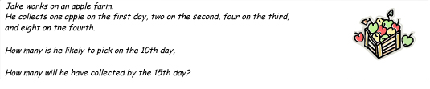

Use the Newman’s prompts (listed above) as a whole class to model how to start thinking about solving the problem. Continue with the same process as before, only this time introduce students to the strategy of looking for a pattern.

Next Steps
Provide lots of different examples where students can talk through the different problem solving strategies they could use. Past NAPLAN papers provide teachers with a good bank of questions to use for this process.
Always ask students if there is another way to solve the problem. Some strategies may be more efficient than others or may be more appropriate, either way; students need to develop a bank of problem solving strategies to use.

Online resources

Nrich website
Maths Problems: Patterns activities for Stage 2
nrich.maths.org/public/search

Back to top
© Learning, High Performance and Accountability Directorate 2014

STAGE 3

Number Sentences

Australian Curriculum Reference: ACMNA133: Continue and create sequences involving whole numbers, fractions and decimals. Describe the rule used to create the sequence .

NSW Syllabus Reference: MA3-8NA: Analyses and creates geometric and number patterns , constructs and completes number sentences

NSW Numeracy Continuum Reference:
Aspect 3: Patterns and number Structure – Number Properties.

NSW Literacy Continuum Reference: VOCC11M2: Vocabulary knowledge, Cluster 11, Marker 2: Demonstrates understanding of new words for new concepts.

Other Literacy Continuum Markers: SPEC11M5: Aspects of speaking, Cluster 11, Marker 5: Uses active listening strategies such as rephrasing ideas and clarifying and repairing breakdowns in communication. WRIC11M5: Aspects of writing, Cluster 11, Marker 5: Selects appropriate language for purpose, e.g. descriptive, persuasive, topic, technical, evaluative, emotive, and colloquial.

Complete number sentences involving missing numbers or missing operations; use inverse operations to solve number sentences

Strategy

Students can:
- complete number sentences involving missing numbers or missing operations
- use inverse operations to solve number sentences

Activities to support the strategy

At this Stage, students will typically use trial-and-error methods to find solutions to number sentences. They need to be encouraged to work backwards and to describe the processes using inverse operations. Students need to be able to justify their solutions and communicate their strategies using mathematical language.

Activity 1– Inverse operations
- Pose this problem for students to solve: I am thinking of a number. When I take 9 away from the number my answer is 19. What number am I thinking of?

Students discuss and write a number sentence that could solve the problem. Compare responses. Determine that the number sentence could be either addition or subtraction, e.g.

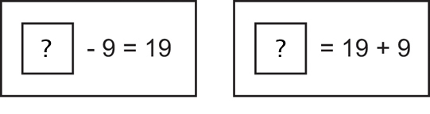

Discuss what is meant by inverse operations.
- Demonstrate how to complete a number of calculations working backwards. Talk aloud the strategy using mathematical language and point out the inverse operations being used.

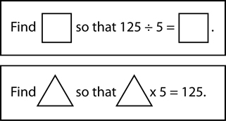
- Students complete number sentences where the operation sign is missing, e.g.

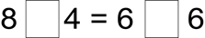

Activity 2 - Missing numbers

Students complete number sentences by finding a missing number, e.g.

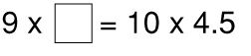

Students write similar problems for their partner to complete.
Ask students to verbalise strategies they know which would help them solve the calculations.
In groups, have students explain the processes they used to solve the number sentences.

Activity 3 – What kind of calculation do you get?

Access the Red dragonfly mathematics challenge intranet version of the book www.curriculumsupport.education.nsw.gov.au/secondary/mathematics/resources/index

Open the challenge titled What kind of calculation do you get? (2)

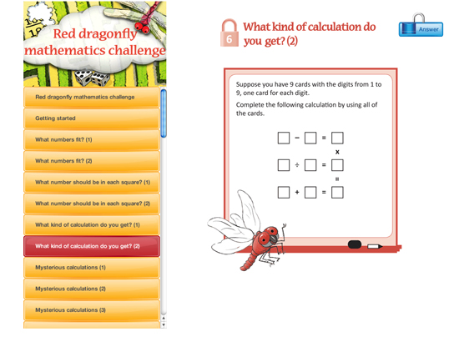

Have students work in pairs to solve the equations.

Students then share their strategies with the class.

Note: NSW DEC intranet only (Resources can be purchased from NSW DEC Curriculum Support)

Activity 4 – number sentences

Complete the following activities from pdf Talking About Patterns and Algebra

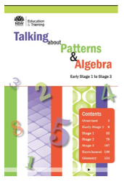
- Completing Number Sentences pp.131–134
  - Incomplete number sentences
  - Find the hidden numbers
- Lesson Breakers p. 135
  - Incomplete number sentence
  - Problem sentences

Note: NSW DEC intranet only (Resources can be purchased from NSW DEC Curriculum Support)

Activity 5 – Equations and Expressions

Students use the Noodle Learning Object to explore algebra. This interactive resource explores and interprets word problems by evaluating expressions and solving equations in different contexts. Included are print activities, solutions, learning strategies, and a board game.

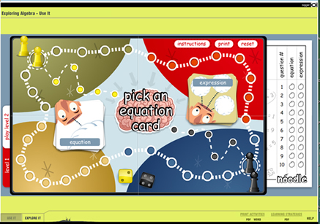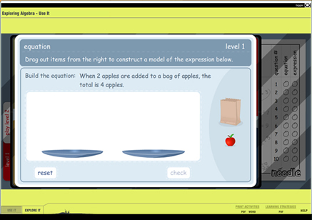

Online resources

Nrich website

Getting the balance
Think of two numbers
Which symbol?
Your number is…

Curriculum Support (NSW DEC intranet only)

Ebook and/or pdf Talking About Patterns and Algebra, downloadable from Curriculum K–12 Directorate, NSW Department of Education and Training, 2005
www.curriculumsupport.education.nsw.gov.au/primary/mathematics/resources/patterns/index

Curriculum Support website
www.curriculumsupport.education.nsw.gov.au/secondary/mathematics/years7_10/teaching/algebra

Student resources

Noodle Learning Object

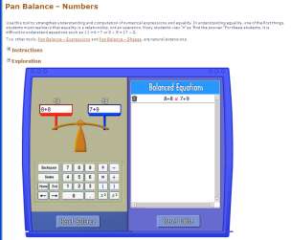

illuminations.nctm.org/ActivityDetail

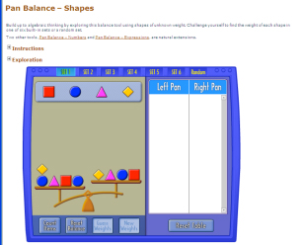

illuminations.nctm.org/ActivityDetail

Numeracy Apps

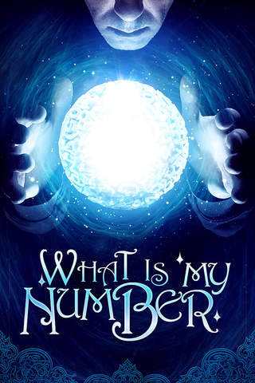What is My Number? Pick a number… ANY NUMBER!!!
What is My Number will do a few calculations and… VOILA!
Your number will magically appear!.

Back to top
© Learning, High Performance and Accountability Directorate 2014
STAGE 4
RATIO and RATES

