SMART

(School Measurement,Assessment and Reporting Toolkit)

The following teaching strategies can assist children meet outcomes in the content areas of:

Number and Algebra

Measurement and Geometry

Statistics and Probability

For syllabus details and specific outcomes click here

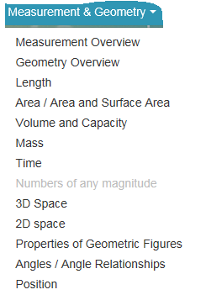
……………………………………………………………………………
MEASUREMENT

Measurement
Measurement enables the identification and quantification of attributes of objects so that they can be compared and ordered.
In this strand, each attribute is developed by the identification of the attribute and comparison of objects, the use of informal units, the use of formal units, as well as consideration of applications and generalisations.
In the primary curriculum students need to be able to select and use appropriate units and measuring tools, and to calculate length, area, volume, mass and time given particular information.
In the secondary curriculum students will continue to develop knowledge, skills and understanding in identifying and quantifying the attributes of shapes and objects and applying measurement strategies.
Teaching Strategies for this strand include a range of engaging interactive activities for Early Stage 1 to Stage 5 to support the development of skills in this strand.
Teachers may adapt many of these resources to suit specific needs.
Space and Geometry is the study of spatial forms. It involves representation of shape, size, pattern, position and movement of objects in the three-dimensional world, or in the mind of the learner.
In the primary curriculum students learn to recognise, visualise and draw shapes, and describe the features and properties of three- dimensional objects and two-dimensional shapes in static and dynamic situations.
In the secondary curriculum students will continue to develop knowledge, skills and understanding in spatial visualisation and geometric reasoning.
Teaching Strategies for this strand include a range of engaging interactive activities for stages ES1 to 5 to support the development of skills in this strand. Teachers may adapt many of these resources to suit specific needs.

Space and Geometry
Space and Geometry is the study of spatial forms. It involves representation of shape, size, pattern, position and movement of objects in the three-dimensional world, or in the mind of the learner.
In the primary curriculum students learn to recognise, visualise and draw shapes, and describe the features and properties of three-dimensional objects and two-dimensional shapes in static and dynamic situations.
In the secondary curriculum students will continue to develop knowledge, skills and understanding in spatial visualisation and geometric reasoning.
Teaching Strategies for this strand include a range of engaging interactive activities for stages ES1 to 5 to support the development of skills in this strand.
Teachers may adapt many of these resources to suit specific needs

Early Stage 1

Measurement: Length: Taller/shorter and Near/Far

Australian Curriculum Reference: ACMMG006: Use direct and indirect comparisons to decide which is longer, and explain their reasoning using everyday language

NSW Syllabus Reference: Mae-9MG: Length: use everyday language to describe length, eg long, short, high, tall, low; use everyday language to describe distance, eg near, far, nearer, further, closer; use comparative language to describe length, eg longer, higher, taller than, shortest, lower than, longest, the same as; Identifies an object that is longer or shorter than another, eg 'Find an object longer than this pencil' (Communicating)

Links to other curriculum areas: HSIE (mapping)

Use comparative language to describe length; Compare lengths by direct comparison; Describe distance using every day language; Use direct and indirect comparisons and explain their reasoning

Strategy

Students can:
- Use comparative language to describe length
- Compare lengths by direct comparison
- Describe distance using every day language
- Use direct and indirect comparisons and explain their reasoning

Activities to support the strategy

At this Stage students need hands on experiences with comparing length and distances of familiar objects and in familiar locations. Students need to fist explore comparing items directly where they can pick up both items to compare them. They also need to have experiences with indirect comparison, i.e. two lines drawn on the floor that cannot be moved. This develops their visualisation of length and distance e.g. ‘I think the red line is longer than the blue line because if I imagine putting the blue line on top of the red one, there is a bit left over’

Activity 1

Am I taller or shorter?

Students move independently around the classroom and identify three objects that are taller than or shorter than themselves. Record by drawing and labelling.
Alternatively, students choose a referent such as their desk and find three things that are shorter than, longer than, higher than their desk.

This activity is from the DEC resource Teaching Measurement Early Stage 1 and Stage 1 book (page 24)

Activity 2

Who’s closer, who’s further?

Students stand and position themselves around the classroom. The teacher stands in the middle of the classroom and asks students Who is closer to me? Ben or Jake? A student is selected and answers e.g. ‘Ben is closer to you and Jake is further away’. The teacher can then ask the student to explain their thinking.

Alternately, the teacher stands in the middle of the classroom and asks students to make up sentences to describe the distance between two students e.g. ‘Billy is the furthest away from Talia.’ When asked to explain why e.g. ‘…because Billy is in the very back corner of the room and Talia is at the front’.

Activity 3

Distance Activities

Provide students with a map of the classroom. Ask students to draw different objects. e.g.
Draw a chair near the teachers’ desk
Draw yourself far away from the classroom door
Draw a book close to the reading corner

Provide students with a sheet of paper and cut out pictures of items/ objects from your classroom (e.g. a picture of a desk, a chair, a bookcase, a door a window, a student).

Ask students to paste the pictures on the paper wherever they like. Then ask the students to write a sentence about the distance between two of the pictures.

Sentence starters may assist the students:
The chair is furthest away from the…
The student is closest to the…
The chair is closer to the… than the …

Students could also verbally answer questions like:
What is closest to the window?
What is further away from the bookcase- the chair or the student?

Online resources

Making Trains

Making Sticks

Sites2See – Measurement for Primary

STAGE 1

Measurement – Length

Australian Curriculum Reference: ACMMG061: Measure, order and compare objects using familiar metric units of length, mass and capacity

NSW Syllabus Reference: MA1-9MG: Measures,records, compares and estimates lengths and distances using uniform informal units, metres and centimetres

NSW Numeracy Continuum Reference:
Aspect 7: Unit structure of length, area and volume – Iterates the unit (Uses a single unit repeatedly to measure).

NSW Literacy Continuum Reference: VOCC5M4: Vocabulary knowledge, Cluster 5, Marker 4: Understands that changing words in a text can alter the meaning.

Other Literacy Continuum Markers: WRIC5M2: Aspects of writing, Cluster 5, Marker 2: Engages in the joint production of texts using a variety of mediums, e.g. podcasts, digital stories. WRIC5M7: Aspects of writing, Cluster 5, Marker 7: Uses a range of adjectives to provide more information about nouns.

Measure lengths using a one metre measure; count the number of informal units needed to equal one metre; measure lengths using a ten centimetre measure

Strategy

Students can:
- measure lengths using a one metre measure
- count the number of informal units needed to equal one metre
- measure lengths using a ten centimetre measure

Activities to support the strategy

Activity 1 – Estimating one metre

Have students visualise how long a metre is. Ask How long is a metre?
- Is it longer than a bed?
- Is it longer than a pencil?
- Is it longer than a garden hose?
- Is it longer than a desk?
- Is it longer than a cricket bat?

Students cut a piece of string one metre long. They look at how long the one metre piece of string or a one metre ruler is.

Students make a collection of objects around the classroom and in the playground that they estimate to be
- less than one metre
- about one metre
- more than one metre along any side.

They use their one metre string to measure the length or width of each object. They choose some of these objects and make a poster by drawing the objects in the correct column.

For example:
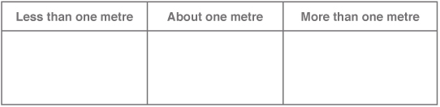

view and print

Discuss as a class:
• Is one metre always a straight line?

Activity 2 – How many objects in a metre?

Display a variety of objects that are less than one metre in length. e.g. a pencil, an exercise book, a school shoe, a CD.

Students in pairs discuss how many of each item listed will fit along a one metre length of string. Students write their estimate in a table then check their estimate by placing a number of each object end to end, along the string, without gaps or overlaps.

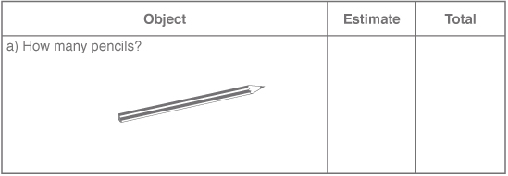

view and print

Activity 3 – Lengths and Distances in metres (m)

Students in pairs estimate the length and distances in the table. They then use a metre ruler or one metre length of string to measure these lengths and distances. Students write the measurement in metres, by using the abbreviation, m.

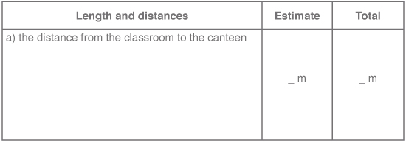

view and print

The first seven lengths and distances which are provided in the table are:
- the distance from the classroom to the canteen
- the height of the doorway in the classroom
- the height of a bookcase or shelves
- the length of a whiteboard/blackboard
- the length of the classroom
- your height
- the height of an adult.

Each pair of students can choose three other lengths to estimate and measure.

After measuring, students report back to the class and compare their results to other pairs of students.

Activity 4 – Metres or centimetres?

Students are shown a variety of cards with drawings of different objects. They decide the most appropriate unit of measurement for these objects.
- The objects that would be measured in centimetres should be placed in one group labelled 'cm'.
- The objects that would be measured in metres should be placed in another group labelled 'm'.

As a class, discuss the answers. Are there objects that could be measured in centimetres and also in metres?

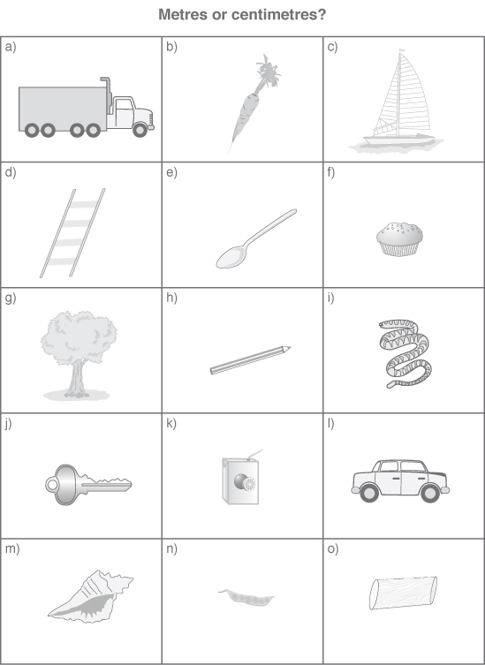

view and print

Activity 5 – Estimating ten centimetres

Students cut out a 10 centimetre measure from paper or ribbon. Fold the paper or ribbon into ten equal pieces, so they can use it to measure.

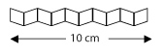
- Give students a worksheet with a variety of lines drawn which are less than 10 cm long. They measure the length of each line using their 10 cm measure and write the measurement at the end of each line.

Make sure students place the beginning of the measure at the beginning of each line.

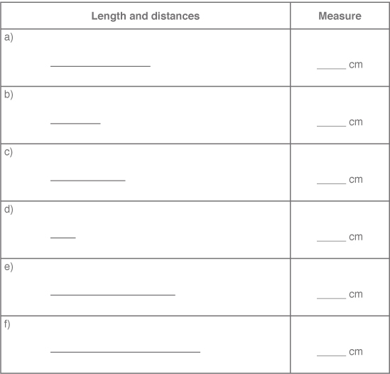

view and print
- Students use their one metre length of string from Activity 1 and cut the metre length of string into pieces that are 10 cm long. Paper streamer or newspaper strips that are one metre long could also be used. Students count the number of 10 cm pieces they cut and fill in the table.

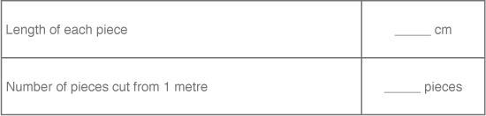

Place the pieces end to end in front of you.

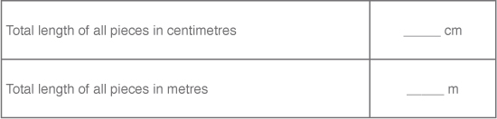

Students complete the following sentences.

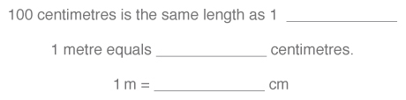

view and print

Arrange the 10 pieces in a different way so they touch but are no longer in a straight line. Try other arrangements.
Discuss:
  - Is the total length of all pieces still 100 cm or 1 m?
  - Does changing the arrangement of the 10 pieces change the total length used? Give your reasons.
  - Why do we need to use centimetres or metres to measure objects?

Online resources

Teacher resources

Curriculum Support

Who has the biggest head?

Lesson Plans

Schools Net

Student resources

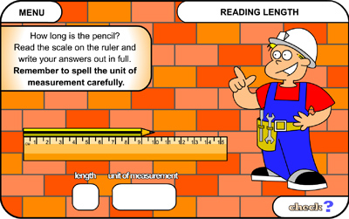

Reading length

STAGE 2

Measurement – Length – Scaled number lines and Temperature

Australian Curriculum Reference: ACMMG084: Use scaled instruments to measure and compare temperatures

NSW Syllabus Reference: MA2-9MG: use a thermometer to measure and compare temperatures to the nearest degree Celsius

Links to other curriculum areas: Science and Technology and HSIE

Read a vertical number line; Recognise and read a many-to-one number line; Read a thermometer; Use the markers on a drawn number line to read a numerical value

Strategy

Students can:
- Read a vertical number line
- Recognise and read a many-to-one number line
- Read a thermometer
- Use the markers on a drawn number line to read a numerical value

Activities to support the strategy

In Stage 2 students are now introduced to temperature and using a scaled instrument in Length. For students to be able to read a scaled thermometer they need to have experience with using a real thermometer for many investigations (including thermometers with various many-to-one scaling). These conceptual understandings are built on from Stage 1 where students are required to use place value knowledge to order numbers on a number line and to use number lines with various numbers visible. This concept is then extended also into Stage 3 where students use a many-to-one scale on the x-axis and y-axis in Data for creating line and column graphs.

Activity 1

Reading Number lines

Provide students with a range of number lines with many-to-one correspondence. This could be commercially made number lines, tape measures, 30 cm rulers, 1 m ruler, number lines students create or some the teacher creates for the task (some with each incremental mark equalling one, two, five and 10)

Ask students to find the same specific number on each number line e.g. find the number 7.
Where is it?
How did you work out where it would be?
Did you use any other numbers/markers near the number?
Is there a marker for number seven at all?
How come they are at different point along each of our example number lines?
Why do you think some number lines use a different scale?

Follow on from this activity by allowing students to make a number line with different many-to-one values.

Activity 2

Telling the temperature

Find a thermometer that has a clear scale (preferably one with only degrees Celsius).
Have a class discussion about what the instrument is, what is it used for, how do we read it?
This may prompt a discussion on negative numbers as well. How do we use the thermometer to measure temperature?

Spend time each day checking the thermometer and recording the temperature. Provide students with investigations around using the thermometer and recording their findings as part of a mathematics lesson or unit of learning.

Additional resources

Temperature Activity (from Sample Units of Work book, 2002 K-6 Mathematics syllabus)

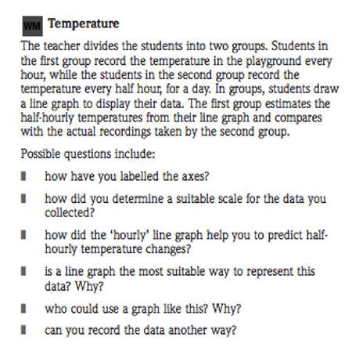

Online resources

Teacher resources

In Order

The BOM census at school website provides classroom teachers with up to date and relevant data to use in lessons. Search here for data on temperature.
Census at school

Murder under the Microscope – Water temperature.pdf

Asia education – Volume, temperature and curious units

Numeracy App

Temperature nearby (ipad app)
STAGE 3

Measurement – Length – metric units

Australian Curriculum Reference: ACMMG135: Connect decimal representations to the metric system

NSW Syllabus Reference: MA3-9MG: Selects and uses the appropriate unit and device to measure lengths and distances, calculates perimeters, and converts between units of length.

NSW Literacy Continuum Reference: VOCC11M3: Vocabulary knowledge, Cluster 11, Marker 3: Applies knowledge of prefixes and suffixes to understand the meanings of new words and to create new words.

Other Literacy Continuum Markers: WRIC11M8: Aspects of writing, Cluster 11, Marker 8: Applies knowledge of generalisations, meanings of base words and word parts (prefixes and suffixes) to spell new words.

Use a ruler and other measuring devices to measure lengths in metres, centimetres and millimetres; record lengths in decimal notation

Strategy

Students can:
- use a ruler and other measuring devices to measure lengths in metres, centimetres and millimetres
- record lengths in decimal notation

Activities to support the strategy
- Introduce key vocabulary for metric conversions of length. Write the following prefixes on the board:

milli – thousandth of

centi – hundredth of

kilo – 1000 wholes

Tell the students that these are prefixes used in the metric system when working with measurement. They tell us how much of something we have. The prefixes milli and centi tell us there is less than one whole.
  - milli means a thousandth of.
  - centi means a hundredth of.
  - kilo means 1000 wholes. A kilometre equals 1000 metres.
- A basic procedure can be used to introduce each of the units of measurement and the process for converting units.
  - Tell the function of the specific unit. For example, metres tell us how long something is. We use millimetres to measure objects that are not very big, centimetres to measure things that are medium sized and metres to measure objects which are big.
  - Use concrete demonstrations of equivalencies in capacity, length and mass to illustrate each unit.
  - Demonstrate how to use measuring tools, measuring to the nearest whole unit.
  - Provide exercises which require students to determine the appropriate tool to use when measuring an object. Ask questions such as: What unit would we use to tell how long a pencil is? What unit would we use to measure how much juice we should give to the baby?
  - Present equivalency facts, such as 10 millimetres equal one centimetre. This step should make links between units from all types of measures. Use an Equivalency Cue Card to support students while working on equivalency problems and to aid memory.

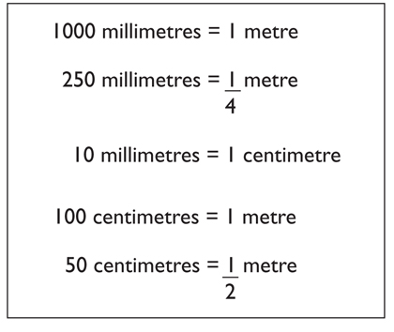

view and print
- Students work in pairs or small groups to find out the length of a piece of string.

Each group is given a ball of string or wool. Discuss strategies that could be used for finding out the total length, then use one of these strategies to determine the approximate length. Students record their measurement using the most appropriate units.

Each group reports back to the class and describes:
  - the strategies they discussed which could be used to measure the length
  - the process they used to measure the length
  - what the actual length was and why they chose this unit to measure
  - what other units could be used to record the length.
- Record the lengths of string for each group on the board. Students in groups discuss how their length can be converted to a different unit. Challenge groups to identify as many ways as possible, using combinations of km, m, cm and mm. Ask each group to report back to the class and explain the different ways, e.g. if a group recorded the length as 157 metres, it could be written as 0.157 km, 15 700 cm, etc.
- In a class discussion ask students to explain the relationship between the size of a unit and the number of units needed, e.g. more metres than kilometres will be needed to measure the same distance. Students explain how they would estimate 1 km using familiar objects.
  - How many 50 m Olympic swimming pools placed end-to-end would make a distance of 1 km?
  - How many desks placed end-to-end would make a distance of 1 km?

Students record measurements and their calculations.

Online resources

Numeracy Wrap

The long and the short – Students can measure objects of different length in centimetres and millimetres, order lengths from shortest to longest, convert between millimetres, centimetres, metres and kilometres.

Lesson Plans and Activities

www.primaryresources.co.uk/maths/mathsE1
onlineintervention.funbrain.com/measure/index

Back to top
© Learning, High Performance and Accountability Directorate 2014

Measurement – Length – Perimeter

Australian Curriculum Reference: ACMMG109: Calculate the perimeters of rectangles using familiar metric units and use the term 'dimensions' to describe the 'lengths' and 'widths' of rectangles

NSW Syllabus Reference: MA3-9MG: Selects and uses the appropriate unit and device to measure lengths and distances, calculates perimeters, and converts between units of length.

Use a ruler and other measuring devices to measure lengths in metres, centimetres and millimetres; record lengths in decimal notation

Strategy

Students can:
- use a ruler and other measuring devices to measure lengths in metres, centimetres and millimetres
- record lengths in decimal notation

Activities to support the strategy

Activity 1
- Students in stages 1 and 2 can use informal units to measure around various shapes
- Discuss the word perimeter. ‘Perimeter’ is derived from the Greek words that mean to measure around the outside: peri meaning ‘around’ and metron meaning ‘measure’. (P219 Numeracy K-6)
- Students are given a worksheet with a variety of drawings of squares, rectangles and triangles. Calculate and record the perimeter of each shape.

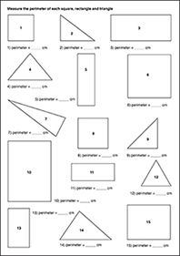

view and print
- Discuss the strategies students used by asking these questions.
  - How did you calculate the perimeter of each shape?
  - Is there an easy way to calculate the perimeter of squares and rectangles?
  - Is there an easy way to calculate the perimeter of different types of triangles?

Activity 2

Students measure the perimeter of objects in their surroundings, such as books, desks, windows, classroom floor, oval or playground. Students choose an appropriate measuring device and measurement unit, justifying which measuring tool would be most suitable to measure different objects, e.g. a trundle wheel for larger areas or ruler or tape measure for tables.

Discuss and compare the strategies students used to calculate the perimeter, then students write a report to explain their strategies.

Where students had different perimeters recorded for the same object, determine the difference and discuss where the measurement error may have occurred.

Activity 3

Using centicubes, students construct squares and rectangles of given perimeters, e.g. 24 cm.

Discuss:
- How many different rectangles can you make with a perimeter of 24 cm? Students make a list of the dimensions of each.
- Can you make different squares with a perimeter of 24 cm? Students give reasons to support their answer.
- Can you change one of the rectangles to make a different polygon but with the same perimeter?

Activity 4

View the video Exploring Area and Perimeter at www.learnalberta.ca. This brief video highlights the role that maths plays on a farm by exploring rectangles of various sizes to determine the perimeter and area of paddocks.

In the Exploring Area and Perimeter Learning Object, students can manipulate the dimensions of rectangles and squares to obtain a target perimeter and area. Print activities are included.

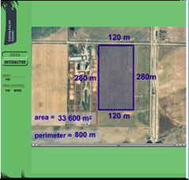

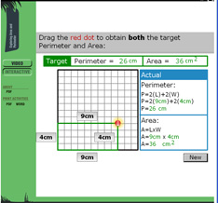

Online resources

Teacher resources

Numeracy Wrap

Round the outside – Students can calculate the perimeter of different shapes, choose the appropriate measuring device and make different shapes from given perimeters.

Math Interactives

Exploring Area and Perimeter

Student resources

www.funbrain.com

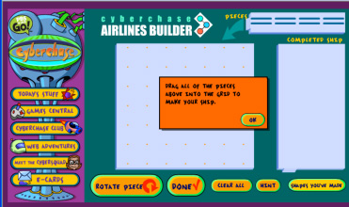

pbskids.org/cyberchase/games/perimeterarea/perimeterarea

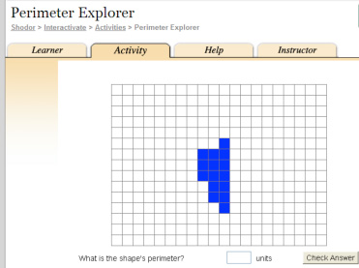

www.shodor.org/interactivate/activities/PerimeterExplorer

primaryhomeworkhelp.co.uk/maths/measures/measure

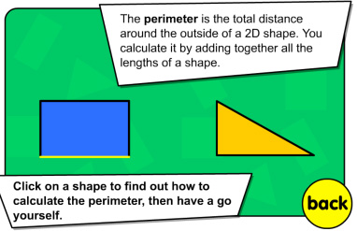

www.bgfl.org/bgfl/custom/resources_ftp/client_ftp/ks2/maths/perimeter_and_area/index
Stage 1

Measurement – Area

Australian Curriculum Reference: ACMMG037: Compare and order several shapes and objects based on length, area, volume and capacity using appropriate uniform informal units

NSW Syllabus Reference: MA1-10MG: Measures, records, compares and estimates areas using uniform and informal units.

NSW Numeracy Continuum Reference:
Aspect 7: Unit structure of length, area and volume – Iterates the unit (Uses a single unit repeatedly to measure).

NSW Literacy Continuum Reference: VOCC5M1: Vocabulary knowledge, Cluster 5, Marker 1: Uses knowledge and understanding of topic words when reading, writing and speaking.

Other Literacy Continuum Markers: WRIC5M1: Aspects of writing, Cluster 5, Marker 1: Selects vocabulary and phrases modelled by the teacher during whole class planning to construct own text.

Measure area by placing identical informal units in rows or columns without gaps or overlaps; estimate the size of a given area in square units

Strategy

Students can:
- measure area by placing identical informal units in rows or columns without gaps or overlaps
- estimate the size of a given area in square units

Activities to support the strategy

At this Stage, students develop an awareness of what area is and some of the language used to describe area.

Students develop an awareness of the attribute of area through covering activities, colouring in and as comparisons of area are made.
- Provide students with a collection of shapes or pattern blocks, some which will tessellate and some which will not. Examples include squares, rectangles, triangles and circles. Students choose the best shape to cover a given area, e.g. a piece of cardboard or a book, so there are no gaps or overlaps. Students draw the shape they used. They explain why it was the best shape and describe how the given area was covered.
- Students use identical square units to make a larger shape of a given area, e.g. students use identical squares to make:
  - a square that is 16 square units
  - a rectangle that is 20 square units.

Students describe how they arranged the square units to make the larger area and compare their solutions to other students.

Teacher draws all the different solutions on the whiteboard. For example:

Area of 20 square units

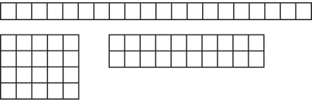

Repeat for a different number of square units, but this time students have to think of and list all the possible solutions.

Discuss: If I use the same number but smaller square units, will the total area be the same size?
- Students estimate how many identical cardboard tiles will cover a given rectangle or square. Check their estimate by covering the shape with tiles. Record the tessellation by tracing or marking.
- Teacher covers a large rectangle with tiles in rows and columns. Students determine the area of the rectangle in square units. Teacher removes some of the tiles and asks, What is the area of the rectangle now covered by tiles? Remove more tiles. What is the area now?
- Show students a rectangle that is partly covered with tiles (e.g. one row and one column). Ask: How many tiles would completely cover this rectangle? How did you work out your answer? Encourage students to visualise the completed grid, rather than draw the grid lines.

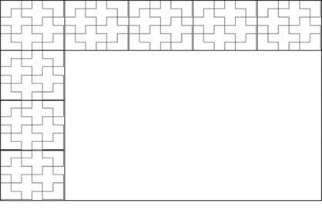

view and print
- Provide students with coloured geometric squares, both plain and patterned. Ask students to select a plain square as the base for their work and some patterned squares.

Students position the squares next to each other so that they create a tessellating shape. The squares are glued into place. Calculate the total area in square units.This activity could follow the theme of making a patchwork quilt.

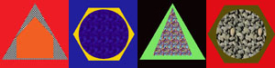

Online resources

Teacher resources

Tile Activity
www.curriculumsupport.education.nsw.gov.au/countmein/children_tiler

Geoboard
www.curriculumsupport.education.nsw.gov.au/countmein/children_geoboard

Different Sizes
nrich.maths.org

Calculating area by counting squares
www.schoolsnet.com/pls/hot_school/sn_primary.page_pls_resource_detail
Stage 2

Measurement – Volume and Capacity

Australian Curriculum Reference: ACMMG084: Use scaled instruments to measure and compare lengths, masses, capacities and; temperatures

NSW Syllabus Reference: MA2-11MG: Measures, records, compares and estimates volumes and capacities using litres, millilitres and cubic centimetres.

NSW Numeracy Continuum Reference:
Aspect 7: Unit structure of length, area and volume – Repeated Layers.

NSW Literacy Continuum Reference: REAC10M4: Reading texts, Cluster 10, Marker 4: Uses topic knowledge, vocabulary knowledge and context to read unknown words when engaging with subject texts.

Other Literacy Continuum Markers: VOCC10M2: Vocabulary knowledge, Cluster 10, Marker 2: Demonstrates expanded content vocabulary by drawing on a combination of known and new topic knowledge. WRIC9M2: Aspects of writing, Cluster 9, Marker 2: Plans and organises ideas using headings, graphic organisers, questions and mind maps. WRIC9M7: Aspects of writing, Cluster 9, Marker 7: Chooses verbs, adverbials, nouns and adjectivals to express specific ideas and details.

Use a variety of containers to measure capacity; read a scale to determine capacity

Strategy

Students can:
- use a variety of containers to measure capacity
- read a scale to determine capacity

Activities to support the strategy

Activity 1
- The teacher shows students a range of containers with labels that hold different amounts of liquid.

Say:
  - I have a container and I want to know what its capacity is. Capacity means how much it will hold.
  - Capacity is measured in litres or millilitres.
  - Each container has a different capacity. Look at the labels to find out how much each container can hold.
  - Students record list of containers and the capacity of each.
- The teacher provides students with a list of cards with terms related to capacity.

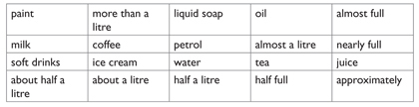

view and print

In groups, students sort the terms into two columns.

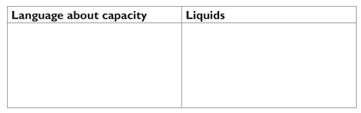

view and print
- The teacher shows students a clearly labelled measuring jug and explains the measuring scales used to determine capacity (e.g. litre, 1 litre, 2 litres).The teacher demonstrates how to measure capacity with the measuring jug by saying, If I pour liquid from this container into the measuring jug, I will know how much it will hold – its capacity! I think (estimate) it holds about (approximately, nearly, almost) 2 litres.
- Estimating and Measuring Capacity:
  - The teacher gives students a set of containers. Students estimate the capacity of each container and record their estimates in a table. After estimating the capacity of each container, students use the measuring jug to find the actual capacity of each container and record it.

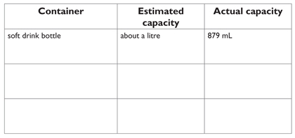

view and print
  - Students are given a variety of unmarked containers of various shapes and sizes. Students then select the container which they think will have a capacity of 1 litre. Students test their prediction by pouring 1 litre of water into the container and record the capacity as being more than, equal to or less than 1 litre.
  - Students collect a variety of containers with a capacity which is marked and less than 1 litre. Students then estimate the number of times this container will have to be filled to equal 1 litre. Students check their estimate by filling and pouring into a 1 litre measuring container.

Activity 2

The teacher provides students with different pictures of measuring containers holding an amount of liquid. Each should have a measuring scale (up to three litres). Students interpret the scale and estimate how much liquid is in each container, using language such as about, half full, about one litre.
- Discuss the gradations on each container. How is the scale recorded, e.g. in 500 mL intervals, 100 mL intervals, 50 mL intervals.

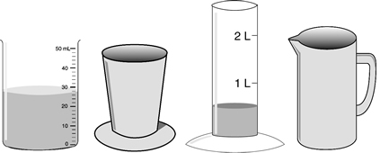

Online resources

Teacher resources

Curriculum Support

Students mark 100 mL gradations on an empty plastic container by pouring water. They use their calibrated container to identify single or multiple objects which displace 100 mL.
Calibrations

Teaching Measurement Stage 2 and Stage 3, NSW Department of Education and Training, 2004, pp 79-109

Lesson Plans and Activities

Students will be able to estimate and measure capacity. Worksheets are included
www.schoolsnet.com

Student resources

www.abc.net.au/countusin/games/game15

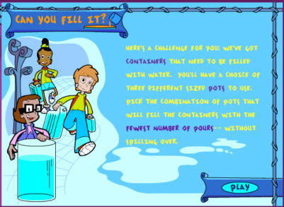
Can you fill it?

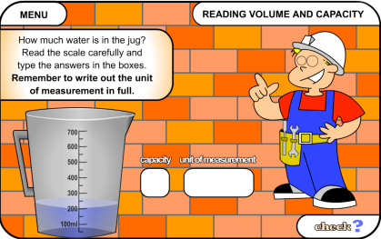
www.bgfl.org/measures
STAGE 3

Measurement – Volume and Capacity

Australian Curriculum Reference: ACMMG108: Choose appropriate units of measurement for length, area, volume, capacity and mass

NSW Syllabus Reference: MA3-11MG: Selects and uses the appropriate unit to estimate, measure and calculate volumes and capacities, and converts between units of capacity

NSW Literacy Continuum Reference: SPEC11M5: Aspects of speaking, Cluster 11, Marker 5: Uses active listening strategies such as rephrasing ideas and clarifying and repairing breakdowns in communication.

Other Literacy Continuum Markers: VOCC11M3: Vocabulary knowledge, Cluster 11, Marker 3: Applies knowledge of prefixes and suffixes to understand the meanings of new words and to create new words.

Determine how many cubes were used in a simple, solid rectangular construction; illustrate two constructions and write how they estimated the number of cubes in each; compare the volumes of the two constructions; discuss the strategies used to calculate the volume of the construction

Strategy

Students can:
- determine how many cubes were used in a simple, solid rectangular construction
- illustrate two constructions and write how they estimated the number of cubes in each
- compare the volumes of the two constructions
- discuss the strategies used to calculate the volume of the construction

Activities to support the strategy
- Students are given a collection of interlocking cubes (centicubes). Ask:
  - How long is the side of each cube?
  - What is the volume of each cube? How did you know?

Students make a rectangular prism using 24 cubes and record the dimensions (length, breadth, height). Determine the volume is 24 cubic units. Look at the relationship between the volume, length, breadth and height.
  - What is the volume of each prism? 24 cubic units/cubic centimetres
  - How can we calculate the volume using the length, breadth and height of the prism?
  - Can you make other rectangular prisms with a volume of 24 cubic units?

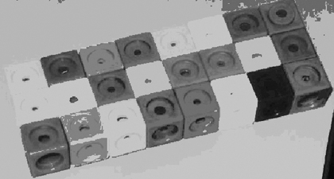

Students attempt to make other prisms, record the results and describe what they notice. Discuss:
  - How is your second prism different from your first prism?
  - How is your second prism similar to your first prism?
  - What is the length, breadth and height of each prism?
  - What generalisations can you make?
  - How do know that you have made all the possible prisms?

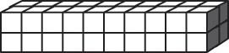

Students draw some of the models they have made.
- Students use centicubes to construct a rectangular prism which is 3 cm long, 2 cm wide and 1 cm high.

Students add more cubes to the prism by following the steps below. After each step they must add the details to the table.
  - What is the volume of the prism? Complete row a) of the table.
  - Add another layer to this prism so the height is now 2 cm. Complete row b) of the table.
  - Add another layer to this prism so the height is now 3 cm. Complete row c) of the table.
  - Repeat with a height of 4 cm. Complete row d) of the table.
  - Repeat with a height of 5 cm. Complete row e) of the table.
  - Students choose their own measurement for the height
and complete row f).

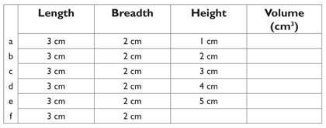

view and print
- Students complete similar tables where they are given two dimensions and the volume of a prism. Students have to calculate the missing dimension, e.g.

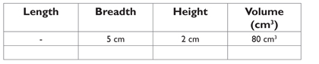
- Provide students with drawings of a variety of rectangular prisms which have the dimensions labelled. Students have to determine the volume of each prism and give reasons for their answer.

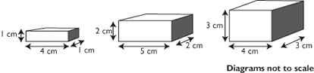
- Exploring higher-order thinking (QTF)

Pose this problem. Imagine a box which is 1 metre long, 1 metre wide and 1 metre high. Ask:
  - What is the volume of the box in cubic metres?
  - What is the volume of the box in cubic centimetres?
  - How did you work out this answer?
  - How many centicubes would be needed to fill the box?

Online resources

Select Capacity/Volume then Volume Visuals (DOC) and Volume (ppt)
www.primaryresources.co.uk/maths/mathsE1

Stage 2

Measurement – Mass

Australian Curriculum Reference: ACMMG084: Use scaled instruments to measure and compare lengths, masses, capacities and; temperatures

NSW Syllabus Reference: MA2-12MG: Measures, records, compares and estimates the masses of objects using kilograms and grams.

NSW Numeracy Continuum Reference:
Aspect 7: Unit structure of length, area and volume – Repeated Layers.

NSW Literacy Continuum Reference: REAC10M4: Reading texts, Cluster 10, Marker 4: Uses topic knowledge, vocabulary knowledge and context to read unknown words when engaging with subject texts.

Other Literacy Continuum Markers: VOCC10M2: Vocabulary knowledge, Cluster 10, Marker 2: Demonstrates expanded content vocabulary by drawing on a combination of known and new topic knowledge. WRIC92: WRIC97:

Compare masses by hefting; measure mass using a variety of scales; measure mass to the nearest 10 grams

Strategy

Students can:
- compare masses by hefting
- measure mass using a variety of scales
- measure mass to the nearest 10 grams

Activities to support the strategy

Activity 1 – Ordering Cupfuls
- Students make a list of objects that they would measure in kilograms which are found:
  - in their kitchen at home
  - in their bedroom
  - in their classroom

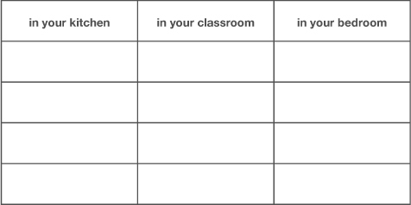

view and print
- Students will investigate the mass of different objects that are less than one kilogram and discover if cupfuls of different materials have the same mass.

Materials:

kitchen scales
plastic bags for measuring
measuring cups
a variety of different materials

Ask students to collect six different materials from around the home and bring to school in different containers. They place the materials in piles on their desk. Suggested materials include flour, rice, beads, sand, small pebbles, cotton wool, leaves, dirt, bark chips.
- Have students fill a cup with the first material, then place the cupful into a plastic bag and tie the bag. Repeat for the other five materials until the students have six bags.
- Students compare two bags at a time by hefting. To do this, choose two bags and hold one in each hand. They decide which bag is the lighter and which bag is the heavier. Then choose another two bags and compare.
- Continue hefting pairs of bags until the students have ordered all the bags from the lightest to the heaviest and recorded the order.

Discuss:
  - What was the order of the materials from the lightest to the heaviest?
  - How do you know which was the heaviest or the lightest material?
  - Did any bags seem to be about the same mass when you hefted? Which ones?
- Students check their estimates by measuring the bags on the kitchen scales. They calculate the mass to the nearest 50 grams and record the results in a table.

For example:

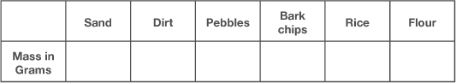

view and print

Ask:
Was there any difference in the order of materials when you hefted and when you measured? Give details.
Each bag contained a cupful. Why did the masses differ if the materials all took up the same space?

Discuss
Which would weigh more - one kilogram of feathers or one kilogram of bricks? Give reasons.

Activity 2 – Using Balance Scales

Discuss what measuring instruments we can use to measure the mass of objects.

Measuring devices may include bathroom scales, kitchen scales and balance scales. Discuss that when using any measuring instrument students must:
- know how to read the scale
- check that the scale is set at zero.

If you only wanted to find out how heavy an object is you could use bathroom scales, kitchen scales, a spring scale or balance scales.

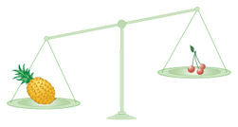

If you wanted to compare two objects to find out which is the heavier you could use balance scales.

On a flat, level surface, such as a table, the teacher places balance scales which are out of balance.

Ask:
Do the two masses on these balance scales weigh the same?
Which is the heavier mass? How do you know?

Activity 3 – Making 100 Grams

Students collect a variety of small objects and estimate how many of each object is needed to equal a mass of 100 grams.

Materials:

balance scales, if you have them, if not, use kitchen scales
weights to balance the scales
objects to weigh e.g. pencils, lego blocks, teaspoons, lollies, erasers, coloured textas, blackboard duster
- Students select one object and compare the mass of the object with a kilogram weight by hefting. They:
  - estimate how many of this object would be needed to equal 100 grams and record their estimate in the table (below).
  - measure and record the actual number of objects using balance scales.

Ensure that students are measuring accurately using the balance scales by following these steps:

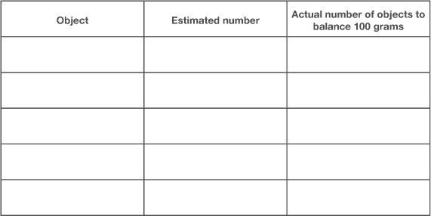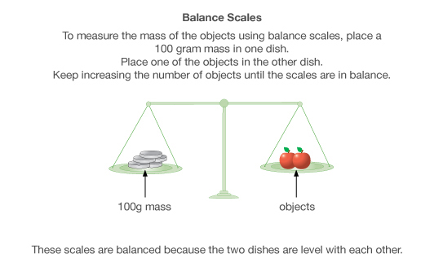

Students use this table to estimate, measure and record the number of objects needed to balance 100 grams.

view and print
- Students choose three different objects from their collection and measure the mass of each object to the nearest 10 grams. They draw or write the objects and record the masses.
- Students could repeat these steps to measure 50 grams.

Activity 4 – "Mass-ive" Model

Materials:

Unifix cubes (or any other interlocking blocks e.g. lego, centicubes)
Kitchen scales or balance scales
- Students build a model using 20 unifix cubes They estimate the mass of their model and record their estimate. Then measure the mass in grams and record in a table.

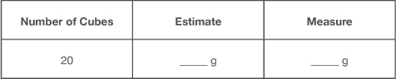

Discuss: Was your estimate close to the actual mass?

Students add more cubes to their model until there are 40 altogether. They estimate the mass, then measure and record the mass in grams. Repeat with 60 cubes and 50 cubes.

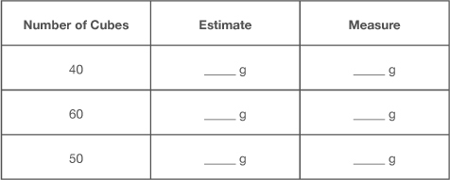

view and print

Using these results students estimate what would be the mass of
  - 100 cubes
  - 200 cubes
  - 400 cubes
  - 1000 cubes
- Students decide on the number of cubes to use and build three more models. They estimate and record the mass of the models in a table.

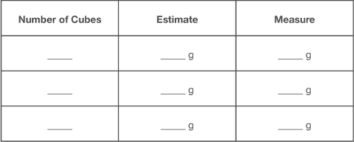

view and print

Discuss:
Were your estimates reasonably accurate?
Did you use other measurements from this activity to help you estimate? Give details.

Activity 5 – Reflecting

Students reflect on the activities they have completed.

Discuss:
Are you close to the correct measure when you estimate mass in kilograms or grams?
Can you accurately measure masses to the nearest 10 grams using balance scales and kitchen scales?
When would you use grams to weigh an object?

Students complete this paragraph to explain what a gram is.

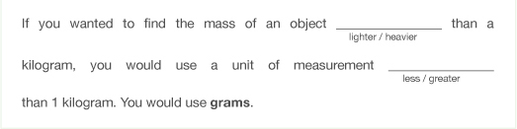

Online resources

Teacher resources

Nrich website activities
Inside Outside
Oranges and Lemons
What’s my weight?
Balance of halves
Pies
Cherry Buns
Weigh to go – (reading article for teachers)

Curriculum Support

www.curriculumsupport.education.nsw.gov.au/primary/mathematics/assets/pdf/stage2/bycupful.pdf
www.curriculumsupport.education.nsw.gov.au/primary/mathematics/assets/pdf/stage2/frtsalad.pdf

Lesson Plans and Activities

www.bbc.co.uk/schools/starship/maths/games/alien_cookbook/small_sound/standard.shtml
www.schoolsnet.com/pls/hot_school/sn_primary.page_pls_unit_detail
www.crickweb.co.uk/assets/resources/flash
www.bbc.co.uk/schools/ks1bitesize/numeracy/measurements/index

Student resources

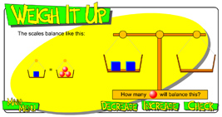

www.bgfl.org/bgfl/custom/resources_ftp/client_ftp/ks2/maths/weigh/index
STAGE 3

Measurement – Mass

Australian Curriculum Reference: ACMMG108: Choose appropriate units of measurement for length, area, volume, capacity and mass

NSW Syllabus Reference: MA3-12MG: Selects and uses the appropriate unit and device to measure the masses of objects and converts between units of mass.

NSW Numeracy Continuum Reference:
Aspect 7: Unit structure of length,area, volume and mass: Repeated layers.

NSW Literacy Continuum Reference: SPEC11M5: Aspects of speaking, Cluster 11, Marker 5: Uses active listening strategies such as rephrasing ideas and clarifying and repairing breakdowns in communication.

Other Literacy Continuum Markers: VOCC11M3: Vocabulary knowledge, Cluster 11, Marker 3: Applies knowledge of prefixes and suffixes to understand the meanings of new words and to create new words.

Measure mass accurately; record mass in grams and kilograms to 3 decimal places; convert between kilograms and grams

Strategy

Students can:
- measure mass accurately
- record mass in grams and kilograms to 3 decimal places
- convert between kilograms and grams

Activities to support the strategy
- Students discuss different ways of recording mass. Complete the table to show equivalence between kilograms and grams.

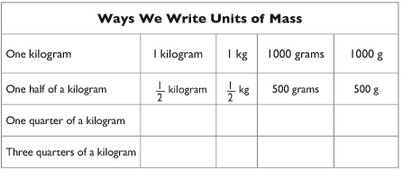

Discuss:

Why is it harder to find examples of the number of grams written in word form? (i.e. too long and unnecessary)

When are kilograms more likely to be used and when are grams more likely to be used?
- Introduce the key vocabulary used in recording metric mass by discussing these prefixes:
milli - thousandth of
centi - hundredth of
kilo - 1000 wholes

These prefixes are used with measurements. They tell us how much of something we have. The prefixes milli and centi tell us there is less than one whole.

Milli means a thousandth of; centi means a hundredth of; kilo means 1000 wholes. A kilometre means 1000 metres and kilogram means 1000 grams.

Use concrete examples of equivalence in mass to illustrate each unit.

Discuss how to convert between kilograms and grams. Students practise converting from grams to kilograms and kilograms to grams.

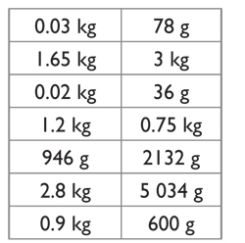

view and print

In pairs, students play 'Top Heavy'.

Prepare a set of cards (see example); each card has a mass written on it in either grams or kilograms. Cards are shuffled and dealt face down to each player. Players each turn over a card; the player who turned over the card with the heavier mass, scores one point.

Play continues until all cards have been played.

The player with the highest score wins the game.
- Students determine the average mass of the lunch eaten by students in the class. Introduce the task by discussing:
  - the strategies the students can use to find the average mass
  - the importance of accuracy when measuring
  - how to convert between kilograms and grams.

Students complete the task by following these steps.
  - Measure and record (in grams) the mass of each item in their lunch box. Find the total number of grams and compare to other students.
  - Divide the class into manageable groups. Group members record the total mass of each student's lunch both in kilograms (recorded to 3 decimal places) and in grams.

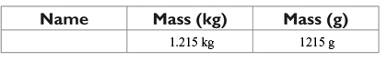

view and print
  - Calculate the average mass of their group's lunches and compare with other groups.

Discuss:
  - Which group had the lightest average mass?
  - Which group had the heaviest average mass?
  - What is the difference between the lightest and heaviest mass?
  - How many 5 kg crates would be needed to carry all the class lunches to the lunch area? How could you work this out?
  - What other questions could we ask to discover more information about our investigation?

Students write a report to explain the strategies they used and the information they discovered.

Present students with other problems which involve converting between kilograms and grams. See Teaching Measurement Stage 2 and Stage 3.

Online resources

Teacher resources

Curriculum Support

Teaching Measurement Stage 2 and Stage 3, NSW Department of Education and Training, 2004, pp 111-139.
Teaching Measurement Stage 2 and Stage 3.pdf

Lesson Plans and Activities

www.teachingmeasures.co.uk/menu

Student resources

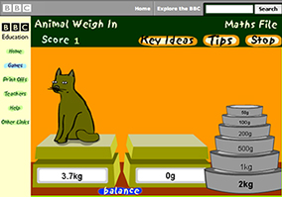

www.bbc.co.uk/education/mathsfile/shockwave/games/animal (requires Shockwave program)

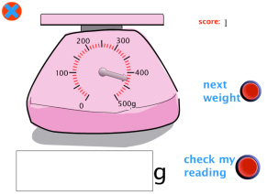

www.ictgames.com/weight
Stage 1

Measurement – Time – Clock

Australian Curriculum Reference: ACMMG020: Tell time to the half – hour. ACMMG039: Tell time to the quarter-hour, using the language of 'past' and 'to'

NSW Syllabus Reference: MA1-13MG: Describes, compares and orders durations of events, and reads half and quarter time.

NSW Literacy Continuum Reference: VOCC5M1: Vocabulary knowledge, Cluster 5, Marker 1: Uses knowledge and understanding of topic words when reading, writing and speaking.

Discriminate and label the long and short hands on a clock; show the direction the hands move; count by fives; read time to the hour and half – hour

Strategy

Students can:
- discriminate and label the long and short hands on a clock
- show the direction the hands move
- count by fives
- read time to the hour and half-hour

Activities to support the strategy
- Use a variety of analogue clock faces to teach students to read the hour. Say When it is 'o'clock' the hour is the number the short hand points to. Give practice by asking: Where is the short hand pointing? So what hour is it?
  - Give example with the short hand on 3. Ask Is the short hour on a number? Answer: Yes. 'What number is it on? Answer: 3. So what hour is it? Answer: It is 3 o'clock.
  - Give non-example with the short hand off the 7. Is the short hand on a number? Answer: No. It is not 7 o'clock.

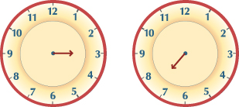
- Say When the time is after the hour (o'clock) the short hand is off the hour. Give multiple opportunities to practise with the short hand on the hour and off the hour.
  - Give example with the short hand after the hour.
Say When the short hand is off a number, look for the last number the short hand pointed to. Find the last number by moving backwards around the clock face to the last number the short hand pointed to. Give multiple demonstrations.
  - Have students discriminate between 'on the hour' and 'after the hour'.
  - Demonstrate conventions for expressing times by listing the alternatives in tables, then ask students to complete missing information in tables, for example:

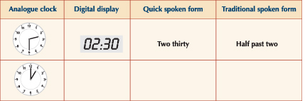

view and print
  - Students are given sets of cards with different ways of telling time. Students work in pairs to match the times shown on the cards.

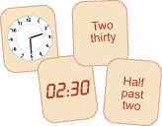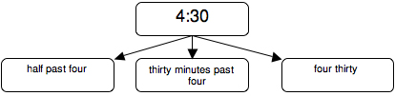

view and print
  - Play Time Bingo — Students are given a card with a number of digital times listed, both hour and half-hour. The teacher shows a time to the hour or half-hour on an analogue clock (or vice versa). Students match to the times shown on their card.
  - Students use the School day: analogue Learning Object to explore digital and analogue time and sequence familiar events in the correct time order.

Online resources

Teacher resources

Interactive White Board Activity

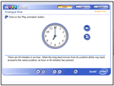
Analogue Time

Student resources

School day: analogue

Clockwise

Mr Ankler Tests – ClockWork

Stage 2

Measurement – Time: Analog and Digital time

Australian Curriculum Reference: ACMMG062: Tell time to the minute and investigate the relationship between units of time.

NSW Syllabus Reference: MA2-13MG: Reads and records time in one – minute intervals and converts between hours, minutes and seconds.

Read time on analogue and digital clocks to the minute; match times on analogue and digital clocks; estimate and compare the length of activities

Strategy

Students can:
- read time on analogue and digital clocks to the minute
- match times on analogue and digital clocks
- estimate and compare the length of activities

Activities to support the strategy

Activity 1
- Students draw their own clock face from memory showing all the markings they know. They describe the features of their clock face to a small group, then compare to a real clock face. Students report to the class and describe the accuracy of their drawing.
- Students are given a page of blank analogue clock faces. They draw the hands on each clock face to show a time on the hour, half-hour or quarter-hour. The teacher calls out a time on the hour, half-hour or quarter-hour. Students mark the clock if they have a matching time.

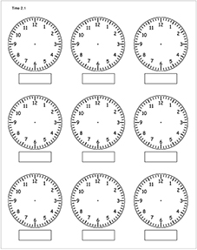

view and print
- Show students a blank analogue clock face. Write the minutes around the outside of the clock. Discuss patterns they can see, e.g. counting by 5s, 10s. Count how many minutes around the clock face. Determine that 60 minutes equals one hour.

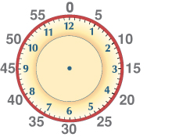

view and print

Teaching minutes after the hour
With the predominant form of time display being digital time, it makes sense to teach students to read ‘minutes after the hour’ on an analogue clock.
- Teach students that the long hand is the minute hand and it says to count by fives. Say When we count the minutes past o'clock, we say zero at 12 then count by fives as we point to each number. Practise pointing and counting by fives from zero to 30.

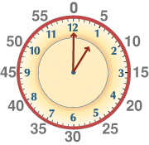
- Provide examples of the long hand pointing to each number 12, 1, 2, 3, 4, 5 and 6 in random order and have students count by fives to give the number of minutes past the hour.
- Tell students If it is thirty minutes after the hour we can also say half past.
- Combine the short hand and long hand by asking the students to identify the hour and the number of minutes after or past the hour. Include examples of o'clock and examples of the minute hand pointing to a number.

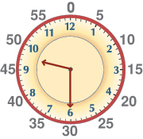

NB: Teaching students to read the time by this method makes it easier to teach minutes after the hour when the minute hand is ‘off a number’. With the bulk of time information being presented in digital form it is not a real problem that students read analogue time as ‘thirty minutes after/past five’.
- Students work in pairs to provide examples of the short hand pointing to each number to show various minutes around the clock face. Have students count by fives and ones to give the number of minutes past the hour/to the hour.
- Students time activities in class that might take 5 minutes, 10 minutes, etc. then practise estimating how long a task has taken.
- Students match cards with alternate recording of the same times.
- Students suggest an activity that can be carried out in a length of time.

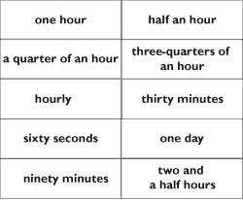

view and print
- Prepare sets of matching times in both analogue and digital forms. Students work in pairs and place the cards face down in a grid and take turns to match pairs of cards.
- Students practise converting from hours to minutes and vice versa, e.g.

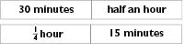
- Students convert between other units of time
e.g. 60 seconds = 1 minute
24 hours = 1 day
365 days = 1 year
366 days = 1 leap year
12 months = 1 year

Complete the activity ‘How Many Days?’ from Mathematics K-6 Sample Units of Work.

Pose the problem ‘How many days have you attended school this term/year?’ Students calculate a solution.

Ask the students ‘How many other ways can you show this information?’ e.g. in hours, in minutes.

Students use a calculator to check their answers.

Extend the activity by asking ‘How many hours have you spent at recess and lunch this week?’ Students could record information in days, hours or minutes on a spreadsheet and then draw a graph.

Activity 2

Students use the Time Tools: 24-hour to the minute Learning Objects to explore time on digital and analogue clocks to one-minute intervals.

Future Teaching Points

Once students can accurately read and record time to 30 minutes past introduce reading time when the minute hand is pointing to 7, 8, 9, 10, 11 or 12, using the sequence of steps outlined above. Emphasise that when the minute hand has moved all the way from 12 around the clock and back to 12, 60 minutes has passed and it is o'clock again. Using this method students will read time as minutes past the hour.

Online resources

Teacher resources

Interactive White Board Activity

Analogue Time

Lesson Plans and Activities

www.teachingtime.co.uk
www.ictgames.com
henryanker.com
www.primaryresources.co.uk
www.bbc.co.uk

Student resources

This website has a variety of games about reading analog and digital clocks.
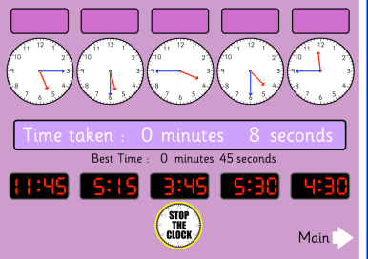
primaryhomeworkhelp.co.uk/maths/measures

Stage 2/3

Measurement – Time – Timetables, Calendars and Timelines

Australian Curriculum Reference: ACMMG062: Tell time to the minute and investigate the relationship between units of time. ACMMG086: Use am and pm notation and solve simple time problems.

NSW Syllabus Reference: MA2-13MG: Reads and records time in one – minute intervals and converts between hours, minutes and seconds.

NSW Literacy Continuum Reference: REAC9M2: Reading texts, Cluster 9, Marker 2: Uses visual representations, e.g. photographs, tables, charts to enhance meaning when reading factual texts.

Other Literacy Continuum Markers: COMC9M3: Comprehension, Cluster 9, Marker 3: Builds understanding about the meaning of a text by actively seeking information from different parts of a text.

Read a simple timetable; read a simple timeline; construct a timeline to show events in their life

Strategy

Students can:
- read a simple timetable
- read a simple timeline
- construct a timeline to show events in their life

Activities to support the strategy

Activity 1 – Simple timetables
- Display a variety of timetables. Examples of timetables could include:
  - weekly class timetables
  - television guides listing the times for TV programs
  - examination timetables
  - transport timetables listing the arrival and departure times for trains, planes, buses, etc.

As a class compare these timetables and identify how they are similar and different.

Discuss:
  - What is one timetable that you use regularly?
  - Why do you use this timetable?
  - What could happen if you did not have this timetable?

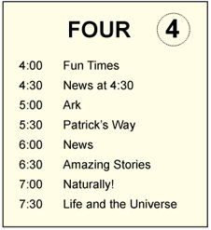
- Students are given a copy of a television guide from the daily newspaper and answer questions about how the timetable is constructed and what information can be provided.

For example, using this television guide showing afternoon programs, questions could include:
  - What TV program begins at 7:00?
  - What TV program begins at 4:30?
  - How long does the News go for?
  - If I began watching TV at 4 o'clock and turned it off after Patrick's Way, how long would I have been watching TV?
  - Can you convert the digital times to analog times?
  - What other information can you interpret from a timetable?
- Students collect a variety of television guides from different sources, such as magazines and newspapers. They:
  - identify anddiscuss features that are common to the different television guides.
  - use the television guides to plan an evening oftelevision viewing and record their plan in a table.

e.g.

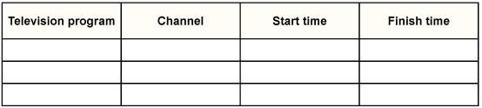

Students share their television viewing plan with the class.

The information in their television viewing plan could be used to draw a timeline. Students could exchange timelines and describe what the other student would be watching that evening and when.
- Use the television guide to practise converting from digital to analog time.
e.g. 10:30 = half past ten, 10:00 = 10 o'clock

Change these digital times to analog times.
  - 7:00 =
  - 4:00 =
  - 7:30 =
  - 5:30 =
- Write a variety of matching digital and analog times on a set of cards.

In small pairs, students jumble the cards and place them face down. Students take turns to turn two cards over. If the cards match, the student keeps them. The winner is the student with the most cards.

After playing the game, the students make additional cards for the game and include times recorded in other ways

Students then repeat the game with the additional cards.

Discuss:
  - Can you read the time on each card?
  - Can you record the time on each card in another way?
  - Can you explain the relationship between the time units?

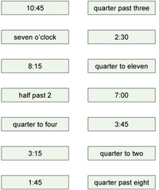

view and print

The cards can also be presented as a worksheet and the students can practise changing between digital and analog time by drawing a line to match cards.
- Students find one example of a timetable and paste it below. You could look:
  - on the internet for a train or bus timetable
  - in the newspaper for a TV guide
  - at a fair or fete or sporting carnival for the program of events.

Students tell the class what information is provided in their timetable. Students write a description which gives details.

Make a class chart of the timetables the students have collected, including their descriptions.

Activity 2 – Daily Time
- Display the table below. It shows the time for one day using one hour intervals.

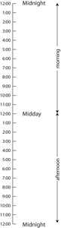

view and print

Discuss:
  - How many hours are there in one day?
  - How many hours from midnight to midday?

A day starts at 12 o'clock at night (midnight) and finishes at 12 o'clock (midnight) 24 hours later.
Have students find 4 o'clock on the table above. Did they find two times for 4 o'clock?
Ask what activities they might be doing at:
~ 4 o'clock in the morning.
~ 4 o'clock in the afternoon.
Repeat for other pairs of times on the daily timeline.
- Display this timeline which shows the daily activities for Jarryd, a school student.

In pairs, students read the timeline for his day, then answer the questions.

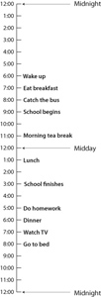

view and print
  - What does Jarryd do at 6 o'clock in the morning?
  - What does Jarryd do at 7 o'clock at night?
  - Is this a school day, a weekend or a holiday? How do you know?
  - What is one activity, which is not listed, that Jarryd could be doing between 7 o'clock and 8 o'clock in the morning?
  - There is a large blank space at the beginning and the end of this 24-hour timeline. What would Jarryd be most likely doing then?
  - If this was your 24-hour timeline what are some changes that you would need to make? It may be a change in a time or an activity.

Activity 3 – My Timeline

Students construct a simple timeline of their life, from birth until now.
Provide each student with this template for a timeline. They follow the steps below to fill in some of the important events in their life.

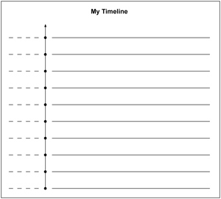

view and print

Step 1 Write this year's number to the left of the top dot. Write in the missing years by counting backwards. Your timeline will show the last 8 or 9 years.

Step 2 Work out the year you started school by counting backwards.
Write 'started school' next on the line next to this year.

Step 3 Choose more important events in your life. Write each event next to the year it happened.
e.g. began to walk, lost first tooth, went on holiday

Students discuss their timeline with a partner.

They write two questions that could be answered using the information in their timeline. Have their partner answer the questions.

Activity 4 – Calendar Patterns

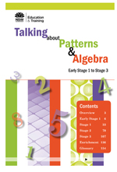

Calendar Patterns (pp.84-85 Talking about Patterns and Algebra)
This activity provides students with a link between reading calendars and number patterns. Students construct a calendar using numeral cards 1- 30 and then complete an investigation around the numbers in the calendar.

Talking about Patterns and Algebra ebook or pdf
This download is only accessible through the DET Portal for DEC employees. Please contact the DEC to purchase a copy.

Online resources

Teacher resources

Nrich website activities

Problems and activities for Time, Calendars and Timetables
Calendar Patterns
Calendar calculations
Month mania
A calendar question
Train timetable
Slow coach

Numeracy Wrap

Horology hiccup

Lesson Plans and Activities

www.educationworld.com/a_lesson/lesson/lesson044
www.primaryresources.co.uk/maths/mathsE2

To generate timelines

www.teach-nology.com/web_tools/materials/timeline
www.teach-nology.com/web_tools/materials/bigtimeline
www.microsoft.com/Education/CreateTimeline
www.dr-mikes-math-games-for-kids.com/timetable-worksheets

Student resources

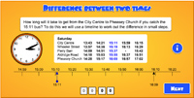

Difference between two times

Back to top
© Learning, High Performance and Accountability Directorate 2014

Stage 2

Space and Geometry – 3D

Australian Curriculum Reference: ACMMG063: Make models of three-dimensional objects and describe key features

NSW Syllabus Reference: MA2-14MG: Makes, compares, sketches and names three-dimensional objects, including prisms, pyramids, cylinders, cones and spheres, and describes their features.

NSW Literacy Continuum Reference: COMC9M3: Comprehension, Cluster 9, Marker 3: Builds understanding about the meaning of a text by actively seeking information from different parts of a text.

Other Literacy Continuum Markers: VOCC9M2: Vocabulary knowledge, Cluster 9, Marker 2: Uses simple content specific vocabulary in appropriate ways when creating texts. SPEC9M4: Aspects of speaking, Cluster 9, Marker 4: Contributes relevant ideas to discussions, asks questions and re-phrases to clarify meaning.

Identify and label the objects in the environment with the correct mathematical names; discuss the features of common objects – the shape of the faces, the number of corners, edges and faces

Strategy

Students can:
- identify and label the objects in the environment with the correct mathematical names
- discuss the features of common objects – the shape of the faces, the number of corners, edges and faces

Activities to support the strategy

Activity 1

Provide students with a variety of common 3D objects, including cones, cubes, cylinders, spheres and prisms, to observe and manipulate. Students look at the objects from different views.
- The teacher models the pronunciation of the name of each object while showing flashcards of the names.
- The teacher and students match the name cards to the objects which are displayed.
- Discuss with students the features of common 3D objects. Make a chart of the features for each object.

Have students collect a variety of 3D objects from around the house. Sort them into groups with the same shape. Students record in words or pictures the groups they have made and report back to the class.

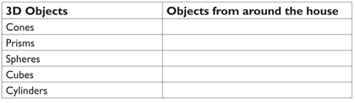

view and print

Activity 2

Provide students with sponges or foam for making a variety of 3D objects.
- Students use paint to print the different faces of the sponge.
- When dry, students cut out the 2D faces and use tape to reassemble the faces as a 3D object.

Activity 3

Students collect a variety of boxes, such as shoe boxes, cereal boxes and match boxes.
- Select a box to display on each student's desk.
- Have students use a coloured text marker to draw the edges of the box that they can see from their seat.
- Select a different coloured text marker to draw the edges they cannot see.

Activity 4

Using the collection of objects from Activity 1, students count the number of faces, edges and corners on each object.

Arrange the objects so all students can see them and play a game of 'What am I?'
- The teacher prepares a set of cards. Each card has a description of a 3D object. The students have to match the description on the card to a 3D object.

view and print
- Students write their own “What am I?” cards to share with a partner.

Online resources

Teacher resources

Stage 1 unit: 3D and 2D Faces of objects from Teaching Space and Geometry K-6 CD, NSW Department of Education and Training, 2008

Interactive Whiteboard Activities

An appealing game where students need to locate the 3D shapes in illustrations of five different locations.

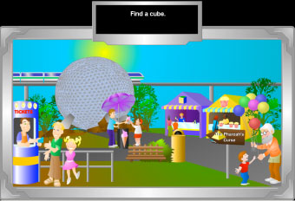

www.starrmatica.com/standalone/starrMatica3DEarthExploration

Student resources

www.bgfl.org/bgfl/custom/resources/.../index
www.crickweb.co.uk/assets/resources/.../MatchingPairs3Dshape

Numeracy App

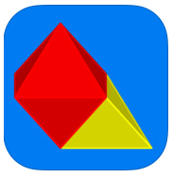Think 3D Free: Explore and interact with 3D shapes on a screen like you never have before.
– Choose from of a variety of 3D shapes
– Create colourful & unlimited combinations
– Add or remove solids with a single tap
– Drag to rotate 3D images in any direction
– Zoom in and out for a better view
– Swipe to spin in any direction
– 3D creations saved in documents
– Share documents with friends over email
– Save pictures of your creations
– Print with AirPrint
Stage 3

Space and Geometry – 3D

Australian Curriculum Reference: ACMMG111: Connect three-dimensional objects with their nets and other two-dimensional representations.

NSW Syllabus Reference: MA3-14MG: Identifies three-dimensional objects, including prisms and pyramids, on the basis of their properties, and visualises, sketches and constructs them given drawings of different views.

NSW Literacy Continuum Reference: VOCC11M1: Vocabulary knowledge, Cluster 11, Marker 1: Makes effective word choices in response to purpose and audience when creating texts.

Other Literacy Continuum Markers: VOCC11M2: Vocabulary knowledge, Cluster 11, Marker 2: Demonstrates understanding of new words for new concepts.

Identify the net of a 3D object; visualise a 3D object given different views; determine the number of faces, edges and vertices of a 3D object

Strategy

Students can:
- identify the net of a 3D object
- visualise a 3D object given different views
- determine the number of faces, edges and vertices of a 3D object

Activities to support the strategy

Activity 1 – Visual Arts

In visual arts, students are often required to recognise measure, draw and construct three-dimensional objects.

Students need to be familiar with key terms used to describe lines, two-dimensional shapes and three-dimensional objects.

When making artworks, it is important that students are able to recognise, visualise and draw two-dimensional shapes and three-dimensional objects.

Group sculpture project

Students construct a free-standing sculpture using three-dimensional objects.
- Ask students to collect or make a variety of three-dimensional objects (cones, cubes, prisms, pyramids and cylinders). They could collect everyday packaging such as cereal boxes or toilet rolls.
- Have students identify and classify the objects according to their properties. Ask students to compare the objects in terms of the number and shape of the faces, and the number of corners and edges. Ensure that students use correct terminology such as prism, pyramid, cylinder, cone, cube, face, edge, corner, angle, vertex, flat, parallel, circular, square and rectangular.
- Ask students to visualise and draw the nets of several objects.

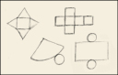

To check the accuracy of the students' drawings, demonstrate by cutting along edges of the everyday packaging to show the net, then re-form the objects.

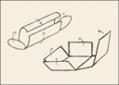

Drawing

Students make linear (using only line) drawings of several objects from observation.

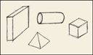

Students imagine, then draw the 'invisible' edges of these objects.

To emphasise the three-dimensional qualities of the objects, add shadows and shading.

Students identify 3D objects used by Picasso in his early Cubist period.

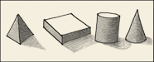

Group sculpture

Groups of 3–5 students each select 4–8 objects and cooperatively plan the construction of a three-dimensional sculpture. The sculpture may represent a theme such as space technology or machinery, or a concept such as power, dynamics or balance. Have each student sketch their proposed sculpture.

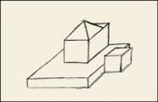

Have each group:
- construct their sculpture and paint it using one light colour (e.g. white, yellow or light blue)
- measure and record the dimensions of their sculpture.

Students make three scale drawings of the sculpture on grid paper. The drawings should show a front, side and top view. Demonstrate to students how to select a suitable scale for the drawings by following these steps.
- Measure and record the length, width and height of their sculpture in centimetres.
- Measure and record the length and width of the grid paper.
- Determine how many times the dimensions of the sculpture need to be reduced to fit the paper whilst remaining in proportion. The length, width and height of the sculpture must be reduced by the same amount.
- Use this ratio of sculpture to paper to determine the scale (e.g. 1 cm on the paper = 5 cm on the sculpture, a ratio of 1:5).

In small groups, students then compare their drawings to the actual views of the sculpture.

Drawing light and dark

Select some sculptures and arrange them in the centre of the room. Use a strong directional light such as an OHP to emphasise the form of the sculptures.
- Have students move around the works, making quick sketches using soft drawing media to record the shadows.
- Repeat the exercise on black paper using white or yellow chalk, crayon or pencil to record the lightened areas.
- Display and compare the two works.

Further Teaching Activities

In groups, students decide on a potential location within the school to build a large scale model of their sculpture. The proposed site should be accurately measured and a plan drawn to scale.

Include accurate measurements for someone else to construct the sculpture. Show front, side, rear and top views.

Use the detailed plan and measurements to develop a list of materials needed. For example, from the scale drawings students could calculate the amount of timber required for the framework by converting the scale drawings to the actual lengths of timber.

Have students present their proposed sculpture to the rest of the class, explaining the design, its dimensions and materials.

Activity 2

Students use the Surface Area, Volume and Nets Learning Object (see Student Resources below) to explore surface area, volume, 3D objects and nets. Objects include rectangular and triangular prisms; rectangular and triangular pyramids; cylinders and cones. Included are print activities, solutions and learning strategies.

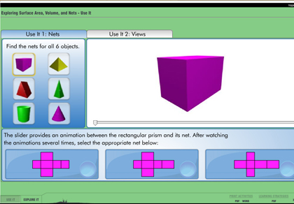

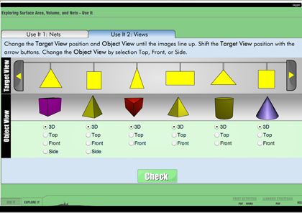

Online resources

Teacher resources

Curriculum Support

Mathematics K-6 (2003) Stage 3 – Three-dimensional Space, pp 143-146

Rectangular prisms, Stage 3, from Mathematics K-6 Assessment and Work Samples, Board of Studies, CD Rom

Lesson Plans and Activities

Students use a real-world situation to help develop spatial visualization skills and geometric understanding. Students determine how many different nets are possible and then analyse the resulting cubes.
illuminations.nctm.org/LessonDetail

The Dynamic Paper tool can be used to create shapes and objects, number lines, number grids, tessellations, spinners and nets. The image created can be exported as a PDF activity sheet for your students or as a JPEG image for use in other applications or on the web.
illuminations.nctm.org/ActivityDetail

Student resources

Surface Area, Volume and Nets Learning Object
www.learnalberta.ca/content/mejhm/index/...//surfaceArea/use_it
www.harcourtschool.com/activity/elab2004/gr4/21

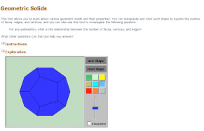

illuminations.nctm.org/ActivityDetail
www.learner.org/interactives/geometry/3d
mathematics.hellam.net/nets
illuminations.nctm.org/ActivityDetail

Numeracy App

Think 3D Free: Explore and interact with 3D shapes on a screen like you never have before.
– Choose from of a variety of 3D shapes
– Create colorful & unlimited combinations
– Add or remove solids with a single tap
– Drag to rotate 3D images in any direction
– Zoom in and out for a better view
– Swipe to spin in any direction
– 3D creations saved in documents
– Share documents with friends over email
– Save pictures of your creations
– Print with AirPrint
Stage 1

Space and Geometry – 2D

Australian Curriculum Reference: ACMMG042: Describe and draw two-dimensional shapes, with and without digital technologies

NSW Syllabus Reference: MA1-15MG: Manipulates, sorts, represents, describes and explores two-dimensional shapes, inlcuding quadrilaterals, pentagons, hexagons and octagons

NSW Literacy Continuum Reference: VOCC8M4: Vocabulary knowledge, Cluster 8, Marker 4: Recognises that different words can be used to describe similar concepts, e.g. everyday or technical language, synonyms.

Other Literacy Continuum Markers: SPEC8M3: Aspects of speaking, Cluster 8, Marker 3: Communicates confidently with a range of less familiar audiences for a wider variety of purposes. SPEC8M5: Aspects of speaking, Cluster 8, Marker 5: Listens and understands a series of instructions related to a task and successfully completes the task.

Name and describe common 2D shapes; identify parallel lines

Strategy

Students can:
- name and describe common 2D shapes
- identify parallel lines

Activities to support the strategy

Activity 1 – 2D Shapes and Parallel Lines
- Collect a variety of transparent coloured plastic 2D shapes, such as rectangles, squares, rhombuses, hexagons and trapeziums. The teacher:
  - displays the 2D shapes on a whiteboard or overhead projector and models the pronunciation of shape names while showing flashcards of names
  - asks students to match the name cards to the shapes which are displayed
  - moves the labels to the bottom of the whiteboard (modify for overhead projector). Teacher and students name each shape and students match labels to shapes
  - removes one shape at a time while students have their eyes closed. The students have to draw the missing shape and copy the label from the board.

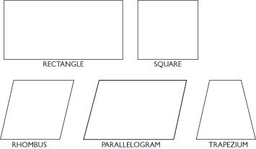

Students select a 2D shape and describe the shape to the class.

Students are given a 2D shape and find other students who have shapes with similar properties. They then explain what the properties were that grouped them together, for example:
  - We all have shapes with three sides.
  - We all have shapes with curved edges.
- Students are given a variety of pattern blocks. Discuss the features of each block and count the number of sides and corners.

Use the pattern blocks to make other shapes by joining. The teacher models the mathematical language while the students discuss the features of the shapes they are constructing, e.g. Ellie has made a shape with all the sides equal and all corners equal.
- The teacher collects or constructs a variety of 2D shapes (pattern blocks, transparent plastic shapes) to use with an IWB/camera projector and leads the following class activity as a discussion.
  - Place two identical equilateral triangles on the projector.

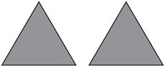

Join the two triangles together to make a new shape.

Ask: What shape have I made?

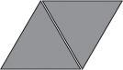
  - Place two identical isosceles triangles on the projector.

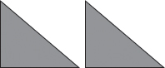

Ask: What shape do you think I can make if these two triangles are joined? Students give reasons to justify their answer.
  - Repeat with two trapeziums.
  - Students use the pattern blocks to make other 2D shapes or pictures by joining. Students describe their pictures and the shapes they used to make them and display the pictures.

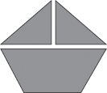
- Ask students to find the number of rectangles in the diagram below and explain or write how they know they have found all of the rectangles.

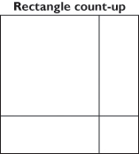
- Students make a list of parallel lines in the classroom. Ask students to explain what makes the lines parallel.

The teacher displays pictures of the environment which include parallel lines. Point to different pairs of lines in the pictures and ask students if the lines are parallel.
- Students label shapes on a worksheet and identify the parallel lines. Vary the orientation of the shapes (see example below).

view and print

Activity 2 – Symmetry

view and print
- Students are given a worksheet with a variety of 2D shapes. They cut out each shape and fold it exactly in half in as many ways as they can.
Discuss:
  - Which shapes can be folded in half only once?
  - Which shapes can be folded in half in more than one way?
  - When two halves exactly overlap, what is the line along the fold called?

On each of the cut outs, students draw the line of symmetry along each fold line.

Students complete the table to record whether each of the shapes is symmetrical and indicate how many lines of symmetry each shape has.

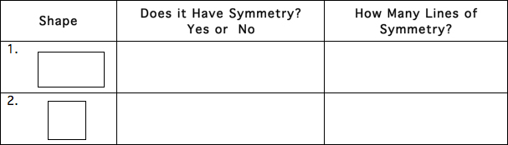

view and print

Students discuss the information. Compare the shapes with the same number of sides. Ask questions such as:
  - Do all four-sided shapes have the same number of lines of symmetry?
  - Do all five-sided shapes have the same number of lines of symmetry?
- Students trace around a circular container and cut out the circle. They
  - fold the circle in half once
  - fold it in half twice
  - then fold it again and again and again.

Discuss:
  - How many times can you fold a circle exactly in half?
  - Can you count the number of times?

Have students explain how many lines of symmetry they think a circle has.

Online resources

Teacher resources

Curriculum Support

Developing Efficient Numeracy Strategies: Stage 2, NSW Department of Education and Training, pp. 228-229, 308-309, 314-315

Tessellate decorate: Three shapes

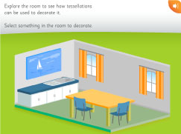

tlf.dlr.det.nsw.edu.au/learningobjects/Content/L7788/object/index

www.homeschoolmath.net/teaching/g/symmetry

Student resources

www.crickweb.co.uk/assets/resources/flash
www.mathplayground.com/patternblocks
www.bbc.co.uk/schools/ks1bitesize/numeracy/shapes/index
www.bbc.co.uk/schools/ks2bitesize/maths/shape_space/
www.bgfl.org/bgfl/custom/resources_ftp/client_ftp/ks2/maths/3d/index
www.innovationslearning.co.uk/subjects/maths/information/shape_facts/shape_facts

Numeracy App

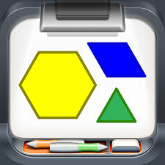Pattern Blocks: Virtual pattern blocks include: triangles, squares, rhombi, trapezoids, hexagons and chevrons.
Stage 2

Space and Geometry – 2D

Australian Curriculum Reference: ACMMG045: Investigate the effect of one – step slides and flips with and without digital technologies. ACMMG088: Compare and describe two-dimensional shapes that result from combining and splitting common shapes, with and without the use of digital technologies.

NSW Syllabus Reference: MA2-15MG: Manipulates, identifies and sketches two-dimensional shapes, including special quadrilaterals, and describes their features.

NSW Literacy Continuum Reference: VOCC9M2: Vocabulary knowledge, Cluster 9, Marker 2: Uses simple content specific vocabulary in appropriate ways when creating texts.

Other Literacy Continuum Markers: SPEC9M4: Aspects of speaking, Cluster 9, Marker 4: Contributes relevant ideas to discussions, asks questions and re-phrases to clarify meaning.

Name and describe common 2D shapes; classify quadrilaterals; identify flips, slides and turns

Strategy

Students can:
- name and describe common 2D shapes
- classify quadrilaterals
- identify flips, slides and turns

Activities to support the strategy

Activity 1 – Flip, slide, turn

Use the following suggested target language to describe the effects of flips, slides and turns.
- If I flip this shape over the dotted line it will look like this.
- If I slide this shape over the dotted line it will look like this.
- If I turn this shape over the dotted line it will look like this.
- Collect a variety of transparent coloured plastic 2D shapes, such as rectangles, squares, rhombuses, parallelograms, hexagons and trapeziums.
- The teacher demonstrates and describes what happens to a shape when it is flipped across a line (flip needs to be demonstrated with a solid shape or a picture on an overhead).
- The teacher repeats to demonstrate what happens to a shape when it is turned and/or when it is slid.

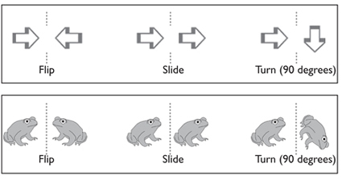

Guided support

In pairs, students choose a shape and practise flipping, sliding and turning the shape.

Students identify how the shape was moved and draw what happens after the shapes crossed the dotted line.

Example of target language: If the triangle is flipped over the line then it will look like this.

Students hypothesise about what these shapes would look like if they were flipped across a line, then draw what they believe the shape will look like.
- In pairs, students brainstorm all the places around the school where you might find a flip, slide or turn pattern, e.g. rows of bricks, patterns on a carpet, tiling patterns.
Students look around the school and try to find an example of each type of pattern – a flip, a slide and a turn pattern. They should draw part of the pattern and write where they found it.

Activity 2 – Identifying quadrilaterals

The teacher displays the following shapes on an overhead projector. Ask students to name each shape and identify what these shapes have in common. Write each of the labels on a card.

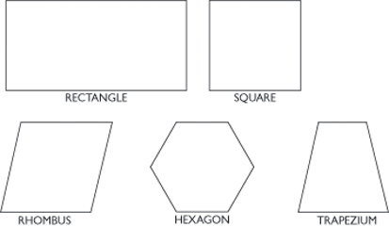

The teacher draws a Venn diagram (reference Mathematics K–6 Syllabus, p.117) to demonstrate that the shapes above are part of a group called quadrilaterals. As the class works through the following definitions the Venn diagram will be completed.

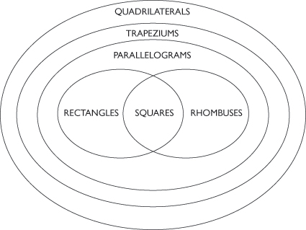
- The teacher reads the definition of a quadrilateral, i.e. any four-sided figure and asks students to identify which of the five shapes fit that classification. As the students determine that a shape fits this classification, they name it and place it on the diagram in the quadrilateral section.

Note: All five shapes will fit the quadrilateral classification.
- The teacher then reads the definition of a trapezium, i.e. a quadrilateral with at least one pair of opposite sides parallel. As the students determine that a shape fits this classification they name it and place it on the diagram in the trapezium section.
Note: All five shapes will fit the trapezium classification.
- The teacher reads the definition of a parallelogram, i.e. a quadrilateral with opposite sides that are parallel and of equal length and opposite angles that are equal. Place matching shapes on the diagram in the parallelogram section.

Note: All shapes, except the trapezium, fit the parallelogram classification.
- The teacher reads the definition of a rhombus, i.e. a rhombus is a parallelogram with four equal sides and equal opposite angles. Place matching shapes on the diagram in the rhombus section.
- The teacher reads the definition of a square, i.e. a quadrilateral with four equal sides, four right angles and opposite sides that are parallel. Place matching shapes on the diagram in the square section.
Note: A square is a special type of rhombus and a special type of rectangle.
- The teacher reads the definition of a rectangle, i.e. a quadrilateral with four right angles and pairs of equal parallel lines. Place matching shapes on the diagram in the rectangle section.

Teacher supports the students to interpret the diagram and make mathematical statements to classify quadrilaterals, e.g.

A rectangle is a quadrilateral. It is also a type of trapezium and parallelogram.

Note: For more advanced students the language can include the properties of each of these classifications in the description, e.g.

A rectangle is a quadrilateral. It may also be considered to be a trapezium that has both pairs of opposites parallel and equal. A rectangle is also a special type of parallelogram that contains a right angle.

Students complete a worksheet in which they have to identify how each shape is classified.

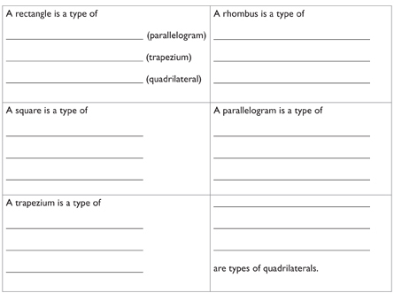

view and print

Using the completed table students write a short description to classify each of the shapes.

Activity 3 – Identifying other polygons

The students can follow similar activities to explore other polygons using the polygon chart below.

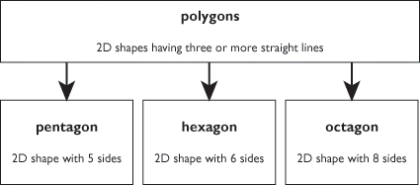

These activities can then be repeated using the chart below.

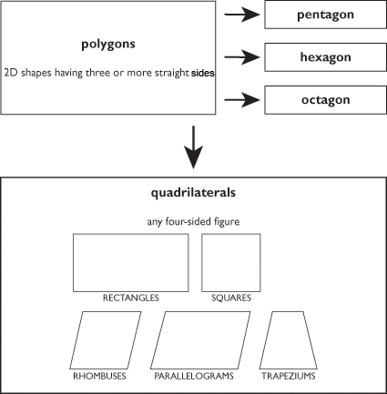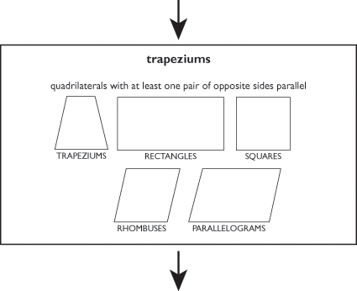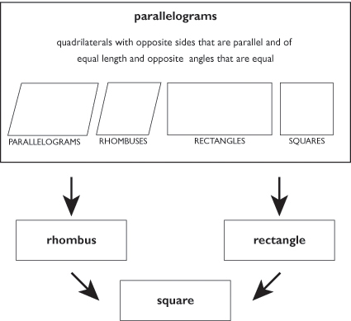

Activity 4 – Symmetry

view and print
- Students are given a worksheet with a variety of 2D shapes. They cut out each shape and fold it exactly in half in as many ways as they can.
Discuss:
  - Which shapes can be folded in half only once?
  - Which shapes can be folded in half in more than one way?
  - When two halves exactly overlap, what is the line along the fold called?

On each of the cut outs, students draw the line of symmetry along each fold line.

Students complete the table to record whether each of the shapes is symmetrical and indicate how many lines of symmetry each shape has.

view and print

Students discuss the information. Compare the shapes with the same number of sides. Ask questions such as:
  - Do all four-sided shapes have the same number of lines of symmetry?
  - Do all five-sided shapes have the same number of lines of symmetry?
- Students trace around a circular container and cut out the circle. They
  - fold the circle in half once
  - fold it in half twice
  - then fold it again and again and again.

Discuss:
  - How many times can you fold a circle exactly in half?
  - Can you count the number of times?

Have students explain how many lines of symmetry they think a circle has.

Activity 5

Students use the Exploring Shape Classification Learning Object to explore 2D shapes and classify shapes based on their properties.

Online resources

Teacher resources

Curriculum Support

Developing Efficient Numeracy Strategies: Stage 2, NSW Department of Education and Training, pp. 228-229, 308-309, 314-315

Tessellate decorate: Three shapes

tlf.dlr.det.nsw.edu.au/learningobjects/Content/L7788/object/index

www.homeschoolmath.net/teaching/g/symmetry

Student resources

www.learnalberta.ca/content/mejhm/index/.../classification/use_it

www.crickweb.co.uk/assets/resources/flash

www.bbc.co.uk/schools/ks1bitesize/numeracy/shapes/index

www.bbc.co.uk/schools/ks2bitesize/maths/shape_space

www.bgfl.org/bgfl/custom/resources_ftp/client_ftp/ks2/maths/3d/index

www.innovationslearning.co.uk/subjects/maths/information/shape_facts/shape_facts

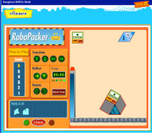

www.eduplace.com/kids/mw/swfs/robopacker_grade3

illuminations.nctm.org/ActivityDetail

Shape Cutter
Students can explore how to decompose shapes and recompose them to make other shapes. Students can draw and cut shapes and also use slides, turns, and flips to move pieces around.
illuminations.nctm.org/ActivityDetail

Shape Tool
Students can create any geometric shape imaginable. Squares, triangles, rhombi, trapezoids and hexagons can be created, coloured, enlarged, shrunk, rotated, reflected, sliced, and glued together.
illuminations.nctm.org/ActivityDetail

Tessellation Creator
Students can make tessellations out of regular polygons.

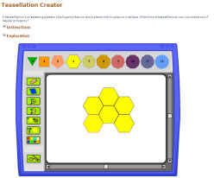

illuminations.nctm.org/ActivityDetail

Numeracy App

Pattern Blocks: Virtual pattern blocks include: triangles, squares, rhombi, trapezoids, hexagons and chevrons
Stage 3

Space and Geometry – 2D

Australian Curriculum Reference: ACMMG112: Estimate, measure and compare angles using degrees. Construct angles using a protractor

NSW Syllabus Reference: MA3-16MG: Measures and constructs angles, and applies angle relationships to find unknown angles.

NSW Literacy Continuum Reference: VOCC11M1: Vocabulary knowledge, Cluster 11, Marker 1: Makes effective word choices in response to purpose and audience when creating texts.

Other Literacy Continuum Markers: VOCC11M2: Vocabulary knowledge, Cluster 11, Marker 2: Demonstrates understanding of new words for new concepts.

Name different angle types; construct a protractor; measure an angle using a protractor

Strategy

Students can:
- name different angle types
- construct a protractor
- measure an angle using a protractor

Activities to support the strategy

Activity 1 – Types of angles
- Provide the definition:

A right angle is an internal angle which is equal to 90 degrees.

Angles can be measured using a protractor.

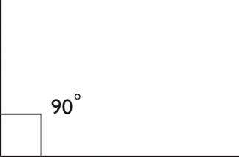

Using an example, point out the right angle and tell students that this square tells you that the type of angle is a right angle and the number tells you the angle size (90). Angles are measured in degrees (°). So a right angle is 90°. All the angles below are right angles.

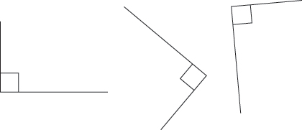

Show students that a right angle can be in any orientation or rotation as long as the internal angle is 90°.

Make up a range of cards showing examples and non-examples of a right angle. Have students respond to each card by saying right angle or not a right angle.

Remember to start with non-examples that are quite different from a right angle and move to non-examples that are close to a right angle. Students could make a right angle tester from card to check.

view and print

Students shape parts of their body to make different types of angles, e.g
  - use your hand/legs to make angles that are:

– a right angle

– smaller than a right angle

– larger than a right angle.

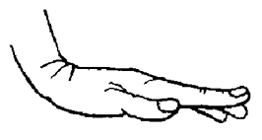

The teacher provides a copy of this picture of a body. Students draw the arms and legs on their picture to show different types of angles.
  - Draw a right angle on the left arm.
  - Draw an angle smaller than a right angle for the right arm.
  - Draw an angle larger than a right angle for the left leg.
  - Draw a right angle for the right leg.

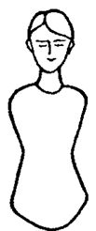

Ask students to find real life objects at home which have angles such as: tools, pliers, clamps, can openers, tongs, crushers, nut openers.

Identify the parts of an angle - the arms and the vertex.
- Introduce the names for the other types of angles - acute, obtuse, reflex, straight, revolution.

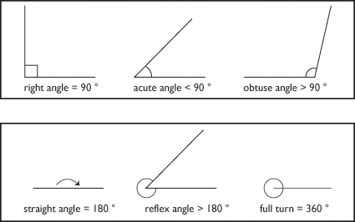

view and print

Students identify and record the different types of angles found in the environment. They describe the angles they have classified, e.g. All these angles are acute because ... Draw each type of angle and label the arms and the vertex, or list examples in a chart.

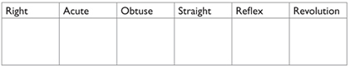

Students could match these descriptions to the correct label by colour coding or by playing matching games with a partner.

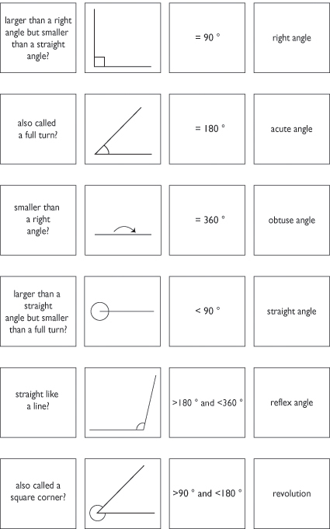

view and print

Activity 2 – Using a protractor
- Students look for pictures of or collect different types of protractors.
  - Discuss and list the features of a protractor, e.g. they all have a baseline, a centre marked on the baseline, a scale beginning at 0°.
  - Most protractors have two scales, one on the inside of the curve and one on the outside of the curve. Each scale goes from 0° to 180°.

Students discuss how to construct a protractor using a semi-circle of cardboard without using another protractor, for example, which angles could be immediately marked on the semi-circle?

Brainstorm strategies for accurately determining where 90°, 45°, 60° and 30° would be located, e.g. folding the cardboard to find 90°, then folding again for 45°. Ask students:
  - Can you locate 60° and 30° by folding?
  - Which angles would need to be estimated to locate on the cardboard?

In pairs, students construct and compare their protractors.

Use the constructed protractors to measure and record angles within the room. Students could also measure objects where the angles can change, such as scissors or a folded card.

Students compare their construction with a real protractor.

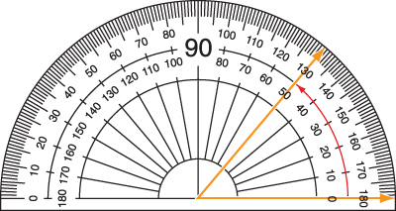
- Students practise measuring angles using a protractor by following these steps:
  - Place the protractor over the angle to be measured.
  - Move the protractor so the centre of the baseline is on top of the vertex of the angle.
  - Make sure the baseline is on top of one arm of the angle.
  - Hold the protractor carefully so it does not move.
  - Count forwards from 0° along the scale until you reach the other arm of the angle.
  - The number where this arm crosses the scale tells you the size of the angle in degrees.

Students who have vision impairment

Examples and non-examples should be printed in bold appropriately sized, clear, bold numerals. Black on white is most effective.

If the student has been prescribed a low vision distance aid encourage them to use it. Students who have difficulties with distance vision should be given an on desk copy of the examples and non-examples in large print.

Students who use Braille

Provide tactile versions or use real objects with angles, including right angles. These can be used as a worksheet for students to label or measure.

Online resources

Teacher resources

Stage 3 Unit: The protractor from Teaching Space and Geometry K–6 NSW Department of Education and Training, 2008

Interactive White Board Activity

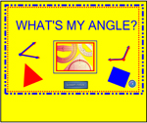

exchange.smarttech.com/details

Student resources

www.sums.co.uk/playground/ss4/playground
www.crickweb.co.uk/assets/resources/flash
www.amblesideprimary.com/ambleweb/mentalmaths/protractor
www.primaryresources.co.uk/maths/mathsE7
http://www.ixl.com/math/practice/grade-5-measure-angles-with-a-protractor
www.bbc.co.uk/schools/ks2bitesize/maths/shape_space

Students can make their own video or photo collection similar to that found on Youtube at: www.youtube.com/user/nadentx

Space and Geometry – 2D

Australian Curriculum Reference: ACMMG114: Describe translations, reflections and rotations of two-dimensional shapes. Identify line and rotational symmetries. ACMMG115: Apply the enlargement transformation to familiar two dimensional shapes and explore the properties of the resulting image compared with the original.

NSW Syllabus Reference: MA3-15MG: Manipulates, classifies and draws two-dimensional shapes, including equilateral, isosceles and scalene triangles and describes their properties.

NSW Literacy Continuum Reference: VOCC11M1: Vocabulary knowledge, Cluster 11, Marker 1: Makes effective word choices in response to purpose and audience when creating texts.

Other Literacy Continuum Markers: VOCC11M2: Vocabulary knowledge, Cluster 11, Marker 2: Demonstrates understanding of new words for new concepts.

Identify quadrilaterals; recognise the properties of regular polygons; identify polygons that have rotational symmetry; use Microsoft Word to draw shapes and rotate shapes; use Microsoft Word to make enlargemnets and reductions of shapes

Strategy

Students can:
- identify quadrilaterals
- recognise the properties of regular polygons
- identify polygons that have rotational symmetry
- use Microsoft Word to draw shapes and rotate shapes
- use Microsoft Word to make enlargements and reductions of shapes

Activities to support the strategy

Activity 1 – Regular Polygons
- Discuss with the class the different features of two dimensional shapes.

Two dimensional shapes can have pairs of sides which are:
  - equal in length
  - unequal in length
  - parallel
  - perpendicular

and angles which are:
  - equal in size
  - acute, right, obtuse, straight, reflex

as well as the shapes being regular or irregular, having axes of symmetry and rotational symmetry.
- Display a variety of quadrilaterals (polygons with four sides) on a whiteboard - square, rectangle, parallelogram, rhombus, trapezium, etc. Students name each quadrilateral and discuss for each one, whether the sides are equal in length and whether the angles are all the same size.

How can we test if the sides are equal in length?
How can we test if the angles are equal in size?
Which shapes have sides that are parallel?

Students could also take turns to draw a variety of quadrilaterals on the whiteboard. Each quadrilateral that the students draw must be different from the previous ones. This way the students are recognising quadrilaterals in different orientations.

Read this definition of a regular polygon.

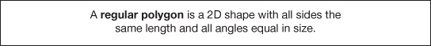

Squares are regular quadrilaterals. Examples of other regular shapes include regular pentagon, regular octagon and regular decagon.

Irregular shapes are shapes in which at least one side is not the same length as the other sides. Examples of irregular shapes include rectangle, trapezium and parallelogram.

Draw a square and a rectangle on the whiteboard or place the shapes on an overhead projector.

Only one of these shapes is a regular polygon, because only one has all sides equal in length and all angles equal in size.

Discuss:
  - Which shape is a regular polygon?
  - How do you know?
  - What is this shape called?
- Provide students with a table showing the different types of quadrilaterals. They complete this table by identifying the side and angle features of different quadrilaterals. Place a tick or cross to indicate if the quadrilateral is regular.

For the quadrilateral to be regular it must have a tick under four equal angles and four equal sides.

The students draw two of their own shapes for (e) and (f) in the table to match the description of the side and angle properties.

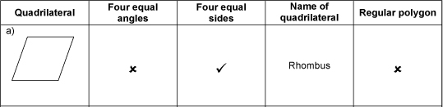

view and print

Explore other shapes using the website Quadrilateral Quest.
- Provide students with an equilateral triangle cut out from coloured paper. They fold the triangle in different ways to find the lines of symmetry.

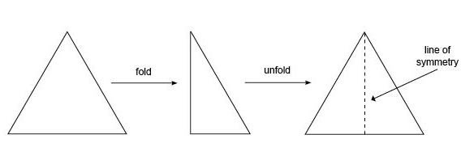

Students describe the shapes produced when they fold along a line of symmetry in an equilateral triangle.

Repeat with a paper square or another regular polygon, such as a pentagon, hexagon or octagon. A worksheet of regular shapes is provided.

Complete these sentences about regular polygons.

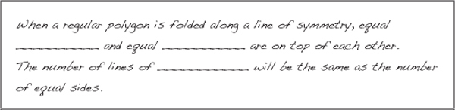

view and print

Activity 2 – Rotational Symmetry
- Explain to students.
Some shapes have lines of symmetry. Shapes can also have turning symmetry or rotational symmetry.

Rotational symmetry occurs when a shape, once rotated, matches the original shape. For example, a square can be rotated:

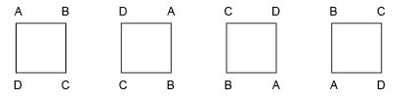

As it takes 4 turns to have square ABCD back in the same position, and the square matches on each turn, a square has rotational symmetry of order 4.

One way to test if an object has rotational symmetry is to trace around its outline onto A4 paper using a sharp pencil. The object is then rotated one full turn to discover if the outline of the object matches its outline on paper more than once as it is rotated.

Students use different materials to test for rotational symmetry.
Materials needed:
paper
exercise book
50 cent coin
school shoe
a mug or glass
- Trace around a school shoe, then lift the shoe and slowly turn it. Keep turning it around until it fits exactly inside the outline again.

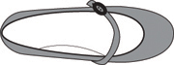

Discuss:
How much did you have to turn the shoe until it fitted inside the outline again?
Did you have to rotate the shoe one full turn to make it fit?

The shoe matches only once with its outline in a full turn. This means the shoe has no rotational symmetry.

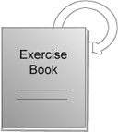
- Trace the rectangular exercise book onto paper. Place the book in its outline then slowly turn it until it fits exactly inside the outline again.
The book can be rotated one half turn and its outline will match.

Discuss:

How many times will the book and its outline match in one full turn?
When the book is turned, did it match its outline two times in a full turn?

This book has rotational symmetry because it can fit exactly inside its outline after a half turn and all angles and sides match. The book matches more than once with its outline in a full turn. It has rotational symmetry of order 2.
- Trace around a 50 cent coin and test for rotational symmetry.

Discuss:
When you turned the coin did it match its outline many times in a full turn?

A 50 cent coin has rotational symmetry because it could match its outline more than once in a full turn. It has rotational symmetry of order 12.
- Trace around either the base or rim of a glass onto paper to test for rotational symmetry.

Before students turn the glass, they should use a pencil to mark both the glass and its outline at one point with matching dots. This will remind then how far the glass has been turned.
Discuss:
When you turned the glass did it match its outline more than once in a full turn?
How many times while you were turning the glass, did the glass match its outline?
Is there any position where the glass did not match its outline on the paper?

A glass has rotational symmetry because it could match its outline more than once in a full turn.
- Provide students with two copies of the worksheet 'Testing for Rotational Symmetry'. One copy can be on coloured cardboard and the other on paper. Students cut out the polygons on the cardboard worksheet only. Using the cardboard cut-outs they test each for rotational symmetry.

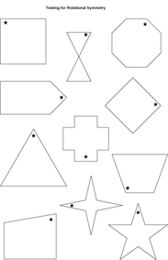

view and print

To do this they have to line up the star on each cut-out with the star on the matching polygon before they start to turn the cardboard cut-out. The star will remind them when they have completed a full rotation.

They complete the table 'Testing for Rotational Symmetry' after they have tested each polygon for rotational symmetry.

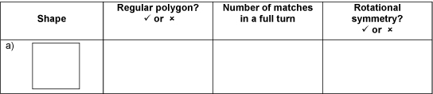

view and print

Students use the information in the table and write what they have learnt about rotational symmetry. e.g.

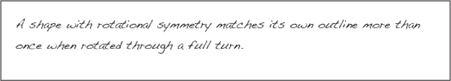

view and print

In pairs, play Concentration using drawings of shapes and descriptions of the features of the shapes.

view and print

Ask students to draw four shapes and write descriptions to match each of their drawings. Students should then play concentration between four paivrs of students using their drawings and descriptions.

Activity 3 – Rotational Symmetry using Word

Students can use Microsoft Word to test for rotational symmetry. The following instructions are available for Microsoft Office 2003 and 2007.

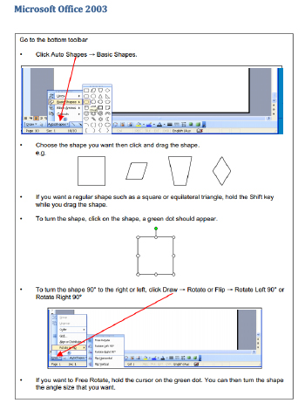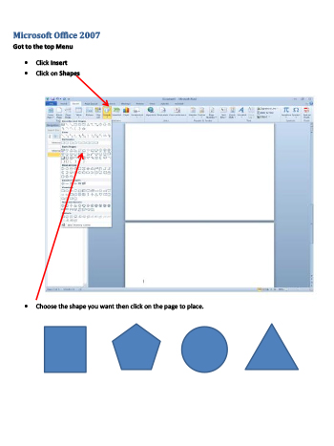

view and print
- Students can create a variety of different shapes using Word. They should label those which have rotational symmetry and those that do not. For the shapes with rotational symmetry they can determine the number of times the shape matches its outline during one full turn.
- Students can also practise enlarging and reducing shapes they have drawn by clicking on a corner of a shape and dragging the shape in or out.

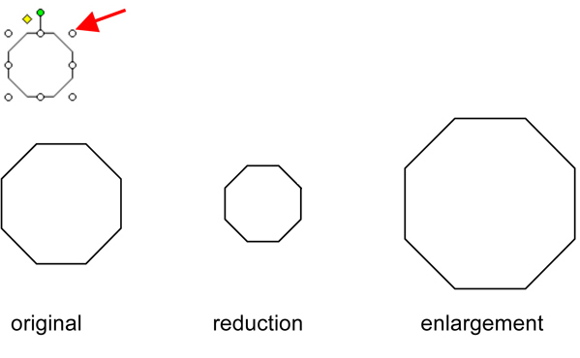
- Students share their drawings with the class.

Activity 4 – Enlargement and Reduction

These drawings have been enlarged and reduced. As a class, discuss what remains the same and what changes.

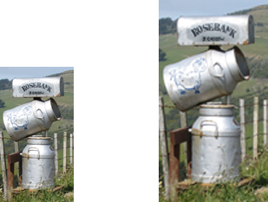

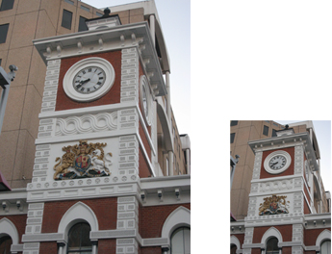

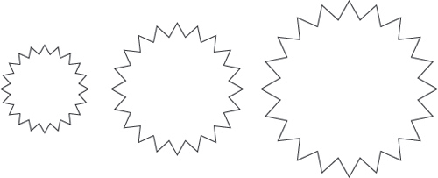

Online resources

Teacher resources

Curriculum Support

Mathematics K-6 Sample Units of Work (2003) Stage 3 – Two-dimensional Space, pp 147-150

Understanding Rotation

Lesson Plans and Activities

www.mathsisfun.com/geometry/symmetry
www.klikkomath.com/klikko-math-lesson1

Student resources

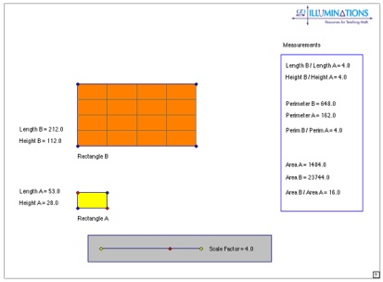

illuminations.nctm.org/ActivityDetail
illuminations.nctm.org
www.innovationslearning.co.uk/subjects/maths/activities/year3/symmetry/shape_game
www.flashymaths.co.uk/swf/rsymmetry
illuminations.nctm.org/ActivityDetail

Quadrilaterals Quest
teams.lacoe.edu/documentation/classrooms/amy/geometry/3-4/activities/quad_quest/quad_quest

Numeracy App

Pattern Blocks: Virtual pattern blocks include: triangles, squares, rhombi, trapezoids, hexagons and chevrons.

Back to top
© Learning, High Performance and Accountability Directorate 2014

Stage 2

Space and Geometry – Position

Australian Curriculum Reference: ACMMG090: Use simple scales, legends and directions to interpret information contained in basic maps.

NSW Syllabus Reference: MA2-17MG: Uses simple maps and grids to represent position and follow routes, including using compass directions.

NSW Literacy Continuum Reference: VOCC9M2: Vocabulary knowledge, Cluster 9, Marker 2: Uses simple content specific vocabulary in appropriate ways when creating texts.

Other Literacy Continuum Markers: SPEC9M4: Aspects of speaking, Cluster 9, Marker 4: Contributes relevant ideas to discussions, asks questions and re-phrases to clarify meaning. SPEC9M5: Aspects of speaking, Cluster 9, Marker 5: Listens attentively, makes appropriate responses to what others say and constructively builds on the ideas of others.

Read a compass; locate a position by following directions; locate a position using coordinates

Strategy

Students can:
- read a compass
- locate a position by following directions
- locate a position using coordinates

Activities to support the strategy

Activity 1

Students can gain experience in locating position using a grid, if the classroom desks are set up as a grid.

To do this:
- Students put their desks in rows and columns.
- Assign a colour to each column and a number to each desk in the column starting with 1.
- Write these on large pieces of paper and display them clearly at the start of the rows and columns. They could be taped to the sides of the desks.
- Give a grid position for each student's desk.
- Using coordinates, students describe how to get from one part of the desk grid to another. For example: My desk is purple 5. To get to my friend Asha's desk I could move forward to purple 3 then turn right and go to green 3, then move up to green 1.
- Discuss the most efficient way (least corners) to travel or set a challenge where you have to make exactly five turns in your travel or you have to travel backwards at least once.

Activity 2 – Dance

Use masking tape to mark a grid on the floor. The masking tape should be positioned at suggested intervals of 1 metre or 0.5 metres over an area that allows for at least 12 grid coordinates. The grid needs to have ABC and 123 coordinates marked.

Divide the class into groups of 5 or 6 students and direct the students to stand around the four sides of the grid area. Direct alternate groups to move within the space, following these instructions.
- Move through the grid by only stepping in between the marks. (At any time the students could be asked to stop and identify the coordinates of the space that they are positioned in.)
- Move through the grid by stepping in between the marks.
- Follow a simple path through the grid using grid coordinates and exit from a given coordinate.
- Follow a complex path through the grid using given coordinates and exit from the same side.
- Make a shape within the grid covering a set of given coordinates.
- Allow the students to create their own path using coordinate language to direct their group.
- Allow the students to create their own path given coordinates that they must pass through.

Using the same grid, remove approximately half the grid markers to reveal an asymmetrical pattern. Students work in groups. Direct the groups to move within the space, following the same instructions as above.

Using the same grid remove approximately half the grid markers again. Students work in groups. Each group creates a sequence of movements to be performed on the grid (the sequence is recorded using grid coordinates). The groups could be given a series of movements to be included in their presentation. The movements could include:
- a travelling pathway that moves across all markers (explore actions such as rolling, sliding, stamping, turning)
- a series of shapes that vary in size.

Activity 3
- Construct a compass using a saucer of water, a slice of cork, a needle and a magnet, following these directions.
  - Place the cork on the water.
  - Rub the magnet one way along the needle repeatedly until magnetised.
  - Lay the needle on the cork. The needle will swing in a north–south direction.
  - When the needle stops mark North, South, East and West on the saucer.

Explain to students these are the four main points of the compass.

Confirm the results from the experiment with a standard compass.

Label walls of the room with North, South, East and West.
- Ask students to describe journeys they have been on, the stops that were made and the directions they travelled in. As they describe their journeys put key words on the board using this diagram as a guide. Create a map of the journey using the description given.

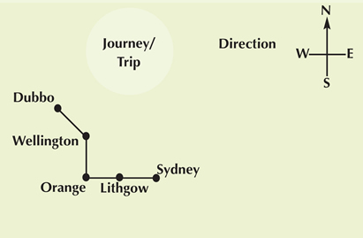

Using the map, have students retell the journey to confirm all the information is correct, e.g. Our family went to Dubbo for a holiday. First we drove west from Sydney to Lithgow where we stopped for breakfast. Then we went west to Orange, then north to Wellington and visited the caves there. Finally we travelled north-west between Wellington and Dubbo.
- Treasure Hunt

Using a compass design a treasure hunt in the playground for students to follow. Every clue requires the use of a compass, e.g.

a) Walk east from the canteen until you reach the large gum tree.

b) Face north–east and then you will find the clue under a seat.

c) Walk west for approximately ten metres. You will find me in the grass.

Complete a joint construction of the treasure hunt. Label a map of the school to show the hunt.

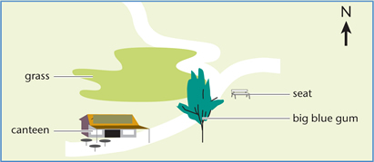
- Barrier Game

Students are each given a simple map of a small town with the four compass points and cut-outs of characters, e.g. a dog, a cat and a rabbit.

One student places a character of their choosing at a set location on the map. The student then provides instructions for their partner to find the location of the character from a set point using compass points to indicate direction. Their partner uses the directions to draw their path on the map, e.g.

a) From the rabbit burrow go north-east till you get to the stream.

b) Turn west and follow the stream until you reach the forest.
- Have students draw a street map of their local area, around their home or school or shopping area.
  - Have students provide the directions to go between places on their map.
  - Ask: Is this the shortest path?
  - Is there another way to go? How would the directional instructions change?
  - Have students list the positional language being used.

Activity 4 – Dance
- Use labels to attach one of the following directions (N, S, E, W, NW/SE, NE/SW) to each face of a die. Start the dance session with a cardiovascular warm-up such as Area Walks from Quantum Leaps (Department of Education and Training, 2002). Give the warm-up a directional focus by using changes in directions such as North, South, East and so on. Also incorporate changes in movement quality.
- Use masking tape to randomly mark crosses on the floor which are within stepping distance of each other. Ask students to:
  - Move across the floor by only stepping on the marks and give a direction, Travel along the marks West, then North, then East. Where are you facing now?
  - Move across the floor by stepping in-between the marks.
  - Make a shape and hold for 3 seconds whenever they step on a mark.
  - Move through the space in time with music, stopping on a mark and freezing in a shape when the music stops.

Use multiple sets of directional cards (North, South, East and West) so students can follow directions. The teacher can use three directions: Move North, West, South, Move North, South, South

Students use their own set of directions and use their own movements – these can be performed in front of others.

Teach students a locomotor dance sequence that moves through the space, stopping in a frozen shape several times. Provide a count for the sequence, including the duration of the freeze in shape. Organise how students will perform the sequence in the space:
- the pathway through the marks that will be followed
- the groupings of students, e.g. 2s, 3s, individuals
- the timing of each group's performance of the sequence
- entrances and exits.

Rehearse and refine the group composition and present the work for an audience.

Online resources

Teacher resources

Curriculum Support

Mathematics K-6 (2003) Stage 2 – Position, pp 116-119

Numeracy wrap

Find it fast
Students find objects on a grid given grid references or coordinates, locate places on a map with and without a grid, draw and label a grid on a map or plan.

Lesson Plans and Activities

www.primaryresources.co.uk/maths/mathsE6

Student resources

pbskids.org/cyberchase/webisode_3/web_game3

www.bbc.co.uk/schools/ks2bitesize/maths/shape_space

resources.oswego.org/games/BillyBug/bugcoord

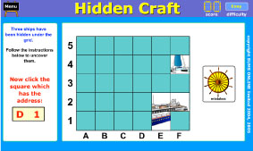

www.sums.co.uk/playground/ss3/playground

www.counton.org/games/flash/virtualmathfest/dinosaur

Back to top
© Learning, High Performance and Accountability Directorate 2014
Stage 3

Space and Geometry – Position

Australian Curriculum Reference: ACMMG113: Use a grid reference system to describe; locations. Describe routes using landmarks; and directional language

NSW Syllabus Reference: MA3-17MG: Locates and describes position on maps using a grid reference system. ENS3.5: Demonstrates an understanding of the interconnectedness between Australia and global environments and how individuals and groups can act in an ecologically responsible manner – See indicators 1,2,3, 9,10, 12. (Current HSIE K – 6 Syllabus in use for 2014 p31)

NSW Literacy Continuum Reference: VOCC11M2: Vocabulary knowledge, Cluster 11, Marker 2: Demonstrates understanding of new words for new concepts.

Other Literacy Continuum Markers: VOCC12M1: Vocabulary knowledge, Cluster 12, Marker 1: Uses new words for known concepts, e.g. blissful for happy.

Use compass points, distance and scale to read and interpret maps; understand the effect on a map when the scale is changed

Strategy

Students can:
- use compass points, distance and scale to read and interpret maps
- understand the effect on a map when the scale is changed

Activities to support the strategy

Activity 1

In this activity, students are given a simple map which has a 2 cm grid or a 2 cm grid overlay can be used.

On a separate page students can:
- draw a 4 cm grid and copy the map, then
- draw a 1 cm grid and copy the map.

Students compare the maps. Discuss:
- Did doubling the size of the grid double the scale? Why?
- Did halving the size of the grid halve the scale? Why?
- Did doubling/halving the size of the grid double/halve the size of the map? Why?
- How could this method be used to enlarge/reduce a smaller section of the map?

Activity 2 – Geography

In geography students use various types of maps to gather data. Maps are the most common tool used by geographers to show the spatial distribution and features of physical and human elements of the environment. Students need practice in identifying landmarks on a map by using a compass and map coordinates.

In geography, students can:
- use atlases to investigate the different types of maps that are produced and discuss the purpose for different maps
- identify the various features on a map, e.g. scale.

In geography, teachers can:
- introduce the mnemonic BOLTS to students as a way to assist them to remember the important elements of a map
- explain the importance of each element and show how students might use each to gain information that may help them.

Exploring metalanguage (QTF)

BOLTS Acronym

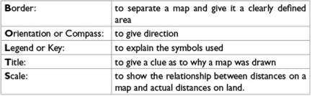

When teaching students to read map coordinates in the geography classroom, it is important to explain that:
- the starting point for reference is the bottom left hand corner of the map
- the horizontal always comes before the vertical. That is, read across the bottom of the map, and then read up the map.

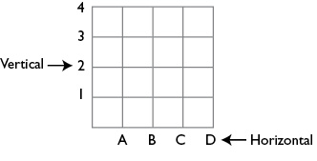

When teaching students to use direction on a map it is important to emphasise the importance of the words 'from' and 'to'.
- From is the starting point. Students need to place a compass on this point aligning it with the map orientation to work out the direction required to reach the end point.
- To is the end point.
- In this activity students will identify landmarks on a map by using a compass and map coordinates. The activity is designed as a team activity with students working in pairs.

Photocopy 15 different pages from a street directory and distribute one page to each pair of students.

Explain to students the importance of being able to locate features on a map when analysing for a specific purpose.

Demonstrate to students how coordinates are helpful by displaying an overhead of the street directory page which shows the school and discussing the school's coordinates.

Highlight the north point on the page.

Ask students to generate a list of ten questions that relate to using the map coordinates and direction on their specific map. Examples of the types of questions students may generate include:
  - What are the main features located in A1? B2? C6?
  - What are the map coordinates for ____________?
  - What direction is ____________ from ____________?
  - If you travelled from ____________ to ____________, what direction would you be travelling?

Students can swap maps and questions to test another group in the class.

Additional ideas can be sourced at the Ed Helper website. This includes sample activities for using easier maps.

Exploring deep knowledge (QTF)
- In this activity students will select an area of study and draw a map including all of the important elements. The activity is designed to be completed by individual students. Select a country that fits within your topic of World Heritage area or global environments, such as China.

Provide blank paper so that students can draw or trace an outline of the country.

Ask students to mark the World Heritage sites found in the country, then draw a holiday route which connects many of the main World Heritage sites, e.g. Great Wall of China, Yungang Grottos and Lushan National Park.

Remind students to include all of the important elements of a map, especially the scale. In groups or individually, students use the scale to calculate the total distance to be travelled on the holiday.

Discuss the distances of each section of the holiday route, the type of environment being traversed (e.g. mountains, rivers) and the modes of transport available.

Discuss which form of transport would be most appropriate for each section and give reasons why the mode of transport was selected.

Students estimate the number of days required for the holiday given the distances to be travelled, the modes of transport being used and the time required to visit the World Heritage sites.

Resources

Curriculum Support
Mathematics K-6 (2003) Stage 3 – Position, pp 154-156

Design a Cross Country track
Students work in pairs or small groups to design a 3 kilometre cross country course for their school. Students draw the course to scale and label their plan with the scale used and the length of each part of the course.

Numeracy wrap: Maps matter
lrrpublic.cli.det.nsw.edu.au/lrrSecure/Cli/ResourceInfo

Numeracy wrap: Find it fast
lrrpublic.cli.det.nsw.edu.au/lrrSecure/Cli/ResourceInfo

Lesson Plans and Activities

Ed Helper website www.edhelper.com/Community_Maps

Interactive White Board Activity

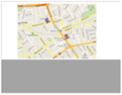
Google Map Listening Stimulus

www.pbs.org/wgbh/nova/everest/earth/lostshock (requires Shockwave browser plug in)
www.eduplace.com/kids/socsci/books/applications/imaps/maps/g1_u3/index

