CONNECTING TO OLIVER

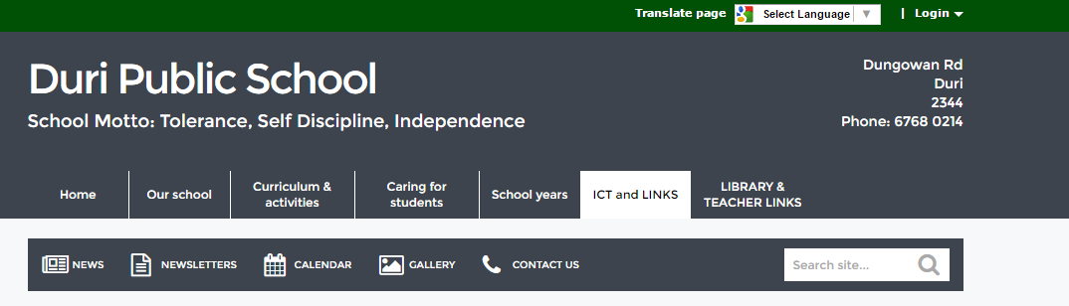
- Locate the Duri P.S. website and click on ‘Login’

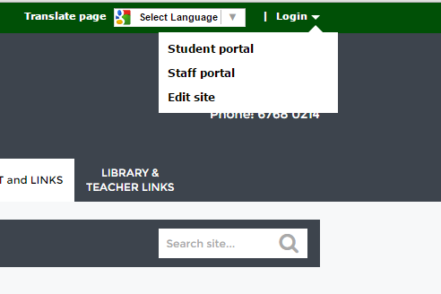
2.Enter as a Student or Teacher

As a Teacher you can find OLIVER under ‘My Application’ and add it to your “Essentials”

3.As a student they will see this portal
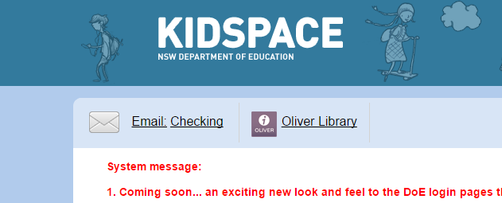
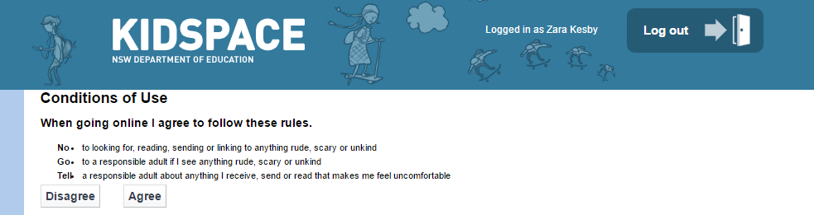
4.The OLIVER library link is here

5.Explore!!!!!!!
